Fifteenth Sunday After Pentecost
September 6, 2026
9:30am


Christ Lutheran Church
6500 E. Stearns Street
Long Beach, California 90815
Phone 562-598-2433
www.christlutheranlb.com

Preschool 562-594-6117
www.clplb.com

Excerpts from Pastor Nikki’s newsletter article…

“The last few months have been full of grief for this congregation as we’ve said goodbye to 6 dear congregation members who have joined the Church Triumphant. As I’ve grieved alongside you and with you, I’ve longed for us to have some common language around grief, how we process loss, and how to move forward with our grief. You might have noticed that this longing has informed my newsletter articles for the months of June and July, and the theme continues this month.
For 6 weeks which began last Sunday, we’ll be sharing in a sermon series that is based on a small group study called, “The Grief Lectionary: A Scriptural Approach to Accessing and Processing Your Grief,” written by Rev. Collette Broady Grund.
As Christians and particularly as human beings, none of us are immune to grief and loss.
They are part of this world in which we live. Whether you’re processing the recent losses of our congregation or other losses in your own life, recent or otherwise, or both,
we all can use some tools to navigate the experience of grief.
The series is not meant to solve or explain away your grief or mine and it might feel tender to some whose grief is so close. You are encouraged to engage as you’re able- whether that means participating in worship online or excusing yourself from your pew if you’re feeling overwhelmed. Also, we are reminded that the Sanctuary is just that- a sanctuary, a safe place to feel all the feelings and that our church community is willing and wanting to help hold you as we navigate this time. So engage as you’re able.”

Session 1: The Flood
Session 2: Jeremiah’s Anger
Session 3: Elijah’s Depression
Session 4: Ruth and the Grieving Community
Session 5: Jesus’ Suffering and Acceptance of Death
Session 6: Resurrection and Making Meaning

Welcome to worship! We’re glad you’re here!
To assist in your worship:
bold print means we respond together
* means rise in body or spirit,
+ you may make the sign of the cross should you so desire.

It is our joy to worship with your whole family!
We encourage everyone of all ages and abilities to worship together.
We offer a “pray-ground” located in the back left of the Sanctuary for those with littles to have some room for movement and activity. The Narthex (gathering space at the entry) also has some resources for families, including activity bags filled with crayons, paper and storybooks. These supplies can be used in the Narthex or brought into the Sanctuary. For those that find themselves in the Narthex, there is a speaker with which you can still hear the service. Lastly, a changing table is located in the restroom off the Narthex. Please ask an usher if you need any assistance.

TODAY’S worship THEME

Conflict is a part of relationships and life in community. Jesus’ words in today's gospel are often used in situations having to do with church discipline. The prophet Ezekiel tells of warning the wicked to turn from their ways, and Paul reminds us that love is the fulfilling of the law. We gather in the name of Christ, assured that he is present among us with gifts of peace and reconciliation.

Worship services for Christ Lutheran Church- Long Beach
are live-streamed and archived to YouTube.
By entering the sanctuary and by your presence here,
you consent to be photographed,
filmed, and/or otherwise recorded.
Please alert an usher if this is of concern to you.

Our liturgy is taken from:
Sundays and Seasons.com. Copyright 2026 Augsburg Fortress. All rights reserved.
Reprinted by permission under Augsburg Fortress Liturgies Annual License #20338.
Reprinted by permission under CCLI license # 230154. All rights reserved.
Reprinted by permission under © 2026 One License #A-706154. All rights reserved.
“The Grief Lectionary: A Scriptural Approach to Accessing and Processing your Grief,” written by Rev. Collette Broady Grund. © 2022. www.colletebroadygrund.com

PRELUDE Roger Halvorson

WELCOME
All are invited to complete the yellow sheet in your bulletin. Once completed, place it to the outside of your pew for the ushers to collect.

GATHERING
The Holy Spirit calls us together as the people of God.

*CONFESSION AND FORGIVENESS

Blessed be the holy Trinity, ☩ one God, who pours love into our hearts and healing upon the earth.
Amen.

Confident that God justifies us by grace through faith, let us confess our sin.

Silence is kept for reflection.

Compassionate God,
we confess that we struggle to embody your goodness
in the world and in our own hearts.
Creation groans from overuse.
Jealousy and bitterness strain our relationships.
Indifference keeps us from seeking justice.
Divisions disrupt your call to show genuine love to others.
Turn our hearts back to you.
Restore our world and reconcile us to one another.
Renew us to live as your holy people, following the way of Jesus Christ.
Amen.

Hear this good news:
We have peace with God through ☩ Jesus Christ,
in whom there is no condemnation,
but only forgiveness and the promise of eternal life.
Receive freely this healing gift of grace.
Amen.

*GATHERING SONG As We Gather at Your Table ELW #522
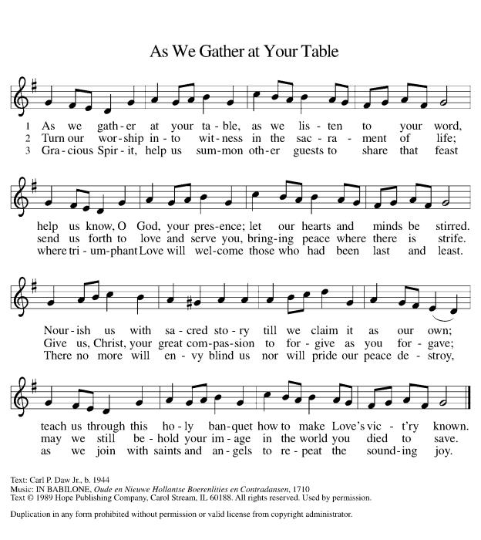

*GREETING

The grace of our Lord Jesus Christ, the love of God, and the communion of the Holy Spirit be with you all.
And also with you.

*PRAYER OF THE DAY

Let us pray together,
O Lord God, enliven and preserve your church with your perpetual mercy.
Without your help, we mortals will fail; remove far from us everything that is harmful, and lead us toward all that gives life and salvation, through Jesus Christ, our Savior and Lord.
Amen.

WORD
God speaks to us in scripture reading, preaching, and song.

CHILDREN’S CHAT
All children are welcomed forward for a children’s time.

PSALM Psalm 119:33-40

³³ Teach me, O Lord, the way of your statutes,
and I will observe it to the end.
³⁴ Give me understanding, that I may keep your law
and observe it with my whole heart.
³⁵ Lead me in the path of your commandments,
for I delight in it.
³⁶ Turn my heart to your decrees
and not to selfish gain.
³⁷ Turn my eyes from looking at vanities;
be gracious to me according to your word.
³⁸ Confirm to your servant your promise,
which is for those who fear you.
³⁹ Turn away the disgrace that I dread,
for your ordinances are good.
⁴⁰ See, I have longed for your precepts;
in your righteousness be gracious to me.

SCRIPTURE READING Romans 13:8-14

Word of God, word of life. Thanks be to God.

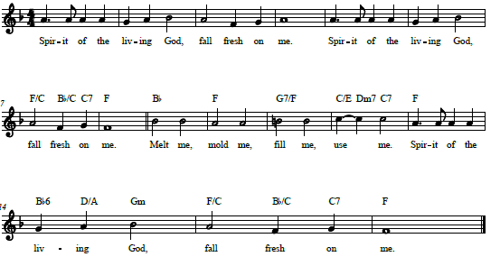
*GOSPEL ACCLAMATION Spirit of the Living God W&P #129

*GOSPEL Luke 24:1-12

The Holy Gospel according to Luke, the 24th chapter. Glory to you, O Lord.
The reading concludes: The Gospel of the Lord. Praise to you, O Christ.

SERMON Pastor Nikki Fielder

SERMON NOTES:

*SERMON HYMN Ten Thousand Reasons ACS #1097

Chorus
Bless the Lord O my soul O my soul
Worship His holy name
Sing like never before O my soul
I'll worship Your holy name

Verse 1
The sun comes up it's a new day dawning
It's time to sing Your song again
Whatever may pass and whatever lies before me
Let me be singing when the evening comes
Chorus

Verse 2
You're rich in love and You're slow to anger
Your name is great and Your heart is kind
For all Your goodness I will keep on singing
Ten thousand reasons for my heart to find
Chorus

Verse 3
And on that day when my strength is failing
The end draws near and my time has come
Still my soul will sing Your praise unending
Ten thousand years and then forevermore
Chorus

*APOSTLES’ CREED

I believe in God, the Father almighty, creator of heaven and earth.

I believe in Jesus Christ, God’s only Son, our Lord, who was conceived by the Holy Spirit, born of the virgin Mary, suffered under Pontius Pilate, was crucified, died, and was buried; he descended to the dead. On the third day he rose again; he ascended into heaven, he is seated at the right hand of the Father, and he will come to judge the living and the dead.

I believe in the Holy Spirit, the holy catholic church, the communion of saints, the forgiveness of sins, the resurrection of the body, and the life everlasting. Amen.
PRAYERS OF THE CHURCH

Reminded of God’s gracious and abundant love, we offer our prayers, confident that God hears us.
A brief silence.
Attend to us, O God.
Your mercy is great.

Grant the prayers we have offered, what we have forgotten to ask, and whatever else you see that we need. We ask this in Jesus’ name.
Amen.

*SHARING OF PEACE

The peace of Christ be with you always.
And also with you.

OFFERTORY In the Name of the Lord Kim Miller & Marvin Moon

*OFFERTORY RESPONSE We Are an Offering ELW #692

Chorus 1
We lift our voices
We lift our hands
We lift our lives up to You
We are an offering
Lord use our voices
Lord use our hands
Lord use our lives they are Yours
We are an offering

Bridge
All that we have
All that we are
All that we hope to be
We give to You
We give to You

Chorus 2
We lift our voices
We lift our hands
We lift our lives up to You
We are an offering
We are an offering

*OFFERTORY PRAYER
Let us pray together,
God of creation, you send rain and the earth springs forth abundantly.
All blessings are from you; make us generous with what we have.
Use our gifts, our abilities, and our hearts in service to you and in love to our neighbors, today and always.
Amen.

MEAL
God feeds us with the presence of Jesus.

*THE GREAT THANKSGIVING
The Lord be with you. And also with you.
Lift up your hearts. We lift them to the Lord,
Let us give thanks to the Lord our God. It is right to give our thanks and praise.

It is indeed right, our duty and our joy, that we should at all times and in all places give thanks and praise to you…we praise your name and join their unending hymn:

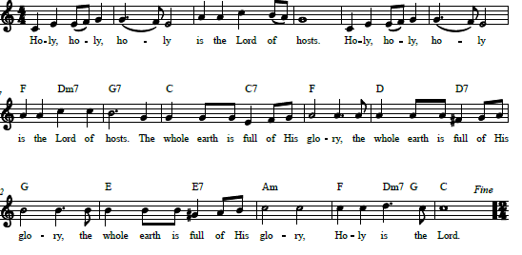
*HOLY, HOLY, HOLY Nolene Prince

*THANKSGIVING AT THE TABLE

O God most mighty, O God most merciful…

Remembering his death, we cry out Amen. Amen.
Celebrating his resurrection, we shout Amen. Amen.
Trusting his presence in every time and place, we plead Amen. Amen.

O God, you are Breath: send your Spirit on this meal…

…the life of the Creator, Redeemer and Sustainer,
life in you, now and forever.
Amen.

*LORD’S PRAYER

Our Father in heaven,
hallowed be your name,
your kingdom come,
your will be done,
on earth as in heaven.
Give us today our daily bread.
Forgive us our sins
as we forgive those
who sin against us.
Save us from the time of trial
and deliver us from evil.
For the kingdom, the power,
and the glory are yours,
now and forever. Amen.

DISTRIBUTION OF HOLY COMMUNION
We believe that this is Jesus' table. All are welcome and invited to commune. We serve communion by “intinction”; receive the bread and dip it in the chalice. Gluten free wafers are available; let your server know. Wine is offered on each side. White grape juice is offered at the center aisle. Should you choose not to commune, you are invited to come forward to receive a blessing. Please cross your arms across your chest to let us know to give you that blessing.

INVITATION TO COMMUNION

Christ invites you to this table. All who are thirsty, all who are hungry, come!
COMMUNION SONGS Let Us Break Bread Together ELW #471

When We Are Living ELW #639
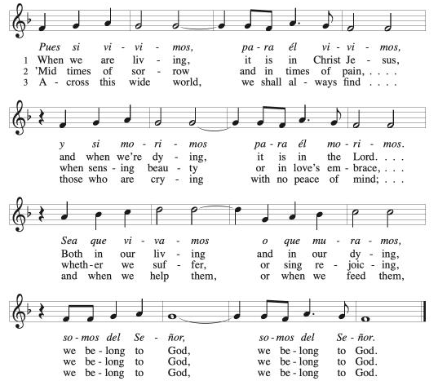

*POST COMMUNION BLESSING
The body and blood of our Lord Jesus Christ strengthen you and keep you in his grace. Amen.

*PRAYER AFTER COMMUNION

Let us pray,
Sustaining God, with this bread and cup, you nourish us with mercy and abundant life. By your Spirit, send us from this table to serve a needy world. Make us living signs of your liberation, healing, and love, following the way of Jesus, in whose name we pray.
Amen.

SENDING
God blesses us and sends us in mission to the world.

ANNOUNCEMENTS

*BLESSING

The God of love draw you into full accord and one mind, in the body of Christ Jesus.
The God of hope grant you strength and joy in all circumstances through the interceding of the Spirit.
The God of grace ☩ bless you now and forever.
Amen.

*SENDING SONG Earth and All Stars! ELW #731
(verses 1, 2, & 5)
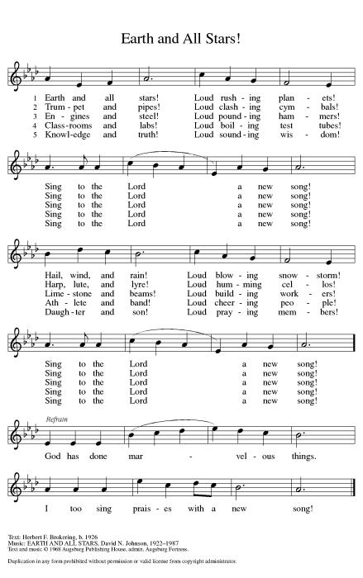
Chil - dren of God!

*Dismissal
Go out in joy. Be led forth in peace.
Thanks be to God.

POSTLUDE Roger Halvorson

CHRIST LUTHERAN CHURCH STAFF

Pastor Rev. Nikki Fielder, pastor@christlutheranlb.com
Office Manager Kim Croes, officemanager@christlutheranlb.com
Preschool Director Lisa Clinton, info@clplb.com
Director of Senior Adult Ministry Shannon Howard, directorsam@christlutheranlb.com
Choir Director Kim Philips, kimsings@msn.com
Accompanist Roger Halvorson
A/V Technicians Brad Croes and Jett Baker
Missionary to Colombia Linda Gawthorne

Mission Statement
Living by Christ’s example, we welcome, serve, and love all through God’s grace.

Vision Statement

Embracing the truth that God’s love and grace is for all, Christ Lutheran Church is a vibrant and active community spreading the good news through acceptance, action, and benevolence.

Our Position
Christ is ALIVE!

Reconciling in Christ (RIC) Welcome Statement
Christ Lutheran Church is a congregation who joyfully welcomes everyone who enters our doors. We recognize that each of us is a unique creation made in the image of God. We celebrate and give thanks for the many diverse gifts that God has bestowed on us. We proclaim ourselves to be an open and affirming congregation to all of God's children, welcoming into our ministry persons of every race, culture, age, gender identity, gender expression, sexual orientation, ability, and economic status. We commit ourselves to the work of anti-racism and creating an anti-racist space. We believe that through our openness we all grow in our faith through Christ's teaching to love one another as God loves us.

