Fifth Sunday After Pentecost
June 28, 2026
9:30am


Christ Lutheran Church
6500 E. Stearns Street
Long Beach, California 90815
Phone 562-598-2433
www.christlutheranlb.com

Preschool 562-594-6117
www.clplb.com

Welcome to worship! We’re glad you’re here!
To assist in your worship:
bold print means we respond together
* means rise in body or spirit,
+ you may make the sign of the cross should you so desire.

It is our joy to worship with your whole family!
We encourage everyone of all ages and abilities to worship together.
We offer a “pray-ground” located in the back left of the Sanctuary for those with littles to have some room for movement and activity. The Narthex (gathering space at the entry) also has some resources for families, including activity bags filled with crayons, paper and storybooks. These supplies can be used in the Narthex or brought into the Sanctuary. For those that find themselves in the Narthex, there is a speaker with which you can still hear the service. Lastly, a changing table is located in the restroom off the Narthex. Please ask an usher if you need any assistance.

TODAY’S worship THEME

The welcome of baptism is for all God’s children. This baptismal gift sets us free from the power of sin and death. In today’s gospel, Christ promises that the disciple who gives a cup of cold water to the little ones serves Christ himself. From worship we are sent on our baptismal mission: to serve the little ones of this world and to be a sign of God’s merciful welcome.

Worship services for Christ Lutheran Church- Long Beach
are live-streamed and archived to YouTube.
By entering the sanctuary and by your presence here,
you consent to be photographed,
filmed, and/or otherwise recorded.
Please alert an usher if this is of concern to you.

Our liturgy is taken from:
Sundays and Seasons.com. Copyright 2026 Augsburg Fortress. All rights reserved.
Reprinted by permission under Augsburg Fortress Liturgies Annual License #20338.
Reprinted by permission under CCLI license # 230154. All rights reserved.
Reprinted by permission under © 2026 One License #A-706154. All rights reserved.

PRELUDE Roger Halvorson

CALL TO WORSHIP Lo, How a Rose E'er Blooming The Mighty Ringtones

WELCOME
All are invited to complete the yellow sheet in your bulletin. Once completed, place it to the outside of your pew for the ushers to collect.

GATHERING
The Holy Spirit calls us together as the people of God.

*CONFESSION AND FORGIVENESS

All may make the sign of the cross, the sign that is marked at baptism, as the presiding minister begins.

Blessed be the holy Trinity,☩ one God, whose compassion endures forever.
Amen.

Let us confess our sin to God.
Silence is kept for reflection.
Compassionate God,
we confess to you all our sins. Our burden is heavy, and we cannot free ourselves. In your mercy, call us back to you. Your yoke is easy and your burden is light. Restore us to dwell in your peace. In Christ’s name we pray, Amen.

Jesus says, “Come to me, all you who are weary and are carrying heavy burdens, and I will give you rest.” In the name of God, Father, ☩ Son, and Holy Spirit, your sins are forgiven. Rest in God’s love.
Amen.

*GATHERING SONG Lost in the Night ELW #243
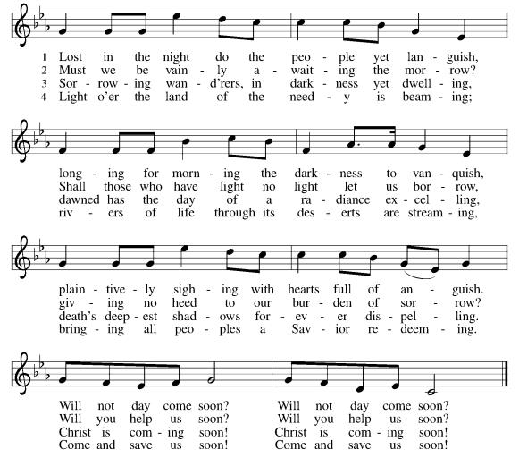
(verses 1, 3, 4)

*GREETING
The grace of our Lord Jesus Christ, the love of God, and the communion of the Holy Spirit be with you all.
And also with you.

*PRAYER OF THE DAY
Let us pray together,
O God, you direct our lives by your grace, and your words of justice and mercy reshape the world. Mold us into a people who welcome your word and serve one another, through Jesus Christ, our Savior and Lord. Amen.

WORD
God speaks to us in scripture reading, preaching, and song.

CHILDREN’S CHAT
All children are welcomed forward for a children’s time.

PSALM Psalm 89:1-4, 15-18

¹ I will sing of your steadfast love, O Lord, forever;
with my mouth I will proclaim your faithfulness to all generations.
² I declare that your steadfast love is established forever;
your faithfulness is as firm as the heavens.
³ You said, “I have made a covenant with my chosen one;
I have sworn to my servant David:
⁴ ‘I will establish your descendants forever
and build your throne for all generations.’ ”
¹⁵ Happy are the people who know the festal shout,
who walk, O Lord, in the light of your countenance;
¹⁶ they exult in your name all day long
and extol your righteousness.
¹⁷ For you are the glory of their strength;
by your favor our horn is exalted.
¹⁸ For our shield belongs to the Lord,
our king to the Holy One of Israel.

SCRIPTURE READING Romans 6:12-23

Word of God, word of life. Thanks be to God.
*GOSPEL ACCLAMATION Alleluia ELW Pg.188

*GOSPEL Matthew 10:40-42

The Holy Gospel according to Matthew, the 10th chapter. Glory to you, O Lord.
The reading concludes: The Gospel of the Lord. Praise to you, O Christ.

SERMON Pastor Nikki Fielder

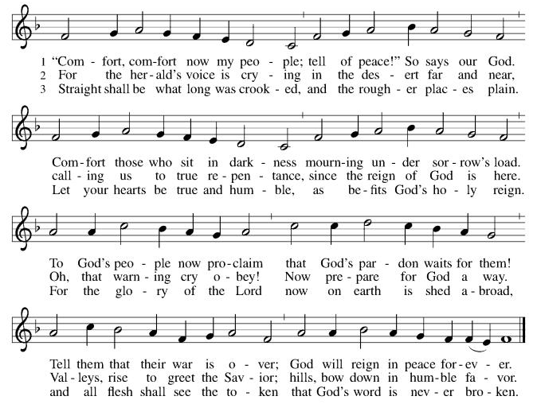
*SERMON HYMN Comfort, Comfort Now My People ELW #256

*APOSTLES’ CREED

I believe in God, the Father almighty, creator of heaven and earth.

I believe in Jesus Christ, God’s only Son, our Lord, who was conceived by the Holy Spirit, born of the virgin Mary, suffered under Pontius Pilate, was crucified, died, and was buried; he descended to the dead. On the third day he rose again; he ascended into heaven, he is seated at the right hand of the Father, and he will come to judge the living and the dead.

I believe in the Holy Spirit, the holy catholic church, the communion of saints, the forgiveness of sins, the resurrection of the body, and the life everlasting. Amen.
PRAYERS OF THE CHURCH

Gathered together by the Holy Spirit, let us pray for the church and the needs of the world.
A brief silence.
God of grace,
hear our prayer.

Trusting you receive all our prayers, we commend our spoken and unspoken prayers to you, O God, through Jesus our Savior.
Amen.

*SHARING OF PEACE

The peace of Christ be with you always. And also with you.

OFFERTORY One Star CLC Fire Choir

*OFFERTORY RESPONSE Let the Vineyards be Fruitful ELW #184

OFFERTORY PRAYER
Let us pray together,
Loving God, we offer at your table the gifts of our hearts. Help us take heart in you and share freely of your love, so that all creation can taste your abundance. We ask this in the name of Jesus, through the Spirit abiding with us now and forever.
Amen.

MEAL
God feeds us with the presence of Jesus.

*THE GREAT THANKSGIVING
The Lord be with you. And also with you.
Lift up your hearts. We lift them to the Lord,
Let us give thanks to the Lord our God.
It is right to give our thanks and praise.

It is indeed right, our duty and our joy, that we should at all times and in all places give thanks and praise to you…we praise your name and join their unending hymn:

*HOLY, HOLY, HOLY elw Pg. 190

*THANKSGIVING AT THE TABLE

Holy, mighty, and merciful Lord...
be all honor and glory, now and forever.
Amen.

*LORD’S PRAYER

Our Father in heaven, hallowed be your name, your kingdom come, your will be done, on earth as in heaven. Give us today our daily bread. Forgive us our sins
as we forgive those who sin against us. Save us from the time of trial and deliver us from evil. For the kingdom, the power, and the glory are yours, now and forever. Amen.

DISTRIBUTION OF HOLY COMMUNION
We believe that this is Jesus' table. All are welcome and invited to commune. We serve communion by “intinction”; receive the bread and dip it in the chalice. Gluten free wafers are available; let your server know. Wine is offered on each side. White grape juice is offered at the center aisle. Should you choose not to commune, you are invited to come forward to receive a blessing. Please cross your arms across your chest to let us know to give you that blessing.

HEALING PRAYER
This morning we offer healing prayer. If you would like our healing minister to pray with and for you, please go to the right transept after taking communion.

INVITATION TO COMMUNION

Heaven has come near. Come, share in the feast!

LAMB OF GOD elw Pg. 191

COMMUNION SONGS
In the Singing ELW #466
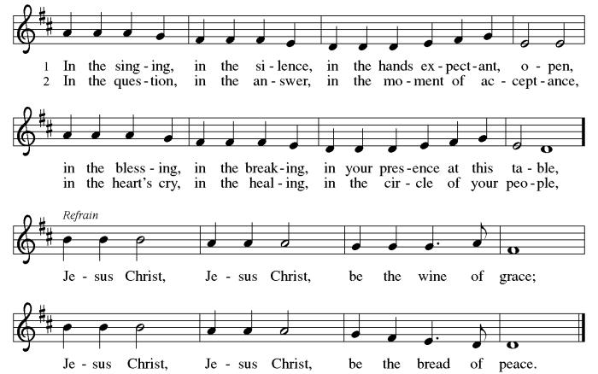

Come, Thou Long-Expected Jesus ELW #254
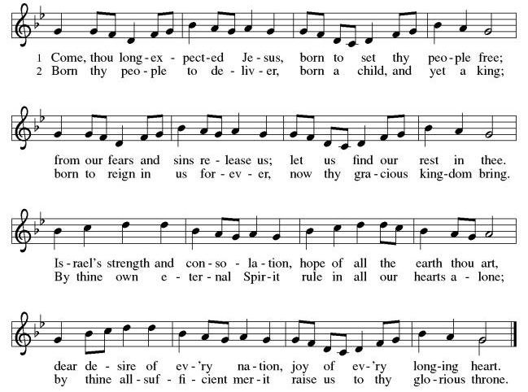

*POST COMMUNION BLESSING
The body and blood of our Lord Jesus Christ strengthen you and keep you in his grace. Amen.

*PRAYER AFTER COMMUNION

Let us pray,
Compassionate God, through the gifts of bread and wine our hearts are filled with the abundance of your love. Strengthen us that we, through this holy meal, may share your love freely, as you have shared with us. We ask this in the name of Jesus, through the Spirit nourishing us now and forever. Amen.
SENDING
God blesses us and sends us in mission to the world.

ANNOUNCEMENTS

EDUCATION LEADERS APPRECIATION

*BLESSING

Creator, Redeemer, Sustainer, ☩ one God, bless, heal, and hold you today and always.
Amen.

*SENDING SONG The Light Will Come CLC Fire Choir

*Dismissal
Heaven has come near. Go, share the good news!
Thanks be to God.

POSTLUDE Roger Halvorson

CHRIST LUTHERAN CHURCH STAFF

Pastor Rev. Nikki Fielder, pastor@christlutheranlb.com
Office Manager Kim Croes, officemanager@christlutheranlb.com
Preschool Director Lisa Clinton, info@clplb.com
Director of Senior Adult Ministry Shannon Howard, directorsam@christlutheranlb.com
Choir Director Kim Philips, kimsings@msn.com
Accompanist Roger Halvorson
A/V Technicians Brad Croes and Jett Baker
Missionary to Colombia Linda Gawthorne

Mission Statement
Living by Christ’s example, we welcome, serve, and love all through God’s grace.

Vision Statement
Embracing the truth that God’s love and grace is for all, Christ Lutheran Church is a vibrant and active community spreading the good news through acceptance, action, and benevolence.

Our Position
Christ is ALIVE!

Reconciling in Christ (RIC) Welcome Statement
Christ Lutheran Church is a congregation who joyfully welcomes everyone who enters our doors. We recognize that each of us is a unique creation made in the image of God. We celebrate and give thanks for the many diverse gifts that God has bestowed on us. We proclaim ourselves to be an open and affirming congregation to all of God's children, welcoming into our ministry persons of every race, culture, age, gender identity, gender expression, sexual orientation, ability, and economic status. We commit ourselves to the work of anti-racism and creating an anti-racist space. We believe that through our openness we all grow in our faith through Christ's teaching to love one another as God loves us.

