Seventh Sunday of Easter
May 17, 2026
9:30am

Christ Lutheran Church
6500 E. Stearns Street
Long Beach, California 90815
Phone 562-598-2433
www.christlutheranlb.com

Preschool 562-594-6117
www.clplb.com

Welcome to worship! We’re glad you’re here!
To assist in your worship:
bold print means we respond together
* means rise in body or spirit,
+ you may make the sign of the cross should you so desire.

It is our joy to worship with your whole family!
We encourage everyone of all ages and abilities to worship together.
We offer a “pray-ground” located in the back left of the Sanctuary for those with littles to have some room for movement and activity. The Narthex (gathering space at the entry) also has some resources for families, including activity bags filled with crayons, paper and storybooks. These supplies can be used in the Narthex or brought into the Sanctuary. For those that find themselves in the Narthex, there is a speaker with which you can still hear the service. Lastly, a changing table is located in the restroom off the Narthex. Please ask an usher if you need any assistance.
TODAY’S worship THEME

In these days between Ascension and Pentecost, we gather with the disciples in the upper room, waiting for the Spirit to transform the church around the world. In today’s gospel Jesus prays for his followers and for their mission in his name. Amid religious, social, and economic divisions, we seek the unity that Jesus had with his Father. Made one in baptism, we go forth to live our faith in the world, eager for the unity that God intends for the whole human family.

Worship services for Christ Lutheran Church- Long Beach
are live-streamed and archived to YouTube.
By entering the sanctuary and by your presence here,
you consent to be photographed,
filmed, and/or otherwise recorded.

Please alert an usher if this is of concern to you.

Our liturgy is taken from:
Sundays and Seasons.com. Copyright 2026 Augsburg Fortress. All rights reserved.
Reprinted by permission under Augsburg Fortress Liturgies Annual License #20338.
Reprinted by permission under CCLI license # 230154. All rights reserved.
Reprinted by permission under © 2026 One License #A-706154. All rights reserved.

PRELUDE Roger Halvorson

WELCOME
All are invited to complete the yellow sheet in your bulletin. Once completed, place it to the outside of your pew for the ushers to collect.

GATHERING
The Holy Spirit calls us together as the people of God.

*THANKSGIVING FOR BAPTISM

Alleluia! Christ is risen.
Christ is risen indeed. Alleluia!
Salvation belongs to our God who is seated on the throne and to the Lamb!
Amen.

Let us give thanks for the gifts of baptism.
Merciful God,
you are the one who was, who is, and who is to come. You lead us beside still waters. We thank you for the waters of creation: morning dew, gentle rain, roaring waves. We thank you for the waters that nourish us.
Blessed are you.
You guide us to springs of the water of life.

Jesus Christ, you are the faithful witness who accompanies us on our journeys. We give you thanks for your life-giving death and resurrection. We praise you for joining us in joy and sorrow.
Blessed are you.
You guide us to springs of the water of life.

Holy Spirit, you anoint our head with oil and our cup overflows. Break down barriers that divide us. Fill us with the breath of peace.
Blessed are you.
You guide us to springs of the water of life.

Holy One, we thank you for the gifts and grace of baptism, and for making us a new creation. We join with saints and angels, giving you honor and praise, now and forever.
Amen.

*GATHERING SONG Gather Us In ELW #532
(verses 1, 3, 4)

*GREETING
The grace of our Lord Jesus Christ, the love of God, and the communion of the Holy Spirit be with you all.
And also with you.

*PRAYER OF THE DAY
Let us pray together,
O God of glory, your Son Jesus Christ suffered for us and ascended to your right hand. Unite us with Christ and each other in suffering and in joy, that all the world may be drawn into your bountiful presence, through Jesus Christ, our Savior and Lord, who lives and reigns with you and the Holy Spirit, one God, now and forever.
Amen.

WORD
God speaks to us in scripture reading, preaching, and song.______________________

CHILDREN’S CHAT
All children are welcomed forward for a children’s time. After that, they will be invited to Sunday school and will return during the passing of the peace.

FIRST READING Acts 1:6-14

SECOND READING Ephesians1:15-23

Word of God, word of life. Thanks be to God.
*GOSPEL ACCLAMATION He is Lord
He is Lord He is Lord
He is risen from the dead
And He is Lord
Ev'ry knee shall bow
Ev'ry tongue confess
That Jesus Christ is Lord

*GOSPEL John 17:1-11

The Holy Gospel according to John, the 17th chapter. Glory to you, O Lord.
The reading concludes: The Gospel of the Lord. Praise to you, O Christ.

SERMON Pastor Nikki Fielder

*SERMON HYMN Alleluia! Sing to Jesus ELW #392
(verses 1, 3, 5)

*APOSTLES’ CREED

I believe in God, the Father almighty, creator of heaven and earth.

I believe in Jesus Christ, God’s only Son, our Lord, who was conceived by the Holy Spirit, born of the virgin Mary, suffered under Pontius Pilate, was crucified, died, and was buried; he descended to the dead. On the third day he rose again; he ascended into heaven, he is seated at the right hand of the Father, and he will come to judge the living and the dead.

I believe in the Holy Spirit, the holy catholic church, the communion of saints, the forgiveness of sins, the resurrection of the body, and the life everlasting. Amen.

PRAYERS OF THE CHURCH

Trusting in the power of Christ’s resurrection to heal and redeem our broken world, let us pray for the needs of all creation.
A brief silence.
Merciful God,
receive our prayer.
God of resurrection power, use us and these prayers to proclaim the good news of new life to all the world, through Jesus Christ, our risen Savior.
Amen.

*SHARING OF PEACE

The peace of Christ be with you always. And also with you.

OFFERTORY Lonnie Timney

*OFFERTORY RESPONSE Bless the Lord, O My Soul ACS #1097

Bless the Lord O my soul O my soul
Worship His holy name
Sing like never before O my soul
I'll worship Your holy name

*OFFERTORY PRAYER

Let us pray together,
Merciful God, accept the fruits of our labor, gathered to give you glory. You have set a table before us, a glimpse of that great day when we will hunger and thirst no more. Nourish us with the body and blood of Jesus, that goodness and mercy may follow us and bless the world you love. In the name of Jesus, Amen.

MEAL
God feeds us with the presence of Jesus.

*THE GREAT THANKSGIVING
The Lord be with you. And also with you.
Lift up your hearts. We lift them to the Lord,
Let us give thanks to the Lord our God.
It is right to give our thanks and praise.

It is indeed right, our duty and our joy, that we should at all times and in all places give thanks and praise to you…we praise your name and join their unending hymn:

*HOLY, HOLY W&P #60

Verse 1
Holy holy holy holy
Holy holy Lord God Almighty
And we lift our hearts before You
As a token of our love
Holy holy holy holy

Verse 5
Hallelujah hallelujah
Hallelujah hallelujah
And we lift our hearts before You
As a token of our love
Hallelujah hallelujah

*THANKSGIVING AT THE TABLE

Blessed are you, O God of the universe. Your mercy is everlasting and your faithfulness endures from age to age…

With this bread and cup we remember our Lord’s passover from death to life as we proclaim the mystery of faith:
Christ has died.
Christ is risen.
Christ will come again.

O God of resurrection and new life:
Pour out your Holy Spirit on us and on these gifts of bread and wine.
Reveal yourself to us in the breaking of the bread.
Raise us up as the body of Christ for the world.
Come, Holy Spirit.

We praise you, O God, blessed and holy Trinity, now and forever.
Amen.

*LORD’S PRAYER

Our Father in heaven, hallowed be your name, your kingdom come, your will be done, on earth as in heaven. Give us today our daily bread. Forgive us our sins
as we forgive those who sin against us. Save us from the time of trial and deliver us from evil. For the kingdom, the power, and the glory are yours, now and forever. Amen.

DISTRIBUTION OF HOLY COMMUNION
We believe that this is Jesus' table. All are welcome and invited to commune. We serve communion by “intinction”; receive the bread and dip it in the chalice. Gluten free wafers are available; let your server know. Wine is offered on each side. White grape juice is offered at the center aisle. Should you choose not to commune, you are invited to come forward to receive a blessing. Please cross your arms across your chest to let us know to give you that blessing.

INVITATION TO COMMUNION

Come to the table of new life. Receive the risen Lord.

COMMUNION SONGS Come to the Table W&P #33
All Who Hunger, Gather Glady ELW #461

*POST COMMUNION BLESSING
The body and blood of our Lord Jesus Christ strengthen you and keep you in his grace. Amen.

*PRAYER AFTER COMMUNION
Let us pray,
Holy One, through this meal you have made your home among us and are making all things new. Send us now to speak peace to anxious hearts, to love our enemies, and to bring your healing to the nations. In the name of Jesus, Amen.

SENDING
God blesses us and sends us in mission to the world.

ANNOUNCEMENTS

*BLESSING

God Almighty, who is the beginning and the end, Jesus Christ, the firstborn of the dead,
and the Spirit, our advocate and peace, ☩ bless you now and forever.
Amen.

*SENDING HYMN Hallelujah! We Sing Your Praises ELW #535

*Dismissal
Go in peace. Praise the Lord. Alleluia!
Thanks be to God. Alleluia!

POSTLUDE Roger Halvorson



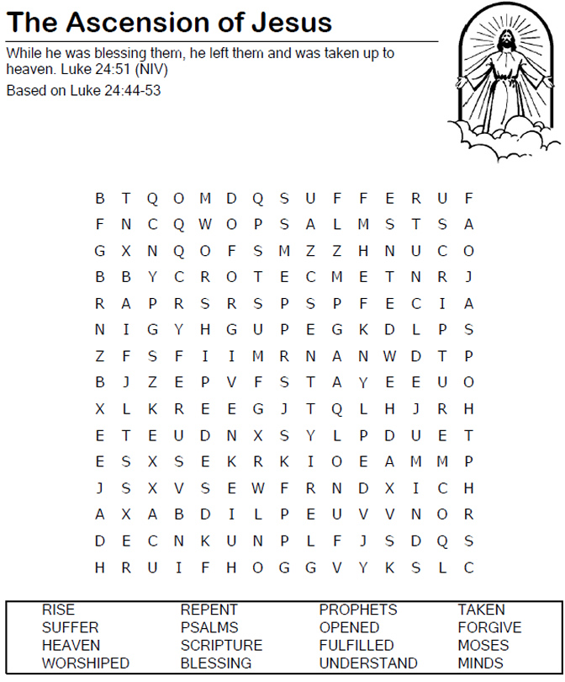CHRIST LUTHERAN CHURCH STAFF

Pastor Rev. Nikki Fielder, pastor@christlutheranlb.com
Office Manager Kim Croes, officemanager@christlutheranlb.com
Preschool Director Lisa Clinton, info@clplb.com
Director of Senior Adult Ministry Shannon Howard, directorsam@christlutheranlb.com
Choir Director Kim Philips, kimsings@msn.com
Accompanist Roger Halvorson
A/V Technicians Brad Croes and Jett Baker
Missionary to Colombia Linda Gawthorne

Mission Statement
Living by Christ’s example, we welcome, serve, and love all through God’s grace.

Vision Statement
Embracing the truth that God’s love and grace is for all, Christ Lutheran Church is a vibrant and active community spreading the good news through acceptance, action, and benevolence.

Our Position
Christ is ALIVE!

Reconciling in Christ (RIC) Welcome Statement
Christ Lutheran Church is a congregation who joyfully welcomes everyone who enters our doors. We recognize that each of us is a unique creation made in the image of God. We celebrate and give thanks for the many diverse gifts that God has bestowed on us. We proclaim ourselves to be an open and affirming congregation to all of God's children, welcoming into our ministry persons of every race, culture, age, gender identity, gender expression, sexual orientation, ability, and economic status. We commit ourselves to the work of anti-racism and creating an anti-racist space. We believe that through our openness we all grow in our faith through Christ's teaching to love one another as God loves us.

