Third Sunday in Lent
March 8, 2026
9:30am



Christ Lutheran Church
6500 E. Stearns Street
Long Beach, California 90815
Phone 562-598-2433
www.christlutheranlb.com

Preschool 562-594-6117
www.clplb.com
Welcome to worship! We’re glad you’re here!
To assist in your worship:
bold print means we respond together
* means rise in body or spirit,
+ you may make the sign of the cross should you so desire.

It is our joy to worship with your whole family!

We encourage everyone of all ages and abilities to worship together.
We offer a “pray-ground” located in the back left of the Sanctuary for those with littles to have some room for movement and activity. The Narthex (gathering space at the entry) also has some resources for families, including activity bags filled with crayons, paper and storybooks. These supplies can be used in the Narthex or brought into the Sanctuary. For those that find themselves in the Narthex, there is a speaker with which you can still hear the service. Lastly, a changing table is located in the restroom off the Narthex. Please ask an usher if you need any assistance.

TODAY’S worship THEME

Jesus will seek water from a well alongside a woman with a theological bent. He has chosen his path. As we join Jesus, God prepares us to receive God’s presence, grace poured out, like songs beside the river, like compassion in times of trouble.

Worship services for Christ Lutheran Church- Long Beach are live-streamed
and archived to YouTube. By entering the sanctuary and by your presence here,
you consent to be photographed, filmed, and/or otherwise recorded.
Please alert an usher if this is of concern to you.

Our liturgy is taken from:
Sundays and Seasons.com. Copyright 2026 Augsburg Fortress. All rights reserved.
Reprinted by permission under Augsburg Fortress Liturgies Annual License #20338.
Reprinted by permission under CCLI license # 230154. All rights reserved.
Reprinted by permission under © 2026 One License #A-706154. All rights reserved.
Pouring Out Grace: A Lenten Liturgy for Grace Poured Out: Intentions, Gathering Words, Prayer of Confession and Assurance of Forgiveness, Prayer of the Day, Eucharistic Prayer, Invitation to Communion, Blessing © 2025 Barn Geese Worship. Used by permission. [Adapted by Pastor Nikki Fielder.]
PRELUDE Roger Halvorson
WELCOME
All are invited to complete the yellow sheet in your bulletin. Once completed, place it to the outside of your pew for the ushers to collect.

GATHERING
The Holy Spirit calls us together as the people of God.

*OPENING DIALOGUE

On this Sunday in Lent, we journey again toward the cross. We feel the weight of all that lies ahead. We wrestle with coming sorrow. We balance our growing needs.

God, we come here today braced for the hazards of this journey.
Instead, you pour out grace. Instead, you anoint us with oil. Instead, you fill our cups to overflowing.

We find beauty in dry places, abundance in want, and welcome in despair.
You call us to the waters of life,
and we respond,
our longings now fulfilled.

*GATHERING SONG Open Now Thy Gates of Beauty ELW #533
(verses 1 & 5)

*CONFESSION AND FORGIVENESS

Blessed be the holy Trinity, ☩ one God,
who forgives all our sin,
whose mercy endures forever.
Amen.

Let us confess our sin in the presence of God and of one another.
(pause for silent reflection)

We know the pull of all that separates us from God. We long for the cleansing water poured out over us again. We seek anointing, the oil running its healing course. We feel this call to reconnect, so we confess our sins.

God, we have forgotten your call, insistent though it is. We stay back- though the waters of baptism call us forward. We separate ourselves- though the bread and cup beckon us to community. We hide our wounds- though the oil of anointing waits at the ready.

God knows us better than we know ourselves. Yet God does not withhold any good gift from us. Like Naaman at the river, we are surprised at how easy it is to experience God’s outpouring of grace. Like the woman at the well, we share living water and watch impenetrable barriers break. Like Mary at the feet of Jesus, we empty ourselves of all we have, only to be filled again.
Beloved, you are forgiven. Receive now, for yourself, the abundant grace that opens your soul to love.
May grace flow free through us once again!

*GREETING

The grace of our Lord Jesus Christ, the love of God, and the communion of the Holy Spirit be with you all.
And also with you.

*PRAYER OF THE DAY

Let us pray,
Searching God, you do not shy away from us, even when we hide ourselves from you. You approach us despite the shame we feel. Notice us once again. Anoint us with your presence and the oil of blessing this day, that we may take our place at your side. Amen.

WORD
God speaks to us in scripture reading, preaching, and song.

CHILDREN’S CHAT
All children are welcomed forward for a children’s time. After that, they will be invited to Sunday school and will return during the passing of the peace.

FIRST READING Exodus 17:1-7

SECOND READING Romans 5:1-11

Word of God, word of life. Thanks be to God.

*GOSPEL VERSE Create in Me a Clean Heart W&P #34

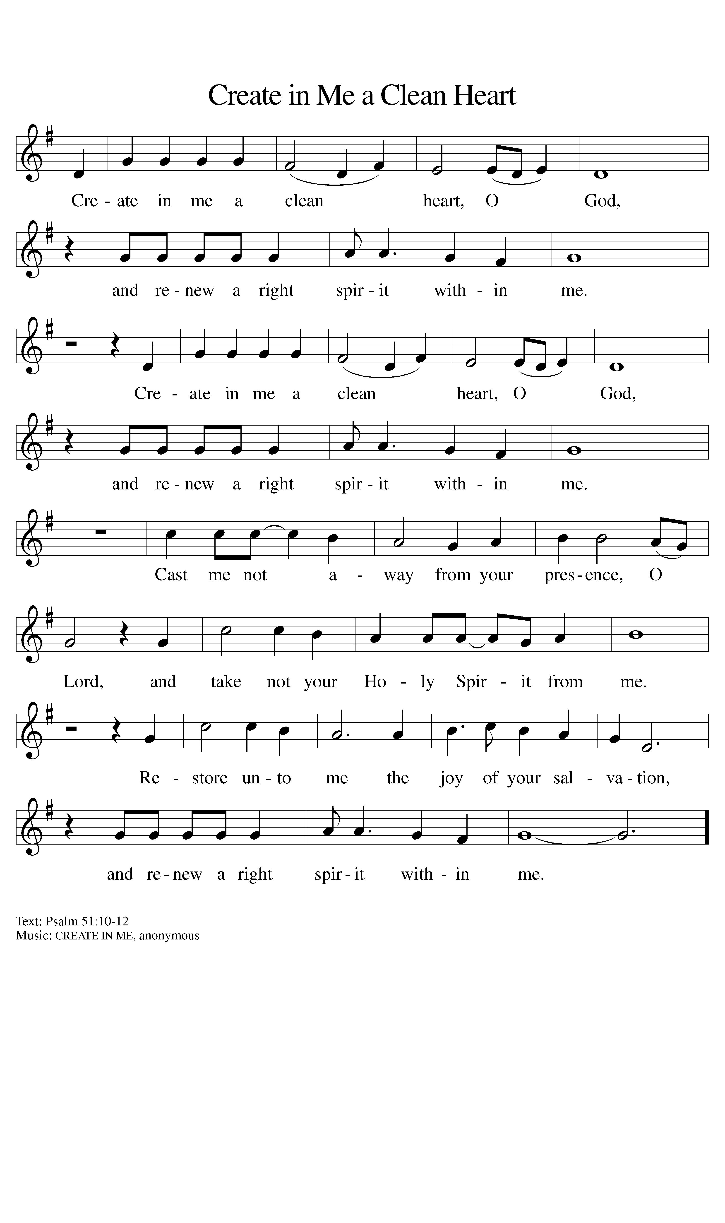

*GOSPEL John 4:5-42

The Holy Gospel according to John the 4th chapter. Glory to you, O Lord.
The reading concludes: The Gospel of the Lord. Praise to you, O Christ.

SERMON Pastor Nikki Fielder

*SERMON SONG For All the Faithful Women ELW #419
(verses 1 & 8)

*APOSTLES’ CREED

I believe in God, the Father almighty, creator of heaven and earth.

I believe in Jesus Christ, God’s only Son, our Lord, who was conceived by the Holy Spirit, born of the virgin Mary, suffered under Pontius Pilate, was crucified, died, and was buried; he descended to the dead. On the third day he rose again; he ascended into heaven, he is seated at the right hand of the Father, and he will come to judge the living and the dead.

I believe in the Holy Spirit, the holy catholic church, the communion of saints, the forgiveness of sins, the resurrection of the body, and the life everlasting. Amen.

PRAYERS OF INTERCESSION
Reconciled by God’s mercy and sustained by God’s presence, let us pray for the world and its needs.
A brief silence.
Hear us, O God.
Your mercy is great.

Receive our prayers, O God, through Jesus Christ, our strength and salvation.
Amen.

*SHARING OF THE PEACE

The peace of Christ be with you always. And also with you.

OFFERTORY Be Ye Glad CLC Fire Choir

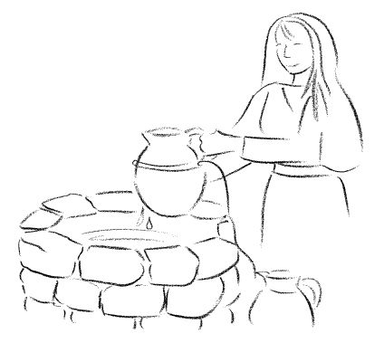

*OFFERTORY RESPONSE Let the Vineyards Be Fruitful ELW #184

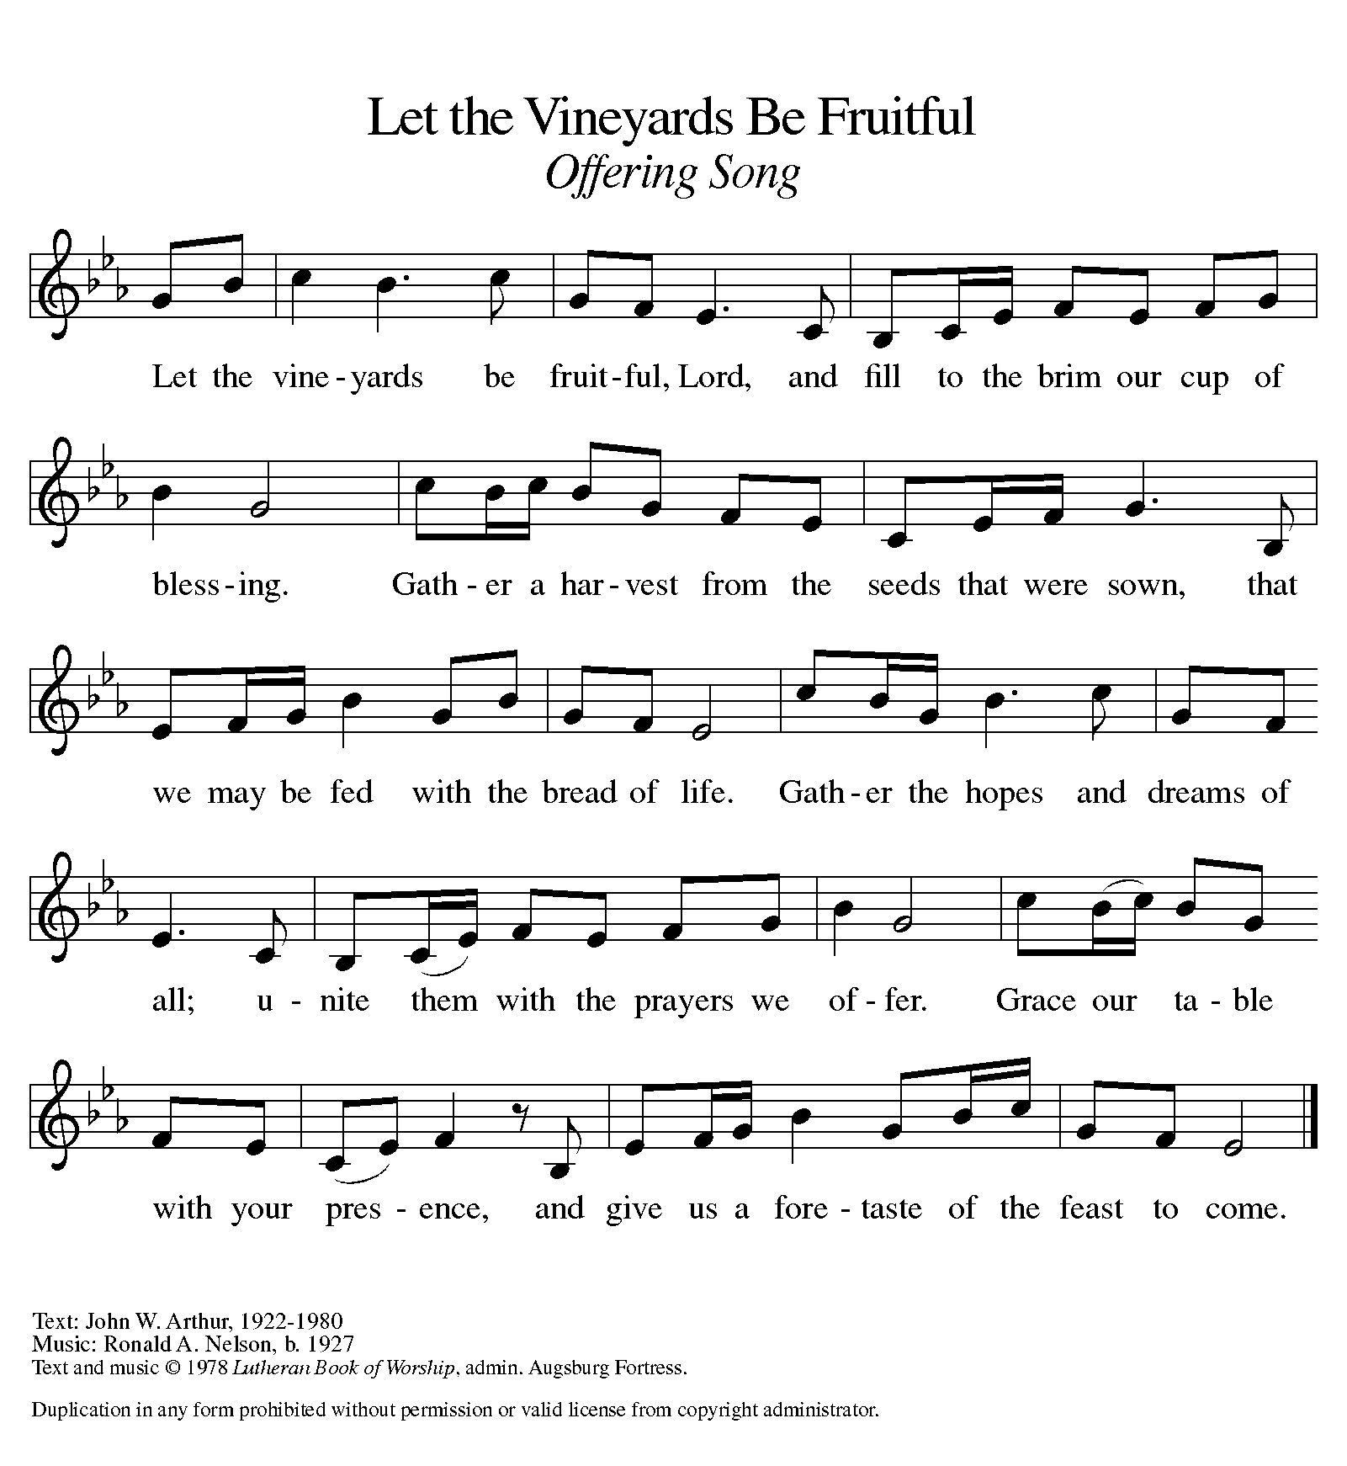

*OFFERTORY PRAYER

Let us pray together,
O God, maker of heaven and earth, your steadfast love embraces all creation. You send rain and sunshine to nourish the earth and bring forth its bounty. Through these gifts of bread and wine, draw us into the death and life of your Son, who calls us to bear witness to his saving work. We ask this in Jesus’ name. Amen.

MEAL
God feeds us with the presence of Jesus.

*THE GREAT THANKSGIVING
The Lord be with you. And also with you.
Lift up your hearts. We lift them to the Lord,
Let us give thanks to the Lord our God. It is right to give our thanks and praise.

God, we have seen your abundant goodness poured out across all times…
we join with all those who sing of your grace, those who have gone before, those who wait ahead, the company of angels and all of creation, voices springing up together:

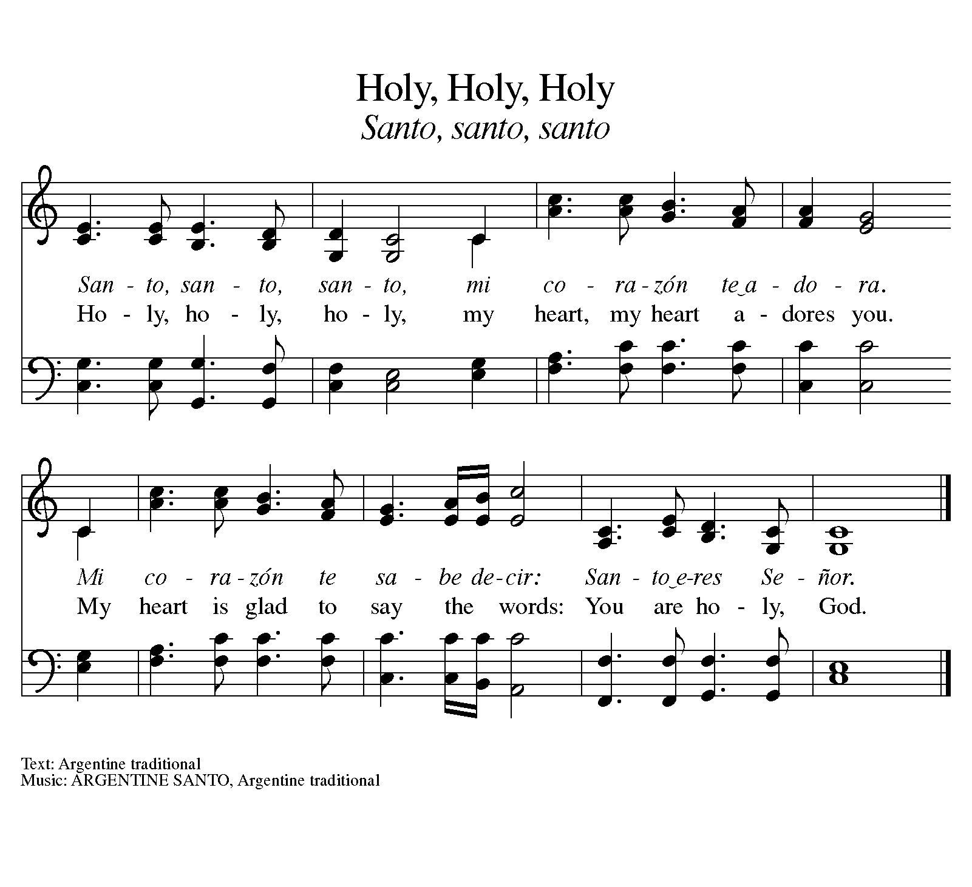*HOLY, HOLY, HOLY ELW #473

*THANKSGIVING AT THE TABLE
God, we trace the signs of your grace…

Jesus, we do remember you.
In the churning depths of our lives, God still calls out the song of abundant grace,
the mystery of our faith:
Christ has died.
Christ is risen.
Christ will come again.

…All glory, power, and honor are yours, God of all abundance that is and will be,
today and every day.
Amen.

*LORD’S PRAYER
Our Father in heaven, hallowed be your name, your kingdom come, your will be done, on earth as in heaven. Give us today our daily bread. Forgive us our sins
as we forgive those who sin against us. Save us from the time of trial and deliver us from evil. For the kingdom, the power, and the glory are yours, now and forever. Amen.

DISTRIBUTION OF HOLY COMMUNION
We believe that this is Jesus' table. All are welcome and invited to commune. We serve communion by “intinction”; receive the bread and dip it in the chalice. Gluten free wafers are available; let your server know. Wine is offered on each side. White grape juice is offered at the center aisle. Should you choose not to commune, you are invited to come forward to receive a blessing. Please cross your arms across your chest to let us know to give you that blessing.

HEALING PRAYER
This morning we offer healing prayer. If you would like our healing minister to pray with and for you, please go to the right transept after taking communion.

INVITATION TO COMMUNION
One loaf, broken yet abundant.
One cup, poured out yet more than enough.
Come, share in the feast.

COMMUNION SONGS
In the Singing ELW #466

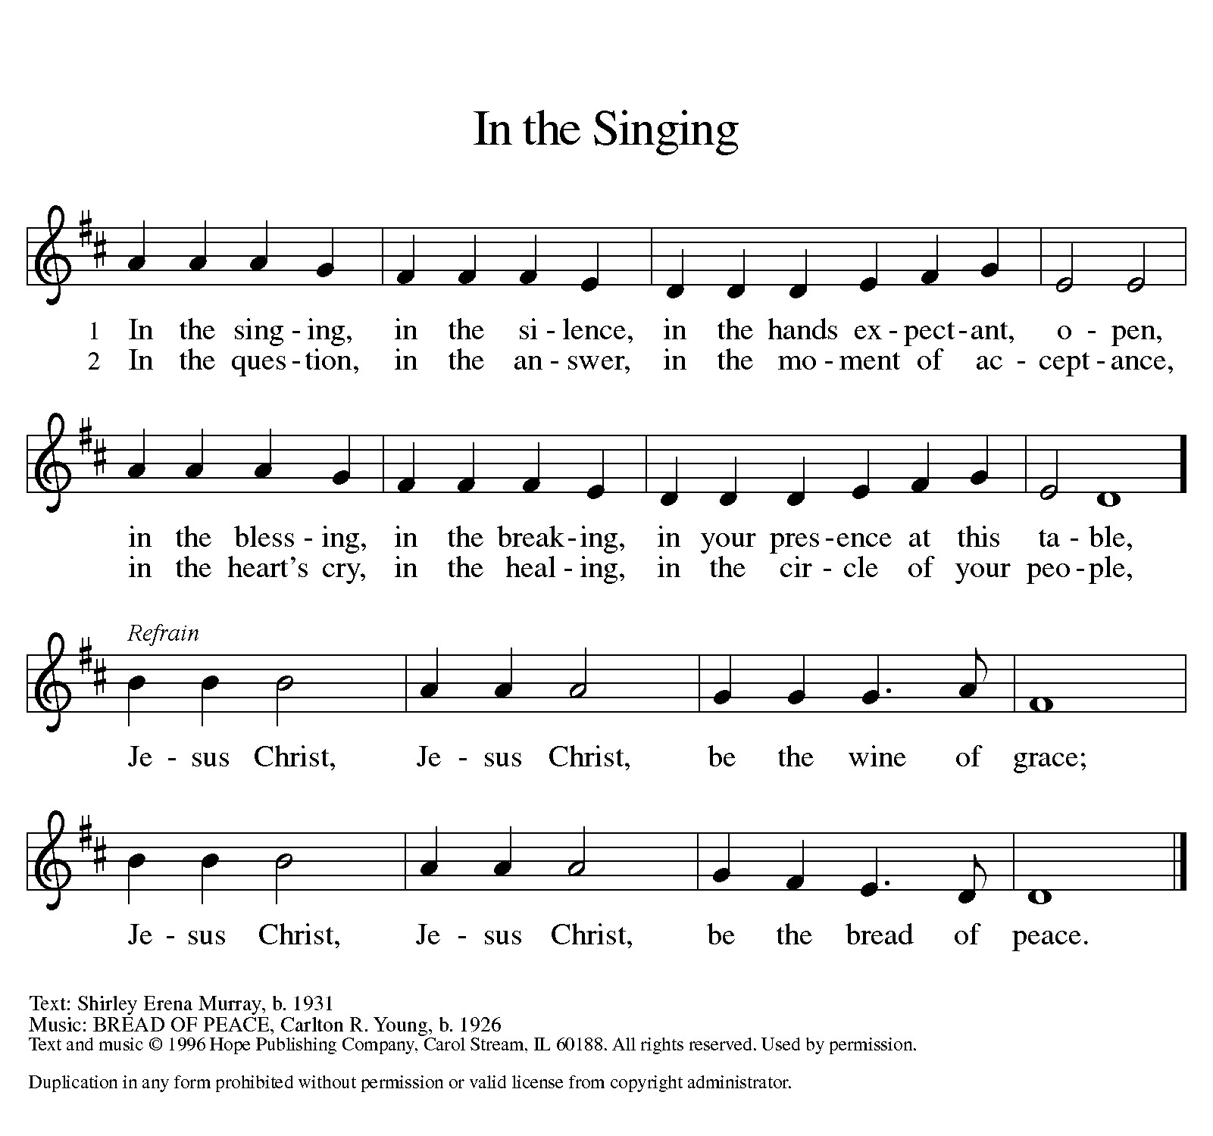

O Bread of Life from Heaven ELW #480

*POST COMMUNION BLESSING
The body and blood of our Lord Jesus Christ strengthen you and keep you in his grace. Amen.

*PRAYER AFTER COMMUNION

Let us pray,
God of our salvation, we give you thanks for this meal that restores our souls,
reconciles us to you, and strengthens us for the journey. Through the body and blood of your Son, may we become Christ’s body in the world, bearing witness to your love for all creation, through Jesus Christ, our Savior and Lord. Amen.

SENDING
God blesses us and sends us in mission to the world.

ANNOUNCEMENTS

*BLESSING

Beloved, receive now this blessing: Life and life abundant is yours, today.
As you leave this place, embrace the transformation you have found here.

Like water changed to wine, we can share delight beyond measure.
Like new wineskins for new wine, we can stretch and change, new vessels for God’s goodness.
Like the wine and oil of the Samaritan on his way from Jerusalem to Jericho, we can offer blessing, even as we seek healing.

God blesses you with abundance.
Christ blesses you with grace.
The Spirit blesses you with love overflowing.

Trust this blessing as you go, and pour yourself out to a world in need.
Amen.

*SENDING HYMN O Jesus, Joy of Loving Hearts ELW #658
(verses 1, 3, 4)

*Dismissal
Go in peace. Believe the good news.
Thanks be to God.

POSTLUDE Roger Halvorson

CHRIST LUTHERAN CHURCH STAFF

Pastor Rev. Nikki Fielder, pastor@christlutheranlb.com
Office Manager Kim Croes, officemanager@christlutheranlb.com
Preschool Director Lisa Clinton, info@clplb.com
Director of Senior Adult Ministry Shannon Howard, directorsam@christlutheranlb.com
Choir Director Kim Philips, kimsings@msn.com
Accompanist Roger Halvorson
A/V Technicians Brad Croes and Jett Baker
Missionary to Colombia Linda Gawthorne

Mission Statement
Living by Christ’s example, we welcome, serve, and love all through God’s grace.

Vision Statement
Embracing the truth that God’s love and grace is for all, Christ Lutheran Church is a vibrant and active community spreading the good news through acceptance, action, and benevolence.

Our Position
Christ is ALIVE!

Reconciling in Christ (RIC) Welcome Statement
Christ Lutheran Church is a congregation who joyfully welcomes everyone who enters our doors. We recognize that each of us is a unique creation made in the image of God. We celebrate and give thanks for the many diverse gifts that God has bestowed on us. We proclaim ourselves to be an open and affirming congregation to all of God's children, welcoming into our ministry persons of every race, culture, age, gender identity, gender expression, sexual orientation, ability, and economic status. We commit ourselves to the work of anti-racism and creating an anti-racist space. We believe that through our openness we all grow in our faith through Christ's teaching to love one another as God loves us.

