Transfiguration of Our Lord
February 15, 2026
9:30am



Christ Lutheran Church
6500 E. Stearns Street
Long Beach, California 90815
Phone 562-598-2433
www.christlutheranlb.com

Preschool 562-594-6117
www.clplb.com

Welcome to worship! We’re glad you’re here!
To assist in your worship:
bold print means we respond together
* means rise in body or spirit,
+ you may make the sign of the cross should you so desire.

It is our joy to worship with your whole family!

We encourage everyone of all ages and abilities to worship together.
We offer a “pray-ground” located in the back left of the Sanctuary for those with littles to have some room for movement and activity. The Narthex (gathering space at the entry) also has some resources for families, including activity bags filled with crayons, paper and storybooks. These supplies can be used in the Narthex or brought into the Sanctuary. For those that find themselves in the Narthex, there is a speaker with which you can still hear the service. Lastly, a changing table is located in the restroom off the Narthex. Please ask an usher if you need any assistance.

TODAY’S worship THEME
Today’s festival is a bridge between the Advent-Christmas-Epiphany cycle that comes to a close today and the Lent-Easter cycle that begins in several days. On a high mountain Jesus is revealed as God’s beloved Son, echoing the words at his baptism. This vision of glory sustains us as Jesus faces his impending death in Jerusalem. We turn this week to Ash Wednesday and our yearly baptismal journey from Lent to Easter. Some churches put aside the alleluia at the conclusion of today’s liturgy. This word of joy will be omitted during the penitential season of Lent and will be sung again at Easter.

Worship services for Christ Lutheran Church- Long Beach are live-streamed
and archived to YouTube. By entering the sanctuary and by your presence here,
you consent to be photographed, filmed, and/or otherwise recorded.
Please alert an usher if this is of concern to you.

Our liturgy is taken from:
Sundays and Seasons.com. Copyright 2026 Augsburg Fortress. All rights reserved.
Reprinted by permission under Augsburg Fortress Liturgies Annual License #20338.
Reprinted by permission under CCLI license # 230154. All rights reserved.
Reprinted by permission under © 2026 One License #A-706154. All rights reserved.
Alleluia, As the Grains of Wheat, Holy, and Lamb of God: Now the Feast and Celebration: An Alternate Eucharistic Setting, created by Marty Haugen.
PRELUDE Roger Halvorson
WELCOME
All are invited to complete the yellow sheet in your bulletin. Once completed, place it to the outside of your pew for the ushers to collect.

GATHERING
The Holy Spirit calls us together as the people of God.

*GATHERING SONG Beautiful Savior ELW #838
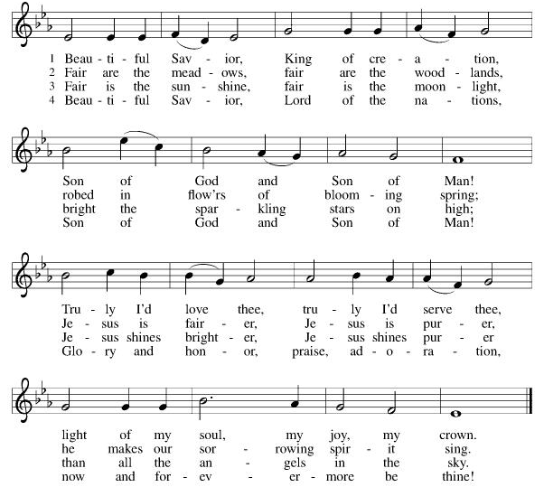
(verses 1, 2, 4)
*CONFESSION AND FORGIVENESS

Blessed be the holy Trinity, ☩ one God, the Creator of heaven and earth, the Word who spoke life into being, the Wind stirring the waters.
Amen.

Let us turn in confession to the one who knows us completely.
Silence is kept for reflection.
Mighty God, lover of justice,
you call us to life in community, but we have served our own interests at the expense of our neighbors. We have sown deceit where honesty was needed.
We say the right words, but our hearts are far from you. Turn us to seek your face. Knit us together and give us the mind of Christ, that we may do justice, love mercy, and walk humbly with you, our God. Amen.

The former things have passed away, and new things God now declares. Like a spring of water that never fails, God covers you in the righteousness of Christ, and forgives your sin in ☩ Jesus’ name. May the Spirit give you strength to live for others, and bless you with the gift of peace.
Amen.

*GREETING

The grace of our Lord Jesus Christ, the love of God, and the communion of the Holy Spirit be with you all.
And also with you.

*SONG OF PRAISE Joyous Light of Heavenly Glory ELW #561
mor - ning fills the
(verse1)
sk - y,
Joyous light of heav’nly glory, loving glow of God’s own face,
You who sing creation’s story, shine on ev’ry land and race.
Now as morning fills the sky, we shall raise our songs to you.
God of daybreak, God of shadows, come and light our hearts anew.

*PRAYER OF THE DAY

Let us pray,
O God, in the transfiguration of your Son you confirmed the mysteries of the faith by the witness of Moses and Elijah, and in the voice from the bright cloud declaring Jesus your beloved Son, you foreshadowed our adoption as your children. Make us heirs with Christ of your glory, and bring us to enjoy its fullness, through Jesus Christ, our Savior and Lord, who lives and reigns with you and the Holy Spirit, one God, now and forever. Amen.

WORD
God speaks to us in scripture reading, preaching, and song.

CHILDREN’S CHAT
All children are welcomed forward for a children’s time. After that, they will be invited to Sunday school and will return during the passing of the peace.

FIRST READING Exodus 24:12-18

SECOND READING 2 Peter 1:16-21

Word of God, word of life. Thanks be to God.


*GOSPEL VERSE Alleluia
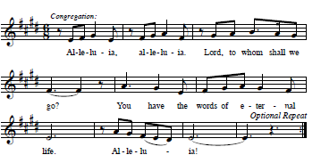
*GOSPEL Matthew 17:1-9

The Holy Gospel according to Matthew the 17th chapter. Glory to you, O Lord.
The reading concludes: The Gospel of the Lord. Praise to you, O Christ.

SERMON Pastor Nikki Fielder

*SERMON HYMN Transfiguration Song

Verse 1:
As we climb up – higher
Break our hearts – wider
Your love grows – greater
Bring a change in me…change in me…
Make my hands – kinder
Make my words – wiser
Make my feet – faster
Call me I’m ready… I’m ready…

Refrain 1:
We will all be changed, our hearts and minds made new.
Verse 2:
James and John and Peter
Climbed the mountain higher
And Jesus’ face shone brighter
Than the stars, than the sun
They said, “It is good for us to be here”
Let us build a house here
Jesus said, “do not fear,”
It’s time to go now, it’s time to go.

Refrain 2:
Jesus climbed the mountain, his face shining like the sun.

Outro
We will all be changed, our hearts and minds made new.
Jesus climbed the mountain, his face shining like the sun.

*APOSTLES’ CREED

I believe in God, the Father almighty, creator of heaven and earth.

I believe in Jesus Christ, God’s only Son, our Lord, who was conceived by the Holy Spirit, born of the virgin Mary, suffered under Pontius Pilate, was crucified, died, and was buried; he descended to the dead. On the third day he rose again; he ascended into heaven, he is seated at the right hand of the Father, and he will come to judge the living and the dead.

I believe in the Holy Spirit, the holy catholic church, the communion of saints, the forgiveness of sins, the resurrection of the body, and the life everlasting. Amen.

PRAYERS OF INTERCESSION
As God’s beloved children united in Christ, let us pray for the church, the whole human community, and the well-being of the earth, our home.
A brief silence.
Merciful God,
receive our prayer.

Confident that the Holy Spirit receives our prayers and answers us, we commend all for whom we pray to God’s loving-kindness made known to us in Christ Jesus our Savior.
Amen.
*SHARING OF THE PEACE

The peace of Christ be with you always. And also with you.

OFFERTORY Special Music

*OFFERTORY RESPONSE As the Grains of Wheat

*OFFERTORY PRAYER

Let us pray together,
God of majesty, no eye has seen, no ear has heard what you have prepared for those who love you, yet in this meal you reveal the wideness of your mercy.
Use what we have gathered to feed us with the reign of God come near, Jesus Christ, our Savior and Lord. Amen.

MEAL
God feeds us with the presence of Jesus.

*THE GREAT THANKSGIVING

The Lord be with you. And also with you.
Lift up your hearts. We lift them to the Lord,
Let us give thanks to the Lord our God.
It is right to give our thanks and praise.
It is indeed right, our duty and our joy …
we praise your name and join their unending hymn:

*HOLY, HOLY, HOLY

*THANKSGIVING AT THE TABLE

Holy, mighty, and merciful Lord, heaven and earth are full of your glory...
...to whom, with you and the Holy Spirit, be all honor and glory, now and forever. Amen.

*LORD’S PRAYER
Our Father in heaven, hallowed be your name, your kingdom come, your will be done, on earth as in heaven. Give us today our daily bread. Forgive us our sins
as we forgive those who sin against us. Save us from the time of trial and deliver us from evil. For the kingdom, the power, and the glory are yours, now and forever. Amen.

DISTRIBUTION OF HOLY COMMUNION
We believe that this is Jesus' table. All are welcome and invited to commune. We serve communion by “intinction”; receive the bread and dip it in the chalice. Gluten free wafers are available; let your server know. Wine is offered on each side. White grape juice is offered at the center aisle. Should you choose not to commune, you are invited to come forward to receive a blessing. Please cross your arms across your chest to let us know to give you that blessing.

INVITATION TO COMMUNION
Here is the Lamb of God who takes away the sin of the world! Come to the table; taste and see.



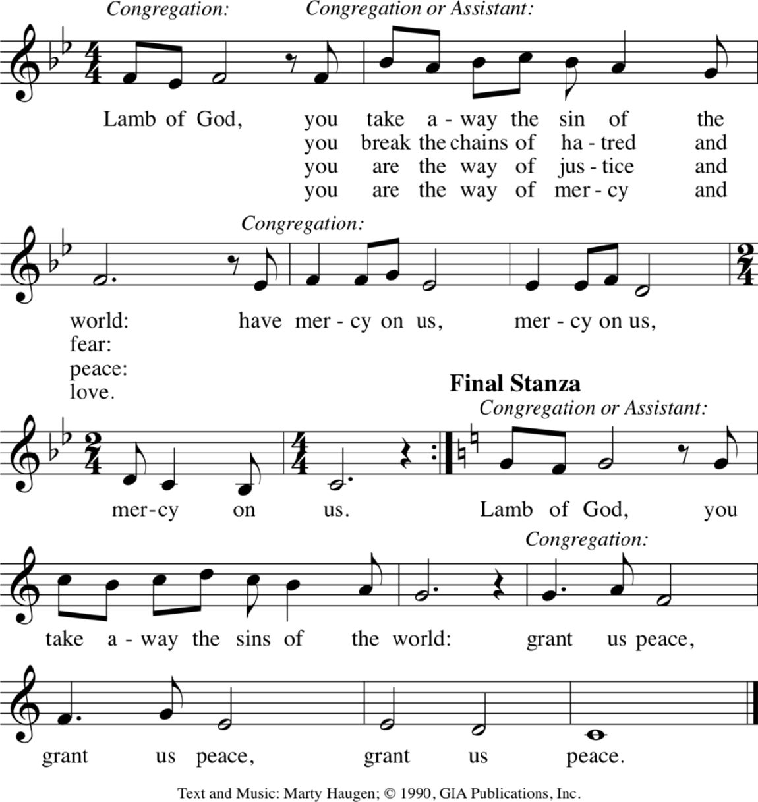
LAMB OF GOD

…you break the chains of hatred and fear:
…you are the way of justice and peace:
…you are the way of mercy and love:
…you are God’s light to all of the world:

COMMUNION SONG I Love to Tell the Story ELW #661

*POST COMMUNION BLESSING
The body and blood of our Lord Jesus Christ strengthen you and keep you in his grace. Amen.

*PRAYER AFTER COMMUNION

Let us pray,
Radiant God, we have seen your glory in the face of Jesus Christ. In the sacrament of his body and blood you have drawn us to your heart. Send us from this table with delight, that our lives may reflect the beauty of your love, and bear witness to all we have seen and heard, through Jesus Christ, our Savior and Lord.
Amen.

SENDING
God blesses us and sends us in mission to the world.

*BLESSING
May the triune God, who has put a new song in your mouth and tuned your heart for praise ☩ bless you now and forever.
Amen.

*SENDING HYMN Shine, Jesus, Shine ELW #671

Verse 1:
Lord, the light of your love is shining
In the midst of the darkness, shining
Jesus, Light of the world, shine upon us
Set us free by the truth you now bring us
Shine on me, shine on me

Chorus:
Shine, Jesus, shine
Fill this land with the Father's glory
Blaze, Spirit, blaze
Set our hearts on fire
Flow, river, flow
Flood the nations with grace and mercy
Send forth your word
Lord, and let there be light

Verse 3:
As we gaze on your kingly brightness
So our faces display your likeness
Ever changing from glory to glory
Mirrored here may our lives tell your story
Shine on me, shine on me (Chorus)

*Dismissal
Go in peace. Do justice. Love mercy.
Thanks be to God.

POSTLUDE Roger Halvorson



CHRIST LUTHERAN CHURCH STAFF

Pastor Rev. Nikki Fielder, pastor@christlutheranlb.com
Office Manager Kim Croes, officemanager@christlutheranlb.com
Preschool Director Lisa Clinton, info@clplb.com
Director of Senior Adult Ministry Shannon Howard, directorsam@christlutheranlb.com
Choir Director Kim Philips, kimsings@msn.com
Accompanist Roger Halvorson
A/V Technicians Brad Croes and Jett Baker
Missionary to Colombia Linda Gawthorne

Mission Statement
Living by Christ’s example, we welcome, serve, and love all through God’s grace.

Vision Statement
Embracing the truth that God’s love and grace is for all, Christ Lutheran Church is a vibrant and active community spreading the good news through acceptance, action, and benevolence.

Our Position
Christ is ALIVE!

Reconciling in Christ (RIC) Welcome Statement
Christ Lutheran Church is a congregation who joyfully welcomes everyone who enters our doors. We recognize that each of us is a unique creation made in the image of God. We celebrate and give thanks for the many diverse gifts that God has bestowed on us. We proclaim ourselves to be an open and affirming congregation to all of God's children, welcoming into our ministry persons of every race, culture, age, gender identity, gender expression, sexual orientation, ability, and economic status. We commit ourselves to the work of anti-racism and creating an anti-racist space. We believe that through our openness we all grow in our faith through Christ's teaching to love one another as God loves us.

