Baptism of Our Lord
January 11, 2026
9:30am

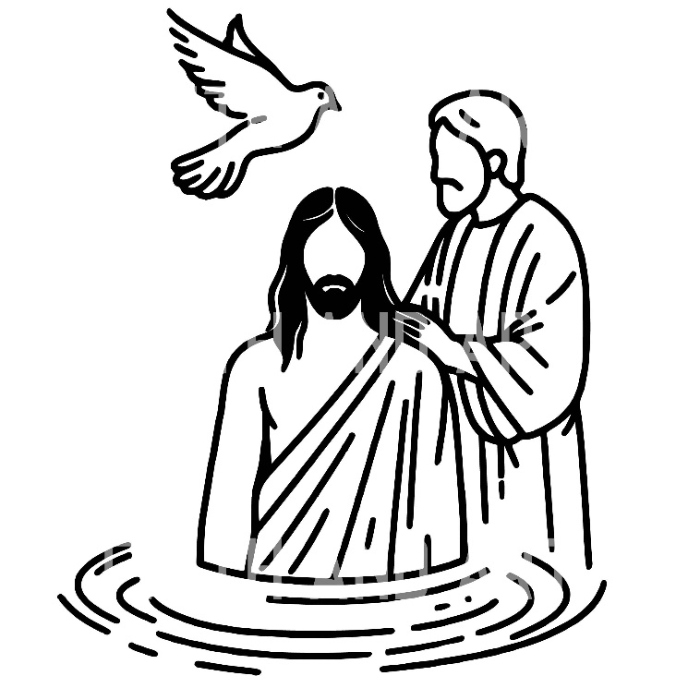

Christ Lutheran Church
6500 E. Stearns Street
Long Beach, California 90815
Phone 562-598-2433
www.christlutheranlb.com

Preschool 562-594-6117
www.clplb.com

Welcome to worship! We’re glad you’re here!
To assist in your worship:
bold print means we respond together
* means rise in body or spirit,
+ you may make the sign of the cross should you so desire.

It is our joy to worship with your whole family!

We encourage everyone of all ages and abilities to worship together.
We offer a “pray-ground” located in the back left of the Sanctuary for those with littles to have some room for movement and activity. The Narthex (gathering space at the entry) also has some resources for families, including activity bags filled with crayons, paper and storybooks. These supplies can be used in the Narthex or brought into the Sanctuary. For those that find themselves in the Narthex, there is a speaker with which you can still hear the service. Lastly, a changing table is located in the restroom off the Narthex. Please ask an usher if you need any assistance.

TODAY’S worship THEME
In the waters of the Jordan, Jesus is revealed as the beloved Son of God. Through this great epiphany, Jesus fulfills all righteousness and becomes the servant of God who will bring forth justice and be a light to the nations. In the waters of baptism we too are washed by the Word, anointed by the Spirit, and named God’s beloved children. Our baptismal mission is to proclaim good news to all who are oppressed or in need of God’s healing.

Worship services for Christ Lutheran Church- Long Beach are live-streamed
and archived to YouTube. By entering the sanctuary and by your presence here,
you consent to be photographed, filmed, and/or otherwise recorded.
Please alert an usher if this is of concern to you.

Our liturgy is taken from:
Sundays and Seasons.com. Copyright 2026 Augsburg Fortress. All rights reserved.
Reprinted by permission under Augsburg Fortress Liturgies Annual License #20338.
Reprinted by permission under CCLI license # 230154. All rights reserved.
Reprinted by permission under © 2026 One License #A-706154. All rights reserved.
Alleluia, As the Grains of Wheat, Holy, and Lamb of God: Now the Feast and Celebration: An Alternate Eucharistic Setting, created by Marty Haugen.
PRELUDE Roger Halvorson
WELCOME AND ANNOUNCEMENTS

GATHERING
The Holy Spirit calls us together as the people of God.

*GATHERING SONG Shall We Gather at the River ELW #423
(verses 1 & 3)

*CONFESSION AND FORGIVENESS

Blessed be the holy Trinity, ☩ one God, the Creator of heaven and earth, the Word who spoke life into being, the Wind stirring the waters.
Amen.

Let us turn in confession to the one who knows us completely.
Silence is kept for reflection.
Mighty God, lover of justice,
you call us to life in community, but we have served our own interests at the expense of our neighbors. We have sown deceit where honesty was needed.
We say the right words, but our hearts are far from you. Turn us to seek your face. Knit us together and give us the mind of Christ, that we may do justice, love mercy, and walk humbly with you, our God. Amen.

The former things have passed away, and new things God now declares. Like a spring of water that never fails, God covers you in the righteousness of Christ, and forgives your sin in ☩ Jesus’ name. May the Spirit give you strength to live for others, and bless you with the gift of peace.
Amen.

*GREETING
The grace of our Lord Jesus Christ, the love of God, and the communion of the Holy Spirit be with you all.
And also with you.

SONG OF PRAISE Joyous Light of Heavenly Glory ELW #561
sk - y,
mor - ning fills the

*PRAYER OF THE DAY

Let us pray,
O God our Father, at the baptism of Jesus you proclaimed him your beloved Son and anointed him with the Holy Spirit. Make all who are baptized into Christ faithful to their calling to be your children, and empower us all with your Spirit, through Jesus Christ, our Savior and Lord, who lives and reigns with you and the Holy Spirit, one God, now and forever. Amen.

WORD
God speaks to us in scripture reading, preaching, and song.

MUSIC MAKERS The youth from our preschool are here this morning to sing
the songs they’re learning from Mrs. Fitzpatrick.

CHILDREN’S CHAT
All children are welcomed forward for a children’s time. After that, they will be invited to Sunday school and middle schoolers are invited to join Stephanie Murray for a separate Sunday school gathering. Everyone will return during the passing of the peace
FIRST READING Isaiah 42:1-9

SECOND READING Acts 10:34-43

Word of God, word of life. Thanks be to God.

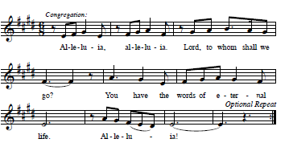
*GOSPEL VERSE Alleluia

*GOSPEL Matthew 3:13-17

The Holy Gospel according to Matthew, the 3rd chapter. Glory to you, O Lord.
The reading concludes: The Gospel of the Lord. Praise to you, O Christ.

SERMON Pastor Nikki Fielder

*SERMON HYMN Christ, When for Us You Were Baptized ELW #304
(verses 1, 2, 4)

BAPTISM OF LUCAS MICHAEL TABER

PRAYERS OF INTERCESSION
As God’s beloved children united in Christ, let us pray for the church, the whole human community, and the well-being of the earth, our home.
A brief silence.
Merciful God,
receive our prayer.

Confident that the Holy Spirit receives our prayers and answers us, we commend all for whom we pray to God’s loving-kindness made known to us in Christ Jesus our Savior.
Amen.
*SHARING OF THE PEACE

The peace of Christ be with you always. And also with you.

OFFERTORY Roger Halvorson

*OFFERTORY RESPONSE As the Grains of Wheat

*OFFERTORY PRAYER

Let us pray together,
God of majesty, no eye has seen, no ear has heard what you have prepared for those who love you, yet in this meal you reveal the wideness of your mercy.
Use what we have gathered to feed us with the reign of God come near, Jesus Christ, our Savior and Lord. Amen.

MEAL
God feeds us with the presence of Jesus.

*THE GREAT THANKSGIVING

The Lord be with you. And also with you.
Lift up your hearts. We lift them to the Lord,
Let us give thanks to the Lord our God.
It is right to give our thanks and praise.

It is indeed right, our duty and our joy …
we praise your name and join their unending hymn:

*HOLY, HOLY, HOLY
*THANKSGIVING AT THE TABLE

Holy, mighty, and merciful Lord, heaven and earth are full of your glory...
...to whom, with you and the Holy Spirit, be all honor and glory, now and forever. Amen.

*LORD’S PRAYER
Our Father in heaven, hallowed be your name, your kingdom come, your will be done, on earth as in heaven. Give us today our daily bread. Forgive us our sins
as we forgive those who sin against us. Save us from the time of trial and deliver us from evil. For the kingdom, the power, and the glory are yours, now and forever. Amen.
DISTRIBUTION OF HOLY COMMUNION
We believe that this is Jesus' table. All are welcome and invited to commune. We serve communion by “intinction”; receive the bread and dip it in the chalice. Gluten free wafers are available; let your server know. Wine is offered on each side. White grape juice is offered at the center aisle. Should you choose not to commune, you are invited to come forward to receive a blessing. Please cross your arms across your chest to let us know to give you that blessing.

HEALING PRAYER
This morning we offer healing prayer. If you would like our healing minister to pray with and for you, please go to the right transept after taking communion.

INVITATION TO COMMUNION
Here is the Lamb of God who takes away the sin of the world! Come to the table; taste and see.


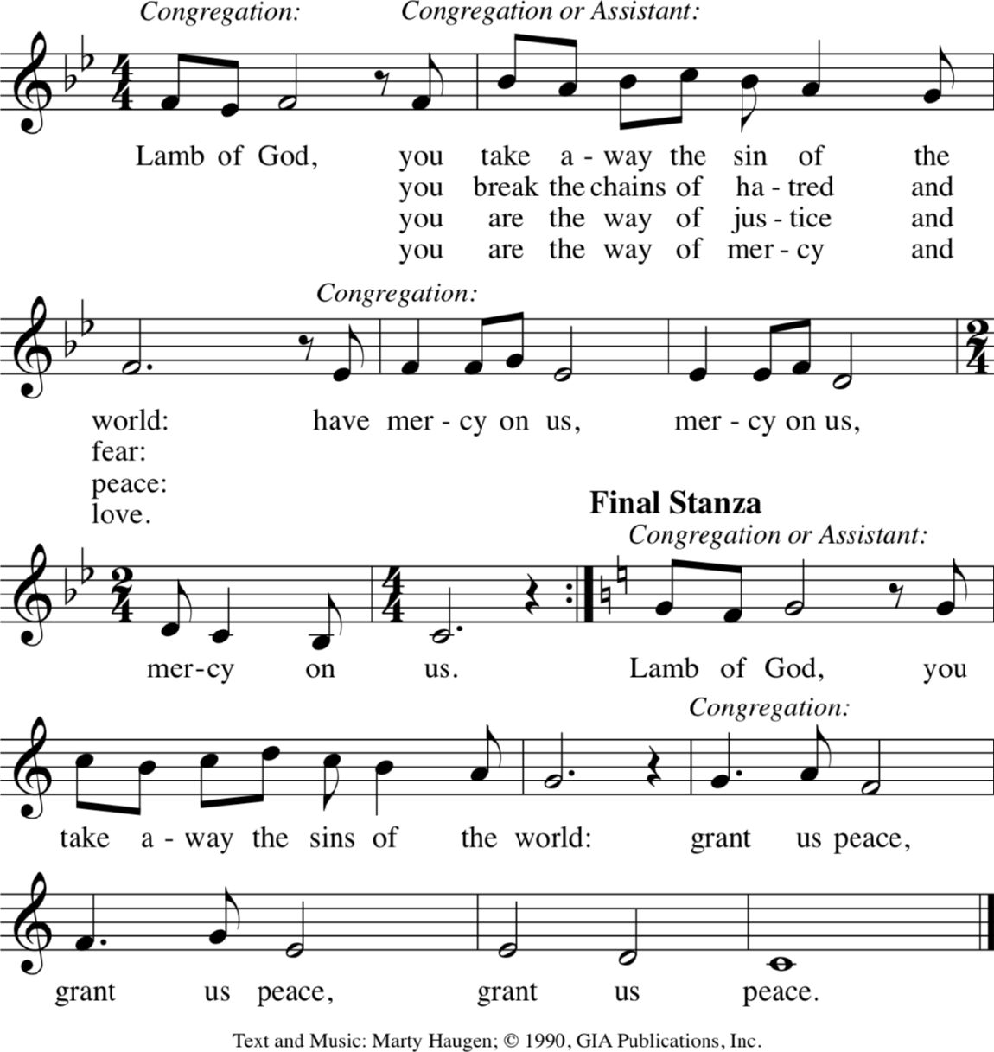
LAMB OF GOD

…you break the chains of hatred and fear:
…you are the way of justice and peace:
…you are the way of mercy and love:
…you are God’s light to all of the world:

COMMUNION SONG Spirit of Gentleness ELW #396

*POST COMMUNION BLESSING
The body and blood of our Lord Jesus Christ strengthen you and keep you in his grace. Amen.

*PRAYER AFTER COMMUNION

Let us pray,
Radiant God, we have seen your glory in the face of Jesus Christ. In the sacrament of his body and blood you have drawn us to your heart. Send us from this table with delight, that our lives may reflect the beauty of your love, and bear witness to all we have seen and heard, through Jesus Christ, our Savior and Lord.
Amen.

SENDING
God blesses us and sends us in mission to the world.

*BLESSING
May the triune God, who has put a new song in your mouth and tuned your heart for praise ☩ bless you now and forever.
Amen.

*SENDING HYMN Wade in the Water ELW #459

*Dismissal
Go in peace. Do justice. Love mercy.
Thanks be to God.

POSTLUDE Roger Halvorson

CHRIST LUTHERAN CHURCH STAFF

Pastor Rev. Nikki Fielder, pastor@christlutheranlb.com
Office Manager Kim Croes, officemanager@christlutheranlb.com
Preschool Director Lisa Clinton, info@clplb.com
Director of Senior Adult Ministry Shannon Howard, directorsam@christlutheranlb.com
Choir Director Kim Philips, kimsings@msn.com
Accompanist Roger Halvorson
A/V Technicians Brad Croes and Jett Baker
Missionary to Colombia Linda Gawthorne

Mission Statement
Living by Christ’s example, we welcome, serve, and love all through God’s grace.

Vision Statement
Embracing the truth that God’s love and grace is for all, Christ Lutheran Church is a vibrant and active community spreading the good news through acceptance, action, and benevolence.

Our Position
Christ is ALIVE!

Reconciling in Christ (RIC) Welcome Statement
Christ Lutheran Church is a congregation who joyfully welcomes everyone who enters our doors. We recognize that each of us is a unique creation made in the image of God. We celebrate and give thanks for the many diverse gifts that God has bestowed on us. We proclaim ourselves to be an open and affirming congregation to all of God's children, welcoming into our ministry persons of every race, culture age, gender identity, gender expression, sexual orientation, ability, and economic status. We commit ourselves to the work of anti-racism and creating an anti-racist space. We believe that through our openness we all grow in our faith through Christ's teaching to love one another as God loves us.

