Lessons & Carols:
Christmas Day
First Sunday of Christmas


Christ Lutheran Church
6500 E. Stearns Street
Long Beach, California 90815
Phone 562-598-2433
www.christlutheranlb.com
Preschool 562-594-6117
www.clplb.com

Christmas Worship Assistants

Thank you to everyone for supporting our Christmas Worship Services. Your commitment to our church family’s Christmas experience is greatly appreciated.

Christmas Day
December 25 at 10:00am

Assisting Minister: Marvin Moon
Reader: Don Koepke
Communion Assistant: Shannon Timney
Ushers: Renu Moon, Heather and Donald Nielsen, Matthew Timney
Altar Guild: Claudia Fitzpatrick and Shannon Timney

First Sunday of Christmas
December 28 at 9:30am

Assisting Minister: Lisa Cottrell
Reader: Doug Holdhusen
Communion Assistants: Lonnie Timney, Scott Fielder, Kim Magee
Healing Prayer Minister: Shannon Howard
Greeters: Kristine and Andy Trost
Ushers: Renu Moon, Heather and Donald Nielsen, Matthew Timney
Altar Guild: Claudia Fitzpatrick

Welcome to worship! We’re glad you’re here!

To assist in your worship:
bold print means we respond together
* means rise in body or spirit,
+ you may make the sign of the cross should you so desire.

It is our joy to worship with your whole family!

We encourage everyone of all ages and abilities to worship together.
We offer a “pray-ground” located in the back left of the Sanctuary for those with littles to have some room for movement and activity. The Narthex (gathering space at the entry) also has some resources for families, including activity bags filled with crayons, paper and storybooks. These supplies can be used in the Narthex or brought into the Sanctuary. For those that find themselves in the Narthex, there is a speaker with which you can still hear the service. Lastly, a changing table is located in the restroom off the Narthex. Please ask an usher if you need any assistance.

TODAY’S worship THEME
On Christmas Day, the Word illumines the world, shining forth to bring all things into being. Today, and in the Christmas season, we celebrate the incarnate Word,
God becoming flesh to live among us in the person of Jesus Christ then and now. Emboldened by the good news of Christ’s birth, along with the shepherds,
Mary and Joseph, and all witnesses to the light of Christ, we declare to the world that we have indeed seen and been transformed by the arrival of “the salvation of our God.”
O come, let us adore!
Worship services for
Christ Lutheran Church- Long Beach
are live-streamed and archived to YouTube.
By entering the sanctuary and by your presence here,
you consent to be photographed,
filmed, and/or otherwise recorded.
Please alert an usher if this is of concern to you.

Our liturgy is taken from:
Sundays and Seasons.com. Copyright 2025 Augsburg Fortress. All rights reserved.
Reprinted by permission under Augsburg Fortress Liturgies Annual License #20338.
Reprinted by permission under CCLI license # 230154. All rights reserved.
Reprinted by permission under © 2025 One License #A-706154. All rights reserved.
PRELUDE Roger Halvorson

WELCOME AND ANNOUNCEMENTS

GATHERING
The Holy Spirit calls us together as the people of God.__________________________

*GATHERING SONG O Come, All Ye Faithful ELW #283
(Verses 1, 3 & 4)

*CONFESSION & FORGIVENESS
Blessed be the holy Trinity, ☩ one God, Wonderful Counselor, Mighty Savior, Prince of Peace.
Amen.

Trusting in God’s steadfast love and faithfulness, let us confess our sin.

Silence is kept for reflection.
Reconciling God,
we yearn for your presence to transform our grief, pain, and despair. We confess that we have not always prepared room in our hearts for your love; we have not always recognized your presence among us; we have not always embraced your message of peace. We cry out, weary with the burden of violence, oppression, and fear. We confess our failure to make room for those seeking refuge; our participation in violent systems that harm your innocent ones; our reluctance to embody your good news. Be born in us today and teach us to sing the joyful song of your salvation. Amen.

God’s grace upon grace flows over you. ☩ Christ’s presence redeems the whole creation. Your sins are forgiven. Let the earth rejoice and be glad!
Amen.

*GREETING

The grace of our Lord Jesus Christ, the love of God, and the communion of the Holy Spirit be with you all.
And also with you.

*pRAYER OF THE DAY

Let us pray together,
All-powerful and unseen God, the coming of your light into our world has brightened weary hearts with peace. Call us out of darkness, and empower us to proclaim the birth of your Son, Jesus Christ, our Savior and Lord, who lives and reigns with you and the Holy Spirit, one God, now and forever. Amen.

WORD
God speaks to us in scripture reading, preaching, and song.______________________

LESSONS AND CAROLS
First Reading: Genesis 1:1-5, 14-18
Second Reading: Micah 5:2-5a
(12/25) Infant Holy, Infant Lowly

1 Infant holy, infant lowly,
for his bed a cattle stall;
oxen lowing, little knowing
Christ the child is Lord of all.
Swiftly winging, angels singing,
bells are ringing, tidings bringing:
Christ the child is Lord of all!
Christ the child is Lord of all!

2 Flocks were sleeping, shepherds keeping
vigil till the morning new
saw the glory, heard the story,
tidings of a gospel true.
Thus rejoicing, free from sorrow,
praises voicing, greet the morrow:
Christ the child was born for you!
Christ the child was born for you!

(12/28) Once in Royal David’s City

1 Once in royal David's city
stood a lowly cattle shed,
where a mother laid her baby
in a manger for his bed:
Mary was that mother mild,
Jesus Christ, her little child.

2 He came down to earth from heaven
who is God and Lord of all,
and his shelter was a stable,
and his cradle was a stall;
with the poor and meek and lowly,
lived on earth our Savior holy.

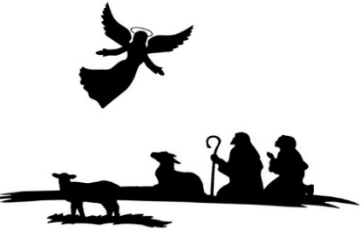
Third Reading: Luke 1:26-35, 38
Fourth Reading: Matthew 1:18-25

(12/25) Angels We Have Heard on High

1 Angels we have heard on high,
sweetly singing o'er the plains,
and the mountains in reply,
echoing their joyous strains.

Refrain
Gloria in excelsis Deo;
gloria in excelsis Deo.

3 Come to Bethlehem and see
him whose birth the angels sing;
come, adore on bended knee
Christ the Lord, the newborn King.
(Refrain)

(12/28) Hark! the Herald Angels Sing
1 Hark! The herald angels sing,
"Glory to the newborn king;
peace on earth, and mercy mild,
God and sinners reconciled."
Joyful, all you nations, rise;
join the triumph of the skies;
with angelic hosts proclaim,
"Christ is born in Bethlehem!"

Refrain:
Hark! The herald angels sing,
"Glory to the newborn king!"

2 Christ, by highest heav'n adored,
Christ, the everlasting Lord,
late in time behold him come,
offspring of a virgin's womb.
Veiled in flesh the Godhead see!
Hail, incarnate deity!
Pleased as man with us to dwell,
Jesus, our Emmanuel! (Refrain)


Fifth Reading: Luke 2:8-20
Sixth Reading: Matthew 2:1-11
Seventh Reading: John 1:1-14

(12/25) What Child Is This

1 What child is this, who, laid to rest,
on Mary's lap is sleeping?
Whom angels greet with anthems sweet
while shepherds watch are keeping?
This, this is Christ the king,
whom shepherds guard and angels sing;
haste, haste to bring him laud,
the babe, the son of Mary!
3 So bring him incense, gold, and myrrh;
come, peasant, king, to own him.
The King of kings salvation brings;
let loving hearts enthrone him.
Raise, raise the song on high,
the virgin sings her lullaby;
joy, joy, for Christ is born,
the babe, the son of Mary!

(12/28) Love Has Come

1 Love has come—a light in the darkness!
Love shines forth in the Bethlehem skies.
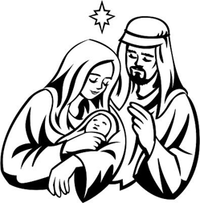
See, all heaven has come to proclaim it;
hear how their song of joy arises:
Love! Love! Born unto you, a Savior!
Love! Love! Glory to God on high.

2 Love is born! Come, share in the wonder.
Love is God now asleep in the hay.
See the glow in the eyes of his mother;
what is the name her heart is saying?
Love! Love! Love is the name she whispers;
Love! Love! Jesus, Immanuel.

*Nicene CREED
We believe in one God, the Father, the Almighty, maker of heaven and earth, of all that is, seen and unseen.
We believe in one Lord, Jesus Christ, the only Son of God, eternally begotten of the Father, God from God, Light from Light, true God from true God, begotten, not made, of one Being with the Father; through him all things were made. For us and for our salvation he came down from heaven, was incarnate of the Holy Spirit and the virgin Mary and became truly human. For our sake he was crucified under Pontius Pilate; he suffered death and was buried. On the third day he rose again in accordance with the scriptures; he ascended into heaven and is seated at the right hand of the Father. He will come again in glory to judge the living and the dead, and his kingdom will have no end.
We believe in the Holy Spirit, the Lord, the giver of life, who proceeds from the Father and the Son, who with the Father and the Son is worshiped and glorified, who has spoken through the prophets.
We believe in one holy catholic and apostolic church. We acknowledge one baptism for the forgiveness of sins. We look for the resurrection of the dead, and the life of the world to come. Amen.

PRAYERS OF THE CHURCH

Empowered by the news of Christ’s birth, let us pray boldly for the church, creation, and all who are in need.
A brief silence.
Hear us, O God. Your mercy is great.

With the joy of Christ’s birth in our hearts, we commend our prayers to you, O God, trusting in your boundless mercy and eternal love; through Jesus Christ our Savior.
Amen.

*SHARING OF PEACE

The peace of the Lord be with you always. And also with you.
OFFERTORY Roger Halvorson

*OFFERTORY RESPONSE The First Noel ELW #300
(verses 1 & 4)
1 The first Noel the angel did say
was to certain poor shepherds in fields as they lay;
in fields where they lay, keeping their sheep,
on a cold winter’s night that was so deep.

Refrain:
Noel, Noel, Noel, Noel!
Born is the King of Israel.

4 This star drew near to the northwest,
o'er Bethlehem it took its rest;
and there it did both stop and stay
right over the place where Jesus lay. (Refrain)

*OFFERTORY PRAYER

Let us pray together,
God of glory, great are your wonders among us and many are the blessings you bestow. Use us and these your gifts for the needs of the world, that all the ends of the earth may rejoice in your saving grace, through Christ our Savior. Amen.

MEAL
God feeds us with the presence of Jesus.

*THE GREAT THANKSGIVING

The Lord be with you. And also with you.
Lift up your hearts. We lift them to the Lord,
Let us give thanks to the Lord our God.
It is right to give our thanks and praise.

*THANKSGIVING AT THE TABLE

Holy One, the beginning and the end, the giver of life…

Let us proclaim the mystery of faith:
Christ has died.
Christ is risen.
Christ will come again.

…All praise and glory are yours, Holy One of Israel, Word of God incarnate, Power of the Most High, one God, now and forever.
Amen.

*LORD’S PRAYER
Our Father in heaven, hallowed be your name, your kingdom come, your will be done, on earth as in heaven. Give us today our daily bread. Forgive us our sins
as we forgive those who sin against us. Save us from the time of trial and deliver us from evil. For the kingdom, the power, and the glory are yours, now and forever. Amen.

DISTRIBUTION OF HOLY COMMUNION
We believe that this is Jesus' table. All are welcome and invited to commune. We serve communion by “intinction”; receive the bread and dip it in the chalice. Gluten free wafers are available; let your server know. Wine is offered on each side. White grape juice is offered at the center aisle. Should you choose not to commune, you are invited to come forward to receive a blessing. Please cross your arms across your chest to let us know to give you that blessing.

INVITATION TO COMMUNION
God is now in flesh appearing. Come to the feast of joy!

COMMUNION SONGS
(12/25) Special Music Roger Halvorson
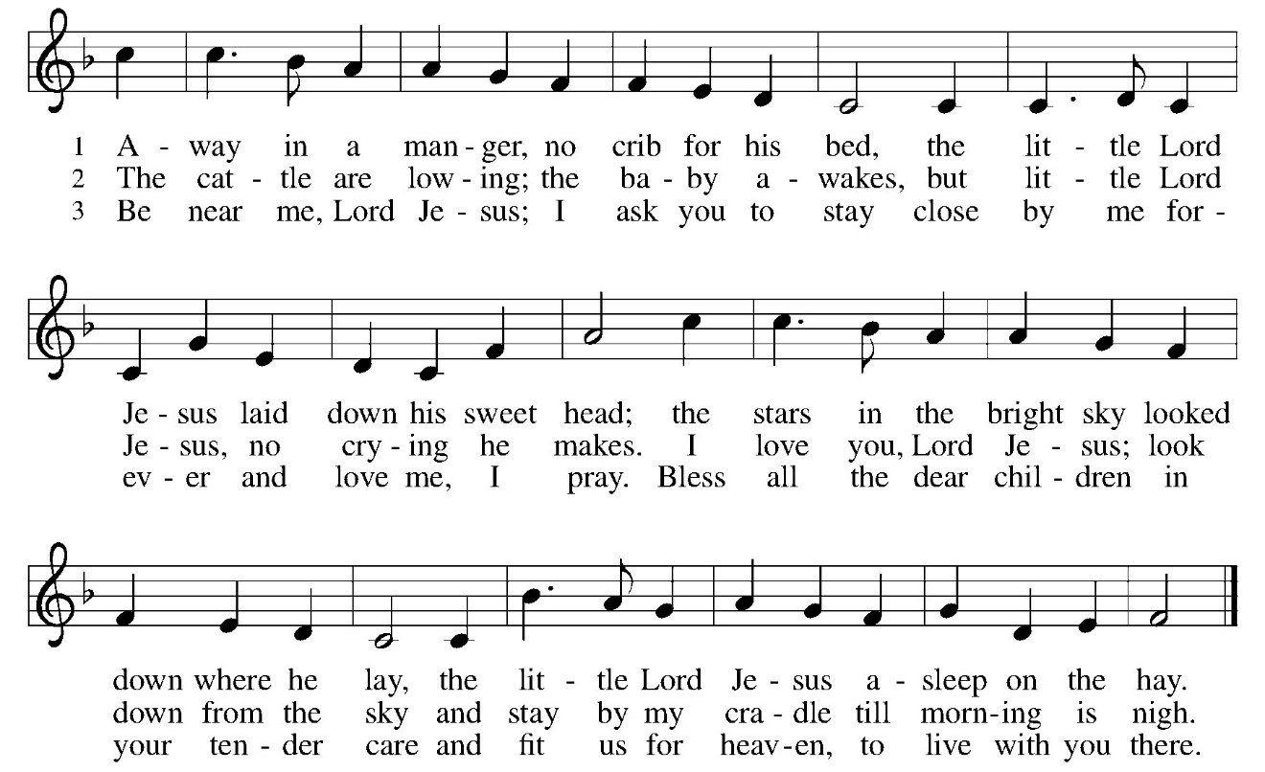
(12/28) Away in a Manger ELW #277

(12/28) O Little Town of Bethlehem ELW #279

*POST COMMUNION BLESSING
The body and blood of our Lord Jesus Christ strengthen you and keep you in his grace. Amen.

*PRAYER AFTER COMMUNION

Let us pray,
Incarnate God, you are among us at this table. May we treasure this gift and ponder in our hearts the mystery of your presence. Move us to discover the wonders of your love in the everyday moments of our lives, through Christ born in us. Amen.

SENDING
God blesses us and sends us in mission to the world.______________________

*BLESSING
The triune God, glorious Mystery, holy Incarnate One, abiding Comforter, ☩ bless you with endless grace, peace, and joy.
Amen.

*SENDING SONG
(12/25) Go Tell It on the Mountain ELW #290

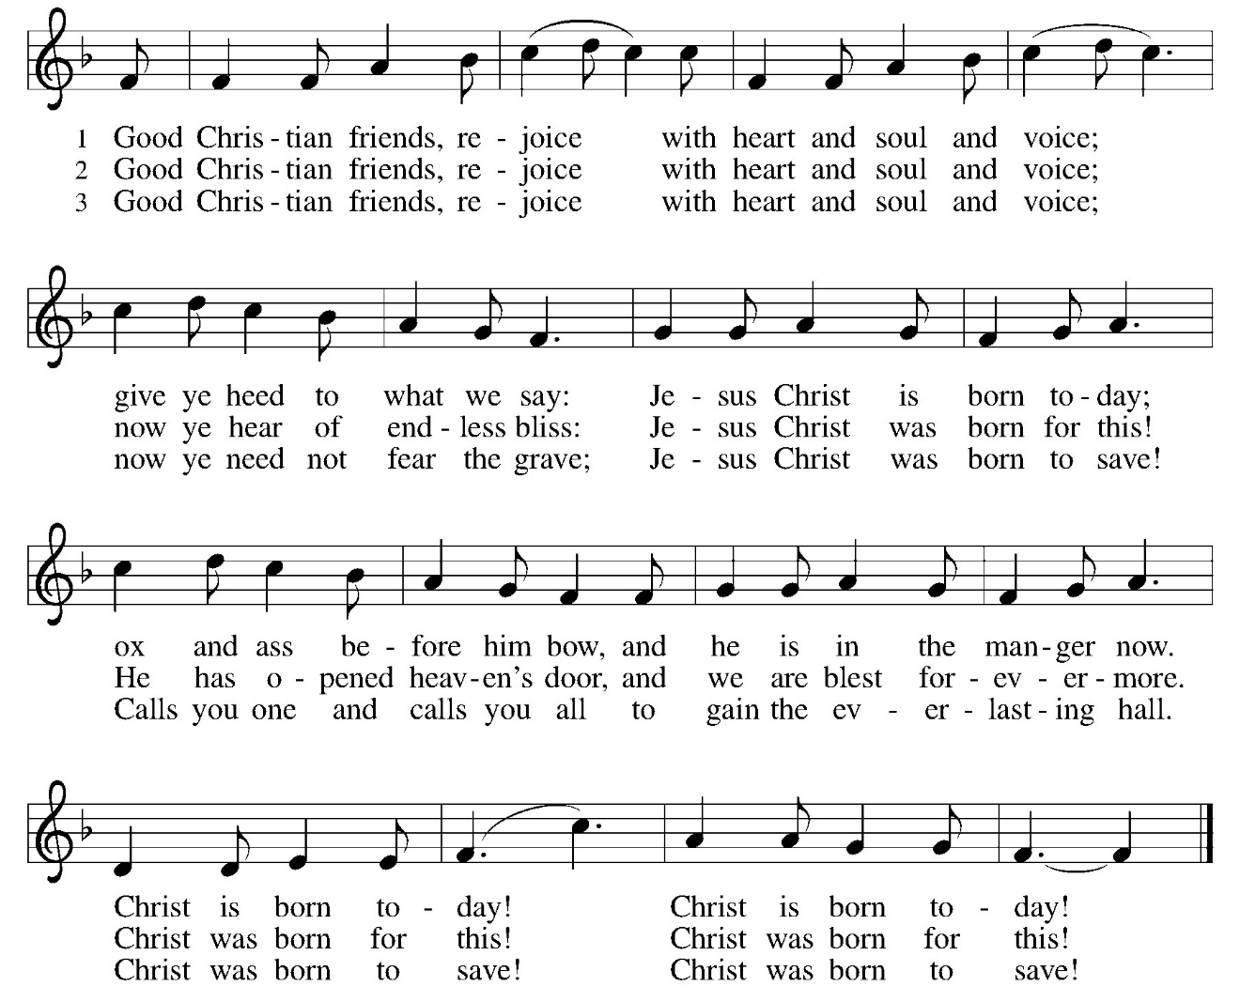
(12/28) Good Christian Friends, Rejoice ELW #288
*DISMISSAL
Glory to God in the highest!
And peace to God’s people on earth!
Go in joy. Embody God’s redeeming grace.
Thanks be to God.

POSTLUDE Roger Halvorson

CHRIST LUTHERAN CHURCH STAFF

Pastor Rev. Nikki Fielder, pastor@christlutheranlb.com
Office Manager Kim Croes, officemanager@christlutheranlb.com
Preschool Director Lisa Clinton, info@clplb.com
Director of Senior Adult Ministry Shannon Howard, directorsam@christlutheranlb.com
Choir Director Kim Philips, kimsings@msn.com
Accompanist Roger Halvorson
A/V Technicians Brad Croes and Jett Baker
Missionary to Colombia Linda Gawthorne

Mission Statement
Living by Christ’s example, we welcome, serve, and love all through God’s grace.

Vision Statement
Embracing the truth that God’s love and grace is for all, Christ Lutheran Church is a vibrant and active community spreading the good news through acceptance, action, and benevolence.

Our Position
Christ is ALIVE!

Reconciling in Christ (RIC) Welcome Statement
Christ Lutheran Church is a congregation who joyfully welcomes everyone who enters our doors. We recognize that each of us is a unique creation made in the image of God. We celebrate and give thanks for the many diverse gifts that God has bestowed on us. We proclaim ourselves to be an open and affirming congregation to all of God's children, welcoming into our ministry persons of every race, culture age, gender identity, gender expression, sexual orientation, ability, and economic status. We commit ourselves to the work of anti-racism and creating an anti-racist space. We believe that through our openness we all grow in our faith through Christ's teaching to love one another as God loves us.

