Epiphany
January 4, 2026
9:30am

Christ Lutheran Church
6500 E. Stearns Street
Long Beach, California 90815
Phone 562-598-2433
www.christlutheranlb.com

Preschool 562-594-6117
www.clplb.com

Welcome to worship! We’re glad you’re here!
To assist in your worship:
bold print means we respond together
* means rise in body or spirit,
+ you may make the sign of the cross should you so desire.

It is our joy to worship with your whole family!

We encourage everyone of all ages and abilities to worship together.
We offer a “pray-ground” located in the back left of the Sanctuary for those with littles to have some room for movement and activity. The Narthex (gathering space at the entry) also has some resources for families, including activity bags filled with crayons, paper and storybooks. These supplies can be used in the Narthex or brought into the Sanctuary. For those that find themselves in the Narthex, there is a speaker with which you can still hear the service. Lastly, a changing table is located in the restroom off the Narthex. Please ask an usher if you need any assistance.

TODAY’S worship THEME
The feast of Epiphany (“manifestation”) concludes the Christmas season with a celebration of God’s glory revealed in the person of Jesus Christ. In Isaiah and Ephesians, that glory is proclaimed for all nations and people. Like the light of the star that guided the magi to Jesus, the light of Christ reveals who we are: children of God who are claimed and washed in the waters of baptism. We are sent out to be beacons of the light of Christ, sharing the good news of God’s love to all people.

Worship services for Christ Lutheran Church- Long Beach are live-streamed
and archived to YouTube. By entering the sanctuary and by your presence here,
you consent to be photographed, filmed, and/or otherwise recorded.
Please alert an usher if this is of concern to you.

Our liturgy is taken from:
Sundays and Seasons.com. Copyright 2026 Augsburg Fortress. All rights reserved.
Reprinted by permission under Augsburg Fortress Liturgies Annual License #20338.
Reprinted by permission under CCLI license # 230154. All rights reserved.
Reprinted by permission under © 2026 One License #A-706154. All rights reserved.

PRELUDE Roger Halvorson
WELCOME AND ANNOUNCEMENTS

GATHERING
The Holy Spirit calls us together as the people of God.

*GATHERING SONG Bright and Glorious Is the Sky ELW #301

*CONFESSION AND FORGIVENESS
Blessed be the holy Trinity, ☩ one God, Wonderful Counselor, Mighty Savior, Prince of Peace.
Amen.

Trusting in God’s steadfast love and faithfulness, let us confess our sin.

Silence is kept for reflection.
Reconciling God,
we yearn for your presence to transform our grief, pain, and despair. We confess that we have not always prepared room in our hearts for your love; we have not always recognized your presence among us; we have not always embraced your message of peace. We cry out, weary with the burden of violence, oppression, and fear. We confess our failure to make room for those seeking refuge; our participation in violent systems that harm your innocent ones; our reluctance to embody your good news. Be born in us today and teach us to sing the joyful song of your salvation. Amen.

God’s grace upon grace flows over you.☩ Christ’s presence redeems the whole creation. Your sins are forgiven. Let the earth rejoice and be glad!
Amen.

*GREETING
The grace of our Lord Jesus Christ, the love of God, and the communion of the Holy Spirit be with you all.
And also with you.

*PRAYER OF THE DAY

Let us pray,
O God, on this day you revealed your Son to the nations by the leading of a star. Lead us now by faith to know your presence in our lives, and bring us at last to the full vision of your glory, through your Son, Jesus Christ our Lord, who lives and reigns with you and the Holy Spirit, one God, now and forever. Amen.

WORD
God speaks to us in scripture reading, preaching, and song.

CHILDREN’S CHAT
All children are welcomed forward for a children’s time. After that, they will be invited to Sunday school and will return during the passing of the peace.
FIRST READING Isaiah 60:1-6

SECOND READING Ephesians 3:1-12

Word of God, word of life. Thanks be to God.

*GOSPEL VERSE Angels We Have Heard on High ELW #289
(verse 1)
Angels we have heard on high,
Sweetly singing o'er the plains,
And the mountains in reply
Echoing their joyous strains.

Refrain:
Gloria in excelsis Deo.
Gloria in excelsis Deo.

*GOSPEL Matthew 2:1-12

The Holy Gospel according to Matthew, the 2nd chapter. Glory to you, O Lord.
The reading concludes: The Gospel of the Lord. Praise to you, O Christ.

SERMON Pastor Nikki Fielder

*SERMON HYMN As With Gladness Men of Old ELW #302
(verses 1-4)

*Nicene CREED
We believe in one God, the Father, the Almighty, maker of heaven and earth, of all that is, seen and unseen.
We believe in one Lord, Jesus Christ, the only Son of God, eternally begotten of the Father, God from God, Light from Light, true God from true God, begotten, not made, of one Being with the Father; through him all things were made. For us and for our salvation he came down from heaven, was incarnate of the Holy Spirit and the virgin Mary and became truly human. For our sake he was crucified under Pontius Pilate; he suffered death and was buried. On the third day he rose again in accordance with the scriptures; he ascended into heaven and is seated at the right hand of the Father. He will come again in glory to judge the living and the dead, and his kingdom will have no end.
We believe in the Holy Spirit, the Lord, the giver of life, who proceeds from the Father and the Son, who with the Father and the Son is worshiped and glorified, who has spoken through the prophets.
We believe in one holy catholic and apostolic church. We acknowledge one baptism for the forgiveness of sins. We look for the resurrection of the dead, and the life of the world to come. Amen.

PRAYERS OF THE CHURCH

Empowered by the news of Christ’s birth, let us pray boldly for the church, creation, and all who are in need.
A brief silence.
Hear us, O God.
Your mercy is great.

With the joy of Christ’s birth in our hearts, we commend our prayers to you, O God, trusting in your boundless mercy and eternal love; through Jesus Christ our Savior.
Amen.

*SHARING OF THE PEACE

The peace of Christ be with you always. And also with you.

OFFERTORY Roger Halvorson
*OFFERTORY RESPONSE The First Noel ELW #300
(verse 1)
1 The first Noel the angel did say
was to certain poor shepherds in fields as they lay;
in fields where they lay, keeping their sheep,
on a cold winter’s night that was so deep.

Refrain:
Noel, Noel, Noel, Noel!
Born is the King of Israel.

*OFFERTORY PRAYER

Let us pray together,
God of glory, great are your wonders among us and many are the blessings you bestow. Use us and these your gifts for the needs of the world, that all the ends of the earth may rejoice in your saving grace, through Christ our Savior. Amen.

MEAL
God feeds us with the presence of Jesus.

*THE GREAT THANKSGIVING

The Lord be with you. And also with you.
Lift up your hearts. We lift them to the Lord,
Let us give thanks to the Lord our God.
It is right to give our thanks and praise.

*THANKSGIVING AT THE TABLE

Holy One, the beginning and the end, the giver of life…

Let us proclaim the mystery of faith:
Christ has died.
Christ is risen.
Christ will come again.

…All praise and glory are yours, Holy One of Israel, Word of God incarnate, Power of the Most High, one God, now and forever.
Amen.

*LORD’S PRAYER
Our Father in heaven, hallowed be your name, your kingdom come, your will be done, on earth as in heaven. Give us today our daily bread. Forgive us our sins
as we forgive those who sin against us. Save us from the time of trial and deliver us from evil. For the kingdom, the power, and the glory are yours, now and forever. Amen.

DISTRIBUTION OF HOLY COMMUNION
We believe that this is Jesus' table. All are welcome and invited to commune. We serve communion by “intinction”; receive the bread and dip it in the chalice. Gluten free wafers are available; let your server know. Wine is offered on each side. White grape juice is offered at the center aisle. Should you choose not to commune, you are invited to come forward to receive a blessing. Please cross your arms across your chest to let us know to give you that blessing.

INVITATION TO COMMUNION
God is now in flesh appearing. Come to the feast of joy!

COMMUNION SONGS
O Little Town of Bethlehem ELW #279

In the Bleak Midwinter ELW #294

*POST COMMUNION BLESSING
The body and blood of our Lord Jesus Christ strengthen you and keep you in his grace. Amen.

*PRAYER AFTER COMMUNION

Let us pray,
Incarnate God, you are among us at this table. May we treasure this gift and ponder in our hearts the mystery of your presence. Move us to discover the wonders of your love in the everyday moments of our lives, through Christ born in us. Amen.

SENDING
God blesses us and sends us in mission to the world.

*BLESSING
The triune God, glorious Mystery, holy Incarnate One, abiding Comforter, ☩ bless you with endless grace, peace, and joy.
Amen.

*SENDING HYMN Shine, Jesus, Shine ELW #671

Verse 1
Lord, the light of your love is shining
In the midst of the darkness, shining
Jesus, Light of the world, shine upon us
Set us free by the truth you now bring us
Shine on me, shine on me

Chorus:
Shine, Jesus, shine
Fill this land with the Father's glory
Blaze, Spirit, blaze
Set our hearts on fire
Flow, river, flow
Flood the nations with grace and mercy
Send forth your word
Lord, and let there be light
Verse 2
Lord, I come to your awesome presence
From the shadows into your radiance
By the blood I may enter your brightness
Search me, try me, consume all my darkness
Shine on me, shine on me (Chorus)

Verse 3
As we gaze on your kingly brightness
So our faces display your likeness
Ever changing from glory to glory
Mirrored here may our lives tell your story
Shine on me, shine on me (Chorus)

*Dismissal
Glory to God in the highest!
And peace to God’s people on earth!
Go in joy. Embody God’s redeeming grace.
Thanks be to God.

POSTLUDE Roger Halvorson

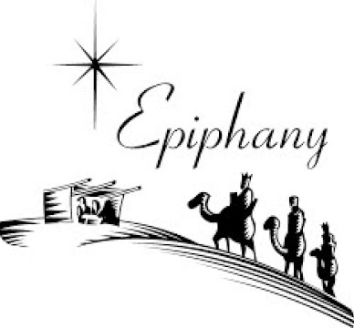

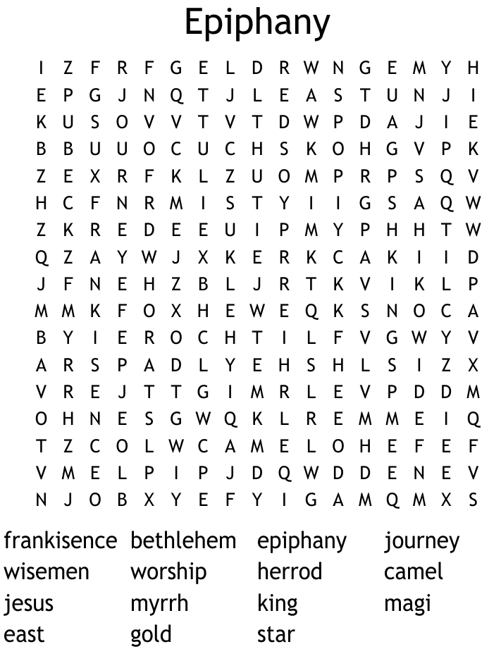

CHRIST LUTHERAN CHURCH STAFF

Pastor Rev. Nikki Fielder, pastor@christlutheranlb.com
Office Manager Kim Croes, officemanager@christlutheranlb.com
Preschool Director Lisa Clinton, info@clplb.com
Director of Senior Adult Ministry Shannon Howard, directorsam@christlutheranlb.com
Choir Director Kim Philips, kimsings@msn.com
Accompanist Roger Halvorson
A/V Technicians Brad Croes and Jett Baker
Missionary to Colombia Linda Gawthorne

Mission Statement
Living by Christ’s example, we welcome, serve, and love all through God’s grace.

Vision Statement
Embracing the truth that God’s love and grace is for all, Christ Lutheran Church is a vibrant and active community spreading the good news through acceptance, action, and benevolence.

Our Position
Christ is ALIVE!

Reconciling in Christ (RIC) Welcome Statement
Christ Lutheran Church is a congregation who joyfully welcomes everyone who enters our doors. We recognize that each of us is a unique creation made in the image of God. We celebrate and give thanks for the many diverse gifts that God has bestowed on us. We proclaim ourselves to be an open and affirming congregation to all of God's children, welcoming into our ministry persons of every race, culture age, gender identity, gender expression, sexual orientation, ability, and economic status. We commit ourselves to the work of anti-racism and creating an anti-racist space. We believe that through our openness we all grow in our faith through Christ's teaching to love one another as God loves us.

