Second Sunday of Advent
December 7, 2025
9:30am

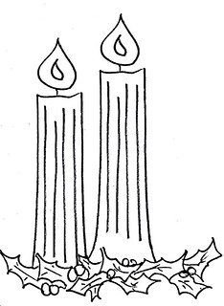

Christ Lutheran Church
6500 E. Stearns Street
Long Beach, California 90815
Phone 562-598-2433
www.christlutheranlb.com

Preschool 562-594-6117
www.clplb.com
Welcome to worship! We’re glad you’re here!
To assist in your worship:
bold print means we respond together
* means rise in body or spirit,
+ you may make the sign of the cross should you so desire.

It is our joy to worship with your whole family!

We encourage everyone of all ages and abilities to worship together.
We offer a “pray-ground” located in the back left of the Sanctuary for those with littles to have some room for movement and activity. The Narthex (gathering space at the entry) also has some resources for families, including activity bags filled with crayons, paper and storybooks. These supplies can be used in the Narthex or brought into the Sanctuary. For those that find themselves in the Narthex, there is a speaker with which you can still hear the service. Lastly, a changing table is located in the restroom off the Narthex. Please ask an usher if you need any assistance.

TODAY’S worship THEME
At the heart of our Advent preparation stands John the Baptist, who calls us to repent and make a new beginning. As the darkness increases we turn toward the approaching light of Christ. For Christians he is the root of Jesse, the righteous judge who welcomes all, especially the poor and meek of the earth. We wait with hope for that day when the wolf will dwell with the lamb, and there will be no more hurt or destruction. From the Lord’s table we are sent in the spirit of John the Baptist to proclaim that in Christ the kingdom of God has come near.
Worship services for Christ Lutheran Church- Long Beach
are live-streamed and archived to YouTube.
By entering the sanctuary and by your presence here,
you consent to be photographed,
filmed, and/or otherwise recorded.
Please alert an usher if this is of concern to you.
Our liturgy is taken from:
Sundays and Seasons.com. Copyright 2025 Augsburg Fortress. All rights reserved.
Reprinted by permission under Augsburg Fortress Liturgies Annual License #20338.
Reprinted by permission under CCLI license # 230154. All rights reserved.
Reprinted by permission under © 2025 One License #A-706154. All rights reserved.
As the Grains of Wheat, Holy, and Lamb of God: Now the Feast and Celebration: An Alternate Eucharistic Setting, created by Marty Haugen.
Advent Wreath Lighting, written by Rev. Jolene Cadenbach, in A Multicultural, Multigenerational Christmas Eve Service.
PRELUDE Roger Halvorson
WELCOME AND ANNOUNCEMENTS

BLESSING OF THE KNIT CAPS

GATHERING
The Holy Spirit calls us together as the people of God.

ADVENT VERSE ELW #257 Verse 1
O come, O come, Emmanuel,
and ransom captive Israel,
that mourns in lonely exile here
until the Son of God appear.

Refrain
Rejoice! Rejoice! Emmanuel
shall come to you, O Israel.

ADVENT WREATH LIGHTING

*GATHERING SONG Hark, the Glad Sound ELW #239
(verses 1, 3, 4)

*CONFESSION AND FORGIVENESS

Blessed be the holy Trinity, ☩ one God, whose home is heaven and earth, whose salvation is sure.
Amen.

Let us confess our sin in the presence of God and of one another.

Silence is kept for reflection.
Long-expected God,
we confess that we look to ourselves for the peace and security only you can provide. We reach for swords and spears, reluctant to release our grip on the ways of war. We become impatient while waiting and weary of keeping awake.
Free us from self-reliance, and teach us to live in harmony with our neighbors.
Increase our trust in God’s timing, and awaken us to your advent among us,
that we may abound in the hope you have promised. Amen.

God judges us not as we deserve, but according to God’s own righteousness. ☩ You are freed and forgiven, saved by grace, and ready to welcome the Savior.
Amen.

*GREETING
The grace of our Lord Jesus Christ, the love of God, and the communion of the Holy Spirit be with you all.
And also with you.

*PRAYER OF THE DAY

Let us pray,
Stir up our hearts, Lord God, to prepare the way of your only Son. By his coming nurture our growth as people of repentance and peace; through Jesus Christ, our Savior and Lord, who lives and reigns with you and the Holy Spirit, one God, now and forever. Amen.
WORD
God speaks to us in scripture reading, preaching, and song.

CHILDREN’S CHAT
All children are welcomed forward for a children’s time. After that, they will be invited to Sunday school and will return during the passing of the peace.
FIRST READING Isaiah 11:1-10

SECOND READING Romans 15:4-13

Word of God, word of life. Thanks be to God.

*GOSPEL VERSE Angels We Have Heard on High ELW #289
*GOSPEL Matthew 3:1-12

The Holy Gospel according to Matthew, the 3rd chapter. Glory to you, O Lord.
The reading concludes: The Gospel of the Lord. Praise to you, O Christ.

SERMON Pastor Nikki Fielder

*SERMON HYMN On Jordan’s Bank the Baptist’s Cry ELW #249
(verses 1, 2, 5)

BAPTISM OF VIVIAN KENNEDY CARR

PRAYERS OF THE CHURCH

In our waiting and watching, we come to you in prayer, O God, trusting your promise to renew the church, the nations, and the whole creation.
A brief silence.
God of grace,
hear our prayer.

Draw near to us, O God, as we commend all for whom we pray, trusting in your mercy through Jesus Christ, Emmanuel.
Amen.

*SHARING OF THE PEACE

The peace of Christ be with you always. And also with you.

OFFERTORY People Look East CLC Fire Choir

*OFFERTORY RESPONSE As the Grains of Wheat

*OFFERTORY PRAYER

Let us pray together,
Nourishing God, you are water in the wilderness and streams in the desert. Through this meal, satisfy our parched places, that we may rejoice and be for the world signs of your kingdom come. Amen.

MEAL
God feeds us with the presence of Jesus.

*THE GREAT THANKSGIVING

The Lord be with you. And also with you.
Lift up your hearts. We lift them to the Lord,
Let us give thanks to the Lord our God.
It is right to give our thanks and praise.

It is indeed right, our duty and our joy …
we praise your name and join their unending hymn:

*HOLY, HOLY, HOLY
*THANKSGIVING AT THE TABLE

Holy One, the beginning and the end, the giver of life…

Let us proclaim the mystery of faith:
Christ has died.
Christ is risen.
Christ will come again.

…All praise and glory are yours, Holy One of Israel, Word of God incarnate, Power of the Most High, one God, now and forever.
Amen.

*LORD’S PRAYER
Our Father in heaven, hallowed be your name, your kingdom come, your will be done, on earth as in heaven. Give us today our daily bread. Forgive us our sins
as we forgive those who sin against us. Save us from the time of trial and deliver us from evil. For the kingdom, the power, and the glory are yours, now and forever. Amen.

DISTRIBUTION OF HOLY COMMUNION
We believe that this is Jesus' table. All are welcome and invited to commune. We serve communion by “intinction”; receive the bread and dip it in the chalice. Gluten free wafers are available; let your server know. Wine is offered on each side. White grape juice is offered at the center aisle. Should you choose not to commune, you are invited to come forward to receive a blessing. Please cross your arms across your chest to let us know to give you that blessing.

INVITATION TO COMMUNION
Here is life. God is with us. Come, receive what God has promised.



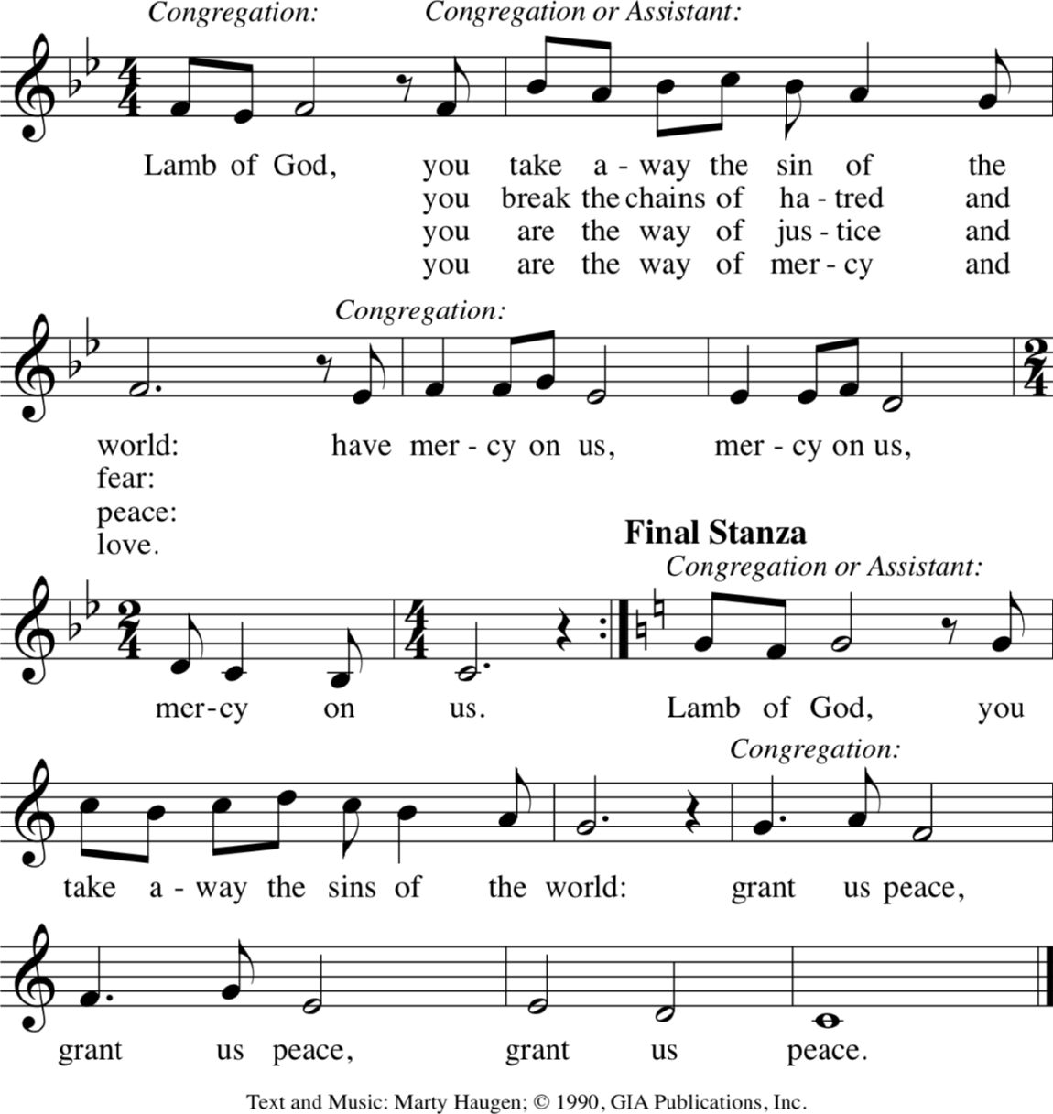
*lamb of god

…you break the chains of hatred and fear:
…you are the way of justice and peace:
…you are the way of mercy and love:
…you give us hope as we wait for you:

COMMUNION SONG Give Thanks W&P #41

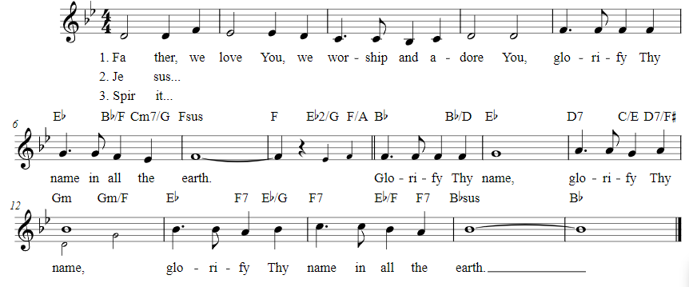
Glorify thy Name W&P #42

*POST COMMUNION BLESSING
The body and blood of our Lord Jesus Christ strengthen you and keep you in his grace. Amen.

*PRAYER AFTER COMMUNION

Let us pray,
God our host, at this table you have fed us with joy and gladness. Send us forth, eager to share the feast, welcome the stranger, and bear good fruit in the name of Jesus. Amen.

SENDING
God blesses us and sends us in mission to the world.

*BLESSING

May God who comes among us, Father, ☩ Son, and Holy Spirit, grant you patience in waiting, peace in the darkness, and good news to share today and always.
Amen.

*SENDING HYMN People Look East ELW #248
(verses 1 & 4)

*Dismissal
Go in peace. Keep awake.
Thanks be to God.

POSTLUDE Roger Halvorson

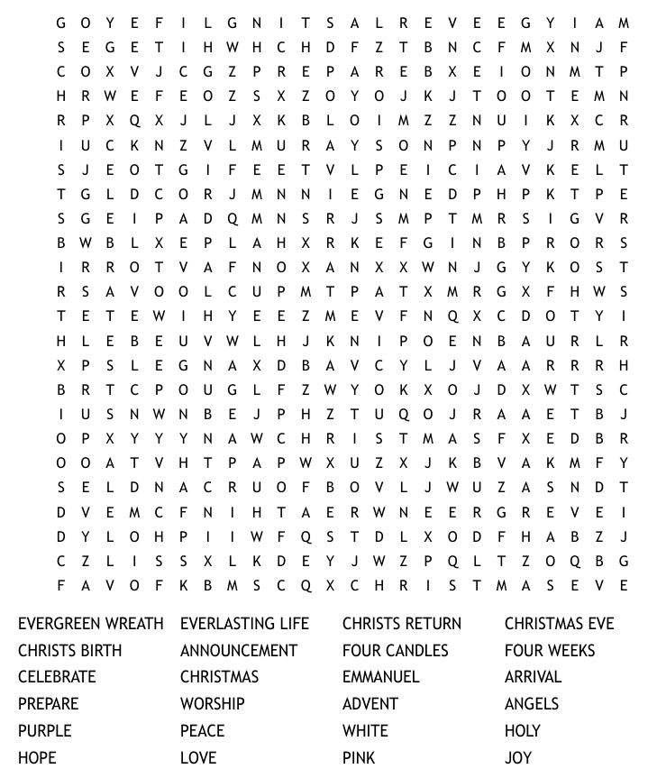
CHRIST LUTHERAN CHURCH STAFF

Pastor Rev. Nikki Fielder, pastor@christlutheranlb.com
Office Manager Kim Croes, officemanager@christlutheranlb.com
Preschool Director Lisa Clinton, info@clplb.com
Director of Senior Adult Ministry Shannon Howard, directorsam@christlutheranlb.com
Choir Director Kim Philips, kimsings@msn.com
Accompanist Roger Halvorson
A/V Technicians Brad Croes and Jett Baker
Missionary to Colombia Linda Gawthorne

Mission Statement
Living by Christ’s example, we welcome, serve, and love all through God’s grace.

Vision Statement
Embracing the truth that God’s love and grace is for all, Christ Lutheran Church is a vibrant and active community spreading the good news through acceptance, action, and benevolence.

Our Position
Christ is ALIVE!

Reconciling in Christ (RIC) Welcome Statement
Christ Lutheran Church is a congregation who joyfully welcomes everyone who enters our doors. We recognize that each of us is a unique creation made in the image of God. We celebrate and give thanks for the many diverse gifts that God has bestowed on us. We proclaim ourselves to be an open and affirming congregation to all of God's children, welcoming into our ministry persons of every race, culture age, gender identity, gender expression, sexual orientation, ability, and economic status. We commit ourselves to the work of anti-racism and creating an anti-racist space. We believe that through our openness we all grow in our faith through Christ's teaching to love one another as God loves us.

