Nineteenth Sunday after Pentecost
October 19, 2025
9:30am


Christ Lutheran Church
6500 E. Stearns Street
Long Beach, California 90815
Phone 562-598-2433
www.christlutheranlb.com

Preschool 562-594-6117
www.clplb.com

Welcome to worship! We’re glad you’re here!
To assist in your worship:
bold print means we respond together
* means rise in body or spirit,
+ you may make the sign of the cross should you so desire.

It is our joy to worship with your whole family!

We encourage everyone of all ages and abilities to worship together.
We offer a “pray-ground” located in the back left of the Sanctuary for those with littles to have some room for movement and activity. The Narthex (gathering space at the entry) also has some resources for families, including activity bags filled with crayons, paper and storybooks. These supplies can be used in the Narthex or brought into the Sanctuary. For those that find themselves in the Narthex, there is a speaker with which you can still hear the service. Lastly, a changing table is located in the restroom off the Narthex. Please ask an usher if you need any assistance.

TODAY’S worship THEME
Pray always. Do not lose heart. This is Christ’s encouragement in the gospel today. Wrestle with the word. Remember your baptism again and again. Come regularly to Christ’s table. Persistence in our every encounter with the divine will be blessed.

Worship services for Christ Lutheran Church- Long Beach
are live-streamed and archived to YouTube.
By entering the sanctuary and by your presence here,
you consent to be photographed,
filmed, and/or otherwise recorded.
Please alert an usher if this is of concern to you.

Our liturgy is taken from:
Sundays and Seasons.com. Copyright 2025 Augsburg Fortress. All rights reserved.
Reprinted by permission under Augsburg Fortress Liturgies Annual License #20338.
Reprinted by permission under CCLI license # 230154. All rights reserved.
Reprinted by permission under © 2025 One License #A-706154. All rights reserved.
Kildare: Alleluia, written by Rev. Steve Beckham.

PRELUDE Roger Halvorson

WELCOME AND ANNOUNCEMENTS

GATHERING
The Holy Spirit calls us together as the people of God.

*GATHERING SONG How Long, O God ELW #698
(vs. 1,3,4)
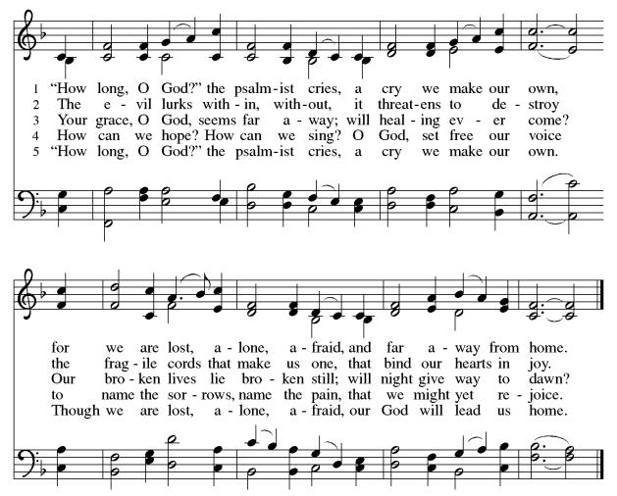

*CONFESSION AND FORGIVENESS
Blessed be the holy Trinity, ☩ one God, who forgives all our sin, whose mercy endures forever.
Amen.
Let us confess our sin in the presence of God and of one another.
Silence is kept for reflection.
Most merciful God,
we confess that we are captive to sin and cannot free ourselves. We have sinned against you in thought, word, and deed, by what we have done and by what we have left undone. We have not loved you with our whole heart; we have not loved our neighbors as ourselves. For the sake of your Son, Jesus Christ, have mercy on us. Forgive us, renew us, and lead us, so that we may delight in your will and walk in your ways, to the glory of your holy name. Amen.
God, who is rich in mercy, loved us even when we were dead in sin, and made us alive together with Christ. By grace you have been saved. In the name of ☩ Jesus Christ, your sins are forgiven. Almighty God strengthen you with power through the Holy Spirit, that Christ may live in your hearts through faith.
Amen.

*GREETING
The grace of our Lord Jesus Christ, the love of God, and the communion of the Holy Spirit be with you all.
And also with you.

*KYRIE ELW Pg. 184
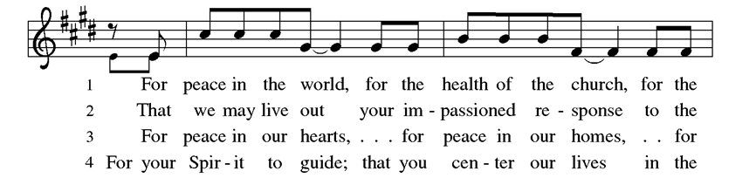
(vs. 2 & 4)

*PRAYER OF THE DAY
Let us pray,
O Lord God, tireless guardian of your people, you are always ready to hear our cries. Teach us to rely day and night on your care. Inspire us to seek your enduring justice for all this suffering world, through Jesus Christ, our Savior and Lord. Amen.

WORD
God speaks to us in scripture reading, preaching, and song.

CHILDREN’S CHAT
All children are welcomed forward for a children’s time. After that, they will be invited to Sunday school and will return during the passing of the peace.

FIRST READING Genesis 32:22-31 Pew Bible Old Testament Pg. 33

SECOND READING 2 Timothy 3:14—4:5 Pew Bible New Testament Pg. 229

Word of God, word of life. Thanks be to God.
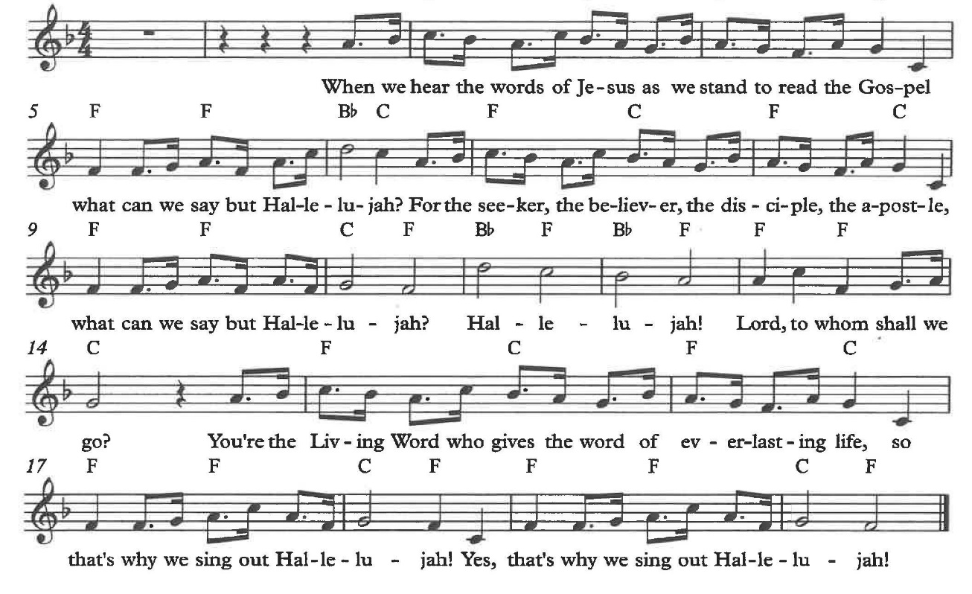
*GOSPEL ACCLAMATION Alleluia

*GOSPEL Luke 18:1-8 Pew Bible New Testament Pg. 83

The Holy Gospel according to Luke, the 18th chapter. Glory to you, O Lord.
The reading concludes: The Gospel of the Lord. Praise to you, O Christ.

SERMON Rev. Don Koepke

*SERMON HYMN Give Me Jesus ELW #770
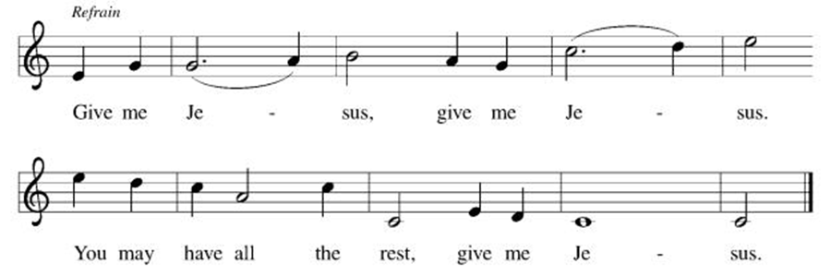
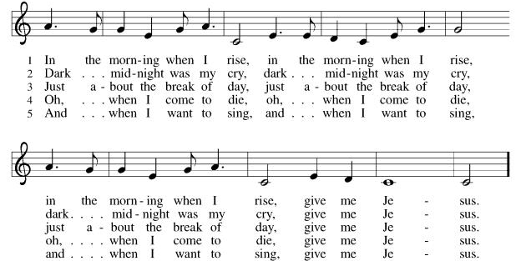
(vs. 1,2,3,5)

*APOSTLES’ CREED

I believe in God, the Father almighty, creator of heaven and earth.

I believe in Jesus Christ, God’s only Son, our Lord, who was conceived by the Holy Spirit, born of the virgin Mary, suffered under Pontius Pilate, was crucified, died, and was buried; he descended to the dead. On the third day he rose again; he ascended into heaven, he is seated at the right hand of the Father, and he will come to judge the living and the dead.

I believe in the Holy Spirit, the holy catholic church, the communion of saints, the forgiveness of sins, the resurrection of the body, and the life everlasting. Amen.

PRAYERS OF THE CHURCH

Renewed in God’s everlasting grace, let us pray for the church, the world, and all creation.
A brief silence.
God of grace,
receive our prayer.

We offer our prayers, O God, trusting in your everlasting grace and mercy, through Jesus Christ our Lord.
Amen.

*SHARING OF THE PEACE

The peace of Christ be with you always. And also with you.

OFFERTORY You Are Holy Chancel Choir

*OFFERTORY RESPONSE We Give Thee But Thine Own ELW #686
(vs.1 & 2)

*OFFERTORY PRAYER

Let us pray together,
Lord of the harvest, we return to you a portion of what you have given to us.
Turn us to set our hope not on the uncertainty of riches, but on you, who richly provides for us. Multiply what we have gathered to bless all who are suffering and in need, through Jesus Christ our Lord. Amen.

MEAL
God feeds us with the presence of Jesus.

*THE GREAT THANKSGIVING

The Lord be with you. And also with you.
Lift up your hearts. We lift them to the Lord,
Let us give thanks to the Lord our God.
It is right to give our thanks and praise.

It is indeed right, our duty and our joy …
we praise your name and join their unending hymn:

*HOLY, HOLY, HOLY ELW Pg. 190

*THANKSGIVING AT THE TABLE

Holy, mighty, and merciful Lord…

…with you and the Holy Spirit, be all honor and glory, now and forever. Amen.

*LORD’S PRAYER
Our Father in heaven, hallowed be your name, your kingdom come, your will be done, on earth as in heaven. Give us today our daily bread. Forgive us our sins
as we forgive those who sin against us. Save us from the time of trial and deliver us from evil. For the kingdom, the power, and the glory are yours, now and forever. Amen.

DISTRIBUTION OF HOLY COMMUNION
We believe that this is Jesus' table. All are welcome and invited to commune. We serve communion by “intinction”; receive the bread and dip it in the chalice. Gluten free wafers are available; let your server know. Wine is offered on each side. White grape juice is offered at the center aisle. Should you choose not to commune, you are invited to come forward to receive a blessing. Please cross your arms across your chest to let us know to give you that blessing.

INVITATION TO COMMUNION
Jesus welcomes sinners and eats with them. Come to this meal of mercy.


*lamb of god ELW Pg. 191

COMMUNION SONG Precious Lord, Take My Hand ELW #773

Precious Lord, take my hand,
Lead me on, let me stand;
I am tired, I am weak, I am worn.
Through the storm, through the night,
Lead me on to the light.
Take my hand, precious Lord; Lead me home.

When my way grows drear,
Precious Lord, linger near,
When my life is almost gone,
Hear my cry, hear my call;
Hold my hand lest I fall.
Take my hand, precious Lord; Lead me home.

When the darkness appears
And the night draws near,
And the day is past and gone,
At the river I stand;
Guide my feet, hold my hand,
Take my hand, precious Lord; Lead me home.

*POST COMMUNION BLESSING
The body and blood of our Lord Jesus Christ strengthen you and keep you in his grace. Amen.

*PRAYER AFTER COMMUNION

Let us pray,
O God, through this meal you have strengthened us and appointed us to be your servants. Send us to do good and to share our possessions with all in need. We ask this in Jesus’ name. Amen.

SENDING
God blesses us and sends us in mission to the world.

*BLESSING

The God of righteousness, who gives justice to the oppressed, who gives food to the hungry, who sets the prisoners free, ☩ bless you now and forever.
Amen.

*SENDING HYMN You Are Holy (Reprise)

You are holy (You are holy)
You are mighty (You are mighty)
You are worthy (You are worthy)
Worthy of praise (Worthy of praise)
And I will follow (I will follow)
I will listen (I will listen)
I will love you (I will love you)
All of my days (All of my days)
(High voices)
I will sing to and worship
The King who is worthy
And I will and adore Him
And I will bow down before Him
And I will sing to and worship
(Low voices)
You are Lord of Lords, You are King of Kings
You are mighty God, Lord of ev’rything
You’re Emmanuel, You’re the great "I AM"
You’re the Prince of Peace who is the Lamb
You’re the living God, You’re my saving grace
You will reign forever, You are ancient of days
You are Alpha, Omega, Beginning and End
You’re my Savior, Messiah, Redeemer, and friend
The King who is worthy
And I will and adore Him
And I will bow down before Him

(Both:)
You’re my Prince of Peace
And I will live my life for you.

*Dismissal

Go in peace. Do not lose heart.
Thanks be to God.

POSTLUDE Roger Halvorson

CHRIST LUTHERAN CHURCH STAFF

Pastor Rev. Nikki Fielder, pastor@christlutheranlb.com
Office Manager Kim Croes, officemanager@christlutheranlb.com
Preschool Director Lisa Clinton, info@clplb.com
Director of Senior Adult Ministry Shannon Howard
Choir Director Kim Philips, kimsings@msn.com
Accompanist Roger Halvorson
A/V Technicians Brad Croes and Jett Baker
Missionary to Colombia Linda Gawthorne

Mission Statement
Living by Christ’s example, we welcome, serve, and love all through God’s grace.

Vision Statement
Embracing the truth that God’s love and grace is for all, Christ Lutheran Church is a vibrant and active community spreading the good news through acceptance, action, and benevolence.

Our Position
Christ is ALIVE!

Reconciling in Christ (RIC) Welcome Statement
Christ Lutheran Church is a congregation who joyfully welcomes everyone who enters our doors. We recognize that each of us is a unique creation made in the image of God. We celebrate and give thanks for the many diverse gifts that God has bestowed on us. We proclaim ourselves to be an open and affirming congregation to all of God's children, welcoming into our ministry persons of every race, culture age, gender identity, gender expression, sexual orientation, ability, and economic status. We commit ourselves to the work of anti-racism and creating an anti-racist space. We believe that through our openness we all grow in our faith through Christ's teaching to love one another as God loves us.

