Eighteenth Sunday after Pentecost
October 12, 2025
9:30am

Christ Lutheran Church
6500 E. Stearns Street
Long Beach, California 90815
Phone 562-598-2433
www.christlutheranlb.com

Preschool 562-594-6117
www.clplb.com

Welcome to worship! We’re glad you’re here!
To assist in your worship:
bold print means we respond together
* means rise in body or spirit,
+ you may make the sign of the cross should you so desire.

It is our joy to worship with your whole family!

We encourage everyone of all ages and abilities to worship together.
We offer a “pray-ground” located in the back left of the Sanctuary for those with littles to have some room for movement and activity. The Narthex (gathering space at the entry) also has some resources for families, including activity bags filled with crayons, paper and storybooks. These supplies can be used in the Narthex or brought into the Sanctuary. For those that find themselves in the Narthex, there is a speaker with which you can still hear the service. Lastly, a changing table is located in the restroom off the Narthex. Please ask an usher if you need any assistance.

TODAY’S worship THEME
It’s a miracle! Multiple miracles! The waters of holy baptism have healed us. The body and blood of Jesus in holy communion have made us clean. We have died with Christ and been raised with him. For all this we have returned to offer thanks. From this place we are sent on our way rejoicing to share the good news.

Worship services for Christ Lutheran Church- Long Beach
are live-streamed and archived to YouTube.
By entering the sanctuary and by your presence here,
you consent to be photographed,
filmed, and/or otherwise recorded.
Please alert an usher if this is of concern to you.

Our liturgy is taken from:
Sundays and Seasons.com. Copyright 2025 Augsburg Fortress. All rights reserved.
Reprinted by permission under Augsburg Fortress Liturgies Annual License #20338.
Reprinted by permission under CCLI license # 230154. All rights reserved.
Reprinted by permission under © 2025 One License #A-706154. All rights reserved.
Kildare: Alleluia, written by Rev. Steve Beckham.
PRELUDE Roger Halvorson

WELCOME AND ANNOUNCEMENTS

GATHERING
The Holy Spirit calls us together as the people of God.

*GATHERING SONG Oh, Sing to the Lord ELW #822
(verses 1, 2, 4, 5)

*CONFESSION AND FORGIVENESS
Blessed be the holy Trinity, ☩ one God, who forgives all our sin, whose mercy endures forever.
Amen.
Let us confess our sin in the presence of God and of one another.
Silence is kept for reflection.
Most merciful God,
we confess that we are captive to sin and cannot free ourselves. We have sinned against you in thought, word, and deed, by what we have done and by what we have left undone. We have not loved you with our whole heart; we have not loved our neighbors as ourselves. For the sake of your Son, Jesus Christ, have mercy on us. Forgive us, renew us, and lead us, so that we may delight in your will and walk in your ways, to the glory of your holy name. Amen.
God, who is rich in mercy, loved us even when we were dead in sin, and made us alive together with Christ. By grace you have been saved. In the name of ☩ Jesus Christ, your sins are forgiven. Almighty God strengthen you with power through the Holy Spirit, that Christ may live in your hearts through faith.
Amen.

*GREETING
The grace of our Lord Jesus Christ, the love of God, and the communion of the Holy Spirit be with you all.
And also with you.
*KYRIE ELW Pg. 184 (verses 3 & 4)
*PRAYER OF THE DAY
Let us pray,
Almighty and most merciful God, your bountiful goodness fills all creation. Keep us safe from all that may hurt us, that, whole and well in body and spirit, we may with grateful hearts accomplish all that you would have us do, through Jesus Christ, our Savior and Lord. Amen.

WORD
God speaks to us in scripture reading, preaching, and song.

CHILDREN’S CHAT
All children are welcomed forward for a children’s time. After that, they will be invited to Sunday school and will return during the passing of the peace.

FIRST READING 2 Kings 5:1-3, 7-15c Pew Bible Old Testament Pg. 974

SECOND READING Psalm 111 Pew Bible New Testament Pg. 229
¹ Praise the Lord!
I will give thanks to the Lord with my whole heart, in the company of the upright, in the congregation.
² Great are the works of the Lord, studied by all who delight in them.
³ Full of honor and majesty is his work, and his righteousness endures forever.
⁴ He has gained renown by his wonderful deeds; the Lord is gracious and merciful.
⁵ He provides food for those who fear him; he is ever mindful of his covenant.
⁶ He has shown his people the power of his works, in giving them the heritage of the nations.
⁷ The works of his hands are faithful and just; all his precepts are trustworthy.
⁸ They are established forever and ever, to be performed with faithfulness and uprightness.
⁹ He sent redemption to his people; he has commanded his covenant forever. Holy and awesome is his name.
¹⁰ The fear of the Lord is the beginning of wisdom; all those who practice it have a good understanding. His praise endures forever.

Word of God, word of life. Thanks be to God.

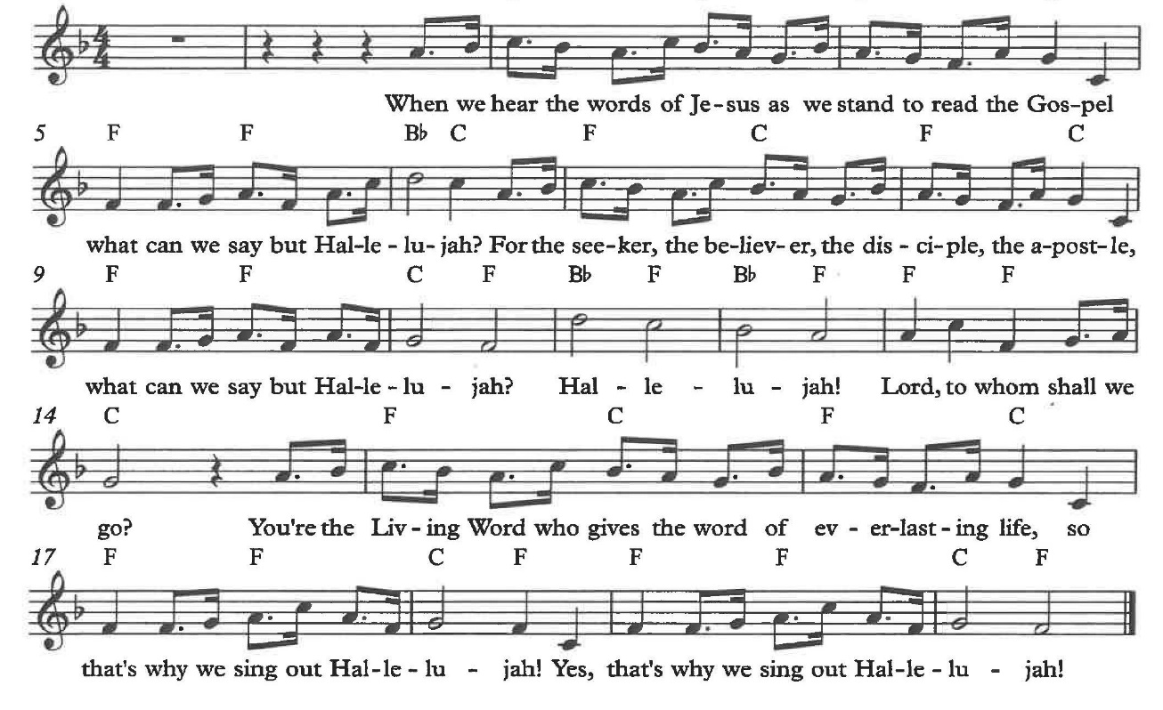
*GOSPEL ACCLAMATION Alleluia

*GOSPEL Luke 17:11-19 Pew Bible New Testament Pg. 82

The Holy Gospel according to Luke, the 17th chapter. Glory to you, O Lord.
The reading concludes: The Gospel of the Lord. Praise to you, O Christ.

SERMON Pastor Nikki Fielder

*SERMON HYMN Baptized and Set Free ELW #453

*APOSTLES’ CREED

I believe in God, the Father almighty, creator of heaven and earth.

I believe in Jesus Christ, God’s only Son, our Lord, who was conceived by the Holy Spirit, born of the virgin Mary, suffered under Pontius Pilate, was crucified, died, and was buried; he descended to the dead. On the third day he rose again; he ascended into heaven, he is seated at the right hand of the Father, and he will come to judge the living and the dead.

I believe in the Holy Spirit, the holy catholic church, the communion of saints, the forgiveness of sins, the resurrection of the body, and the life everlasting. Amen.
PRAYERS OF THE CHURCH

Renewed in God’s everlasting grace, let us pray for the church, the world, and all creation.
A brief silence.
God of grace,
receive our prayer.

We offer our prayers, O God, trusting in your everlasting grace and mercy, through Jesus Christ our Lord.
Amen.

*SHARING OF PEACE

The peace of Christ be with you always. And also with you.

OFFERTORY Roger Halvorson

*OFFERTORY RESPONSE We Give Thee But Thine Own ELW #686
(vs.1 & 2)

*OFFERTORY PRAYER

Let us pray together,
Lord of the harvest, we return to you a portion of what you have given to us.
Turn us to set our hope not on the uncertainty of riches, but on you, who richly provides for us. Multiply what we have gathered to bless all who are suffering and in need, through Jesus Christ our Lord. Amen.

MEAL
God feeds us with the presence of Jesus.

*THE GREAT THANKSGIVING

The Lord be with you. And also with you.
Lift up your hearts. We lift them to the Lord,
Let us give thanks to the Lord our God.
It is right to give our thanks and praise.

It is indeed right, our duty and our joy …
we praise your name and join their unending hymn:

*HOLY, HOLY, HOLY ELW Pg. 190

*THANKSGIVING AT THE TABLE

Holy, mighty, and merciful Lord…

…with you and the Holy Spirit, be all honor and glory, now and forever. Amen.

*LORD’S PRAYER
Our Father in heaven, hallowed be your name, your kingdom come, your will be done, on earth as in heaven. Give us today our daily bread. Forgive us our sins
as we forgive those who sin against us. Save us from the time of trial and deliver us from evil. For the kingdom, the power, and the glory are yours, now and forever. Amen.

DISTRIBUTION OF HOLY COMMUNION
We believe that this is Jesus' table. All are welcome and invited to commune. We serve communion by “intinction”; receive the bread and dip it in the chalice. Gluten free wafers are available; let your server know. Wine is offered on each side. White grape juice is offered at the center aisle. Should you choose not to commune, you are invited to come forward to receive a blessing. Please cross your arms across your chest to let us know to give you that blessing.

HEALING PRAYER
This morning we offer healing prayer. If you would like our healing minister to pray with and for you, please go to the right transept after taking communion.

INVITATION TO COMMUNION
Jesus welcomes sinners and eats with them. Come to this meal of mercy.

*lamb of god ELW Pg. 191

COMMUNION SONG Here is Bread W&P #58

*POST COMMUNION BLESSING
The body and blood of our Lord Jesus Christ strengthen you and keep you in his grace. Amen.

*PRAYER AFTER COMMUNION

Let us pray,
O God, through this meal you have strengthened us and appointed us to be your servants. Send us to do good and to share our possessions with all in need. We ask this in Jesus’ name. Amen.

SENDING
God blesses us and sends us in mission to the world.

*BLESSING

The God of righteousness, who gives justice to the oppressed, who gives food to the hungry, who sets the prisoners free, ☩ bless you now and forever.
Amen.

*SENDING HYMN I’m So Glad Jesus Lifted Me ELW #860

*Dismissal

Go in peace. Do not lose heart.
Thanks be to God.

POSTLUDE Roger Halvorson

CHRIST LUTHERAN CHURCH STAFF

Pastor Rev. Nikki Fielder, pastor@christlutheranlb.com
Office Manager Kim Croes, officemanager@christlutheranlb.com
Preschool Director Lisa Clinton, info@clplb.com
Choir Director Kim Philips, kimsings@msn.com
Accompanist Roger Halvorson
A/V Technicians Brad Croes and Josh Baker
Missionary to Colombia Linda Gawthorne

Mission Statement
Living by Christ’s example, we welcome, serve, and love all through God’s grace.

Vision Statement
Embracing the truth that God’s love and grace is for all, Christ Lutheran Church is a vibrant and active community spreading the good news through acceptance, action, and benevolence.

Our Position
Christ is ALIVE!

Reconciling in Christ (RIC) Welcome Statement
Christ Lutheran Church is a congregation who joyfully welcomes everyone who enters our doors. We recognize that each of us is a unique creation made in the image of God. We celebrate and give thanks for the many diverse gifts that God has bestowed on us. We proclaim ourselves to be an open and affirming congregation to all of God's children, welcoming into our ministry persons of every race, culture age, gender identity, gender expression, sexual orientation, ability, and economic status. We commit ourselves to the work of anti-racism and creating an anti-racist space. We believe that through our openness we all grow in our faith through Christ's teaching to love one another as God loves us.

