All Saints Sunday
November 2, 2025
9:30am


Christ Lutheran Church
6500 E. Stearns Street
Long Beach, California 90815
Phone 562-598-2433
www.christlutheranlb.com

Preschool 562-594-6117
www.clplb.com

Welcome to worship! We’re glad you’re here!
To assist in your worship:
bold print means we respond together
* means rise in body or spirit,
+ you may make the sign of the cross should you so desire.

It is our joy to worship with your whole family!

We encourage everyone of all ages and abilities to worship together.
We offer a “pray-ground” located in the back left of the Sanctuary for those with littles to have some room for movement and activity. The Narthex (gathering space at the entry) also has some resources for families, including activity bags filled with crayons, paper and storybooks. These supplies can be used in the Narthex or brought into the Sanctuary. For those that find themselves in the Narthex, there is a speaker with which you can still hear the service. Lastly, a changing table is located in the restroom off the Narthex. Please ask an usher if you need any assistance.

TODAY’S worship THEME
In holy baptism God makes saints out of sinners. In holy communion God forgives the sins of all the saints. In worship today we give thanks for all the saints “who from their labors rest.” In the same breath we petition our God for the strength to hear and to heed the admonitions of Jesus in today’s gospel. Sealed by the Spirit and sustained by the Savior’s body and blood, we live with joy as God gives us breath, to the praise of God’s glory.

Worship services for Christ Lutheran Church- Long Beach
are live-streamed and archived to YouTube.
By entering the sanctuary and by your presence here,
you consent to be photographed,
filmed, and/or otherwise recorded.
Please alert an usher if this is of concern to you.

Our liturgy is taken from:
Sundays and Seasons.com. Copyright 2025 Augsburg Fortress. All rights reserved.
Reprinted by permission under Augsburg Fortress Liturgies Annual License #20338.
Reprinted by permission under CCLI license # 230154. All rights reserved.
Reprinted by permission under © 2025 One License #A-706154. All rights reserved.
Kildare: Alleluia, written by Rev. Steve Beckham.

PRELUDE Roger Halvorson

WELCOME AND ANNOUNCEMENTS

GATHERING
The Holy Spirit calls us together as the people of God.

*GATHERING SONG Bind Us Together W&P #18

Refrain:
Bind us together, Lord. Bind us together with cords that cannot be broken.
Bind us together, Lord. Bind us together, Lord, bind us together with love.

Verse 1
There is only on God. There is only one King.
There is only one Body: that is why we can sing:
(Refrain)
Verse 2
You are the fam’ly of God. You are the promise divine.
You are God’s chosen desire, you are the glorious new wine.
(Refrain)

*CONFESSION AND FORGIVENESS
Blessed be the holy Trinity, ☩ one God, who forgives all our sin, whose mercy endures forever.
Amen.
Let us confess our sin in the presence of God and of one another.
Silence is kept for reflection.

Faithful God,
you have shown us the ways of your heart, yet we stray from your paths.
We are stuck in sinful systems of oppression and do not embrace the freedom of your faithful promises. We ignore our neighbors. We exploit the earth.
We reject your abundance, trusting our impulses instead of your steadfast love. Repair our relationships, restore what we have broken, renew our hearts, and bring us to new life. Amen.

Hear the good news: God the Faithful One loves you, ☩ in Christ Jesus your sins are forgiven, and by the power of the Holy Spirit you are set free.
Amen.

*GREETING
The grace of our Lord Jesus Christ, the love of God, and the communion of the Holy Spirit be with you all.
And also with you.

*KYRIE ELW Pg. 184
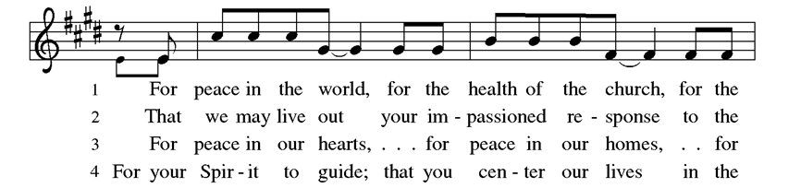
(vs. 3 & 4)
*PRAYER OF THE DAY
Let us pray,
Almighty God, you have knit your people together in one communion in the mystical body of your Son, Jesus Christ our Lord. Grant us grace to follow your blessed saints in lives of faith and commitment, and to know the inexpressible joys you have prepared for those who love you, through Jesus Christ, our Savior and Lord, who lives and reigns with you and the Holy Spirit, one God, now and forever. Amen.

WORD
God speaks to us in scripture reading, preaching, and song.

CHILDREN’S CHAT
All children are welcomed forward for a children’s time. After that, they will be invited to Sunday school and will return during the passing of the peace.

Psalm Psalm 149:1-5

¹ Hallelujah! Sing to the Lord a new song,
God’s praise in the assembly of the faithful.
² Let Israel rejoice in their maker;
let the children of Zion be joyful in their ruler.
³ Let them praise their maker’s name with dancing;
let them sing praise with tambourine and harp.
⁴ For the Lord takes pleasure in the people
and adorns the poor with victory.
⁵ Let the faithful rejoice in triumph;
let them sing for joy on their beds.

READING Ephesians 1:11-23
Word of God, word of life. Thanks be to God.

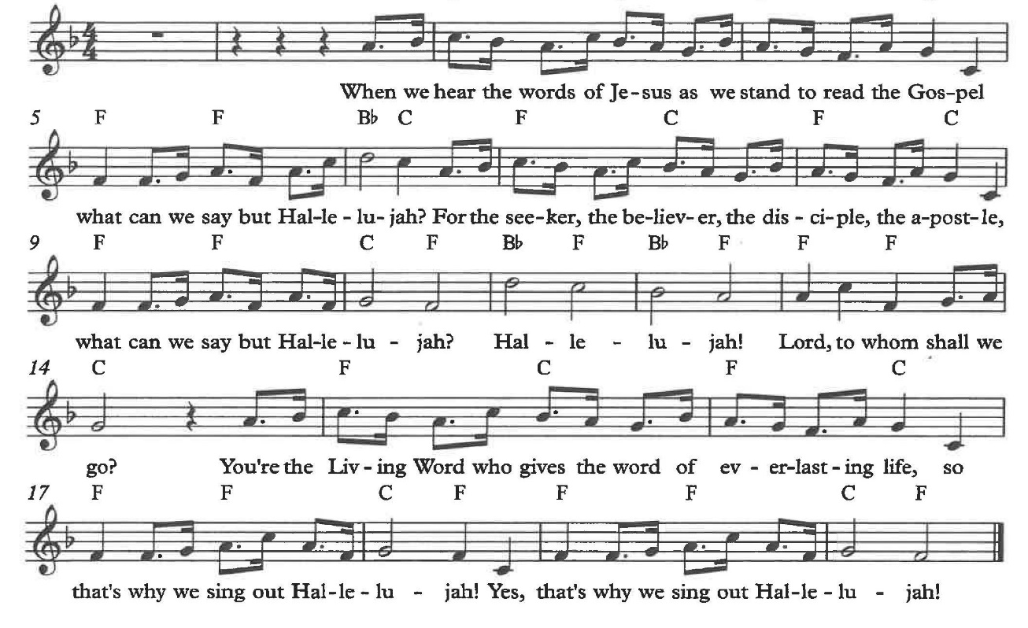
*GOSPEL ACCLAMATION Alleluia Kildare by Rev. Steve Beckham

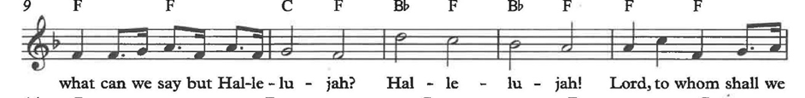
*GOSPEL Luke 6:20-31

The Holy Gospel according to Luke, the 6th chapter. Glory to you, O Lord.
The reading concludes: The Gospel of the Lord. Praise to you, O Christ.

SERMON Pastor Nikki Fielder



*SERMON HYMN The Church’s One Foundation ELW #654
(vs. 1,2,4,5)

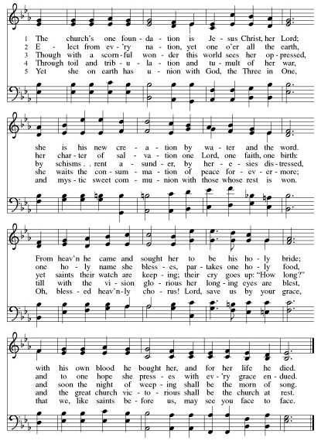
*APOSTLES’ CREED

I believe in God, the Father almighty, creator of heaven and earth.

I believe in Jesus Christ, God’s only Son, our Lord, who was conceived by the Holy Spirit, born of the virgin Mary, suffered under Pontius Pilate, was crucified, died, and was buried; he descended to the dead. On the third day he rose again; he ascended into heaven, he is seated at the right hand of the Father, and he will come to judge the living and the dead.

I believe in the Holy Spirit, the holy catholic church, the communion of saints, the forgiveness of sins, the resurrection of the body, and the life everlasting. Amen.

PRAYERS OF THE CHURCH

Gathered with one voice, we offer our prayers for the church, the world, and all who are in need.
A brief silence.
Hear us, O God.
Your mercy is great.

We offer these and all our prayers to you, O God, trusting in your grace and unyielding love; through Jesus Christ, our Lord.
Amen.

*SHARING OF THE PEACE

The peace of Christ be with you always. And also with you.

OFFERTORY Breath of God Chancel Choir
(featuring Lonnie Timney on cello)

*OFFERTORY RESPONSE We Give Thee But Thine Own ELW #686
(vs.1 & 2)

*OFFERTORY PRAYER

Let us pray together,
God of healing and hope, you bless those who are hungry, promising to fill them with good things. Fulfill that promise through us and these your gifts. Nourish us with the abundance of your feast and unite us into the blessed body of Jesus Christ our Savior, now and forever. Amen.

MEAL
God feeds us with the presence of Jesus.

*THE GREAT THANKSGIVING

The Lord be with you. And also with you.
Lift up your hearts. We lift them to the Lord,
Let us give thanks to the Lord our God.
It is right to give our thanks and praise.

It is indeed right, our duty and our joy …
we praise your name and join their unending hymn:

*HOLY, HOLY, HOLY ELW Pg. 190

*THANKSGIVING AT THE TABLE

Holy, mighty, and merciful Lord…

…with you and the Holy Spirit, be all honor and glory, now and forever. Amen.

*LORD’S PRAYER
Our Father in heaven, hallowed be your name, your kingdom come, your will be done, on earth as in heaven. Give us today our daily bread. Forgive us our sins
as we forgive those who sin against us. Save us from the time of trial and deliver us from evil. For the kingdom, the power, and the glory are yours, now and forever. Amen.

DISTRIBUTION OF HOLY COMMUNION
We believe that this is Jesus' table. All are welcome and invited to commune. We serve communion by “intinction”; receive the bread and dip it in the chalice. Gluten free wafers are available; let your server know. Wine is offered on each side. White grape juice is offered at the center aisle. Should you choose not to commune, you are invited to come forward to receive a blessing. Please cross your arms across your chest to let us know to give you that blessing.

CANDLE LIGHTING
After you have received communion, you may light a candle in memory of someone in your life who has passed away.

INVITATION TO COMMUNION
There is a place for you at the table of God. Come, receive the food that does not perish, a taste of life eternal.

*lamb of god ELW Pg. 191

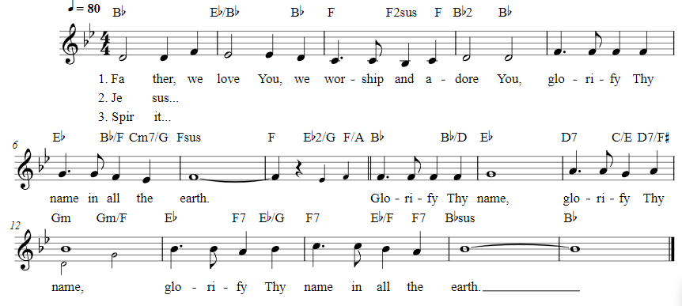
COMMUNION SONGS Glorify Thy Name W&P #42

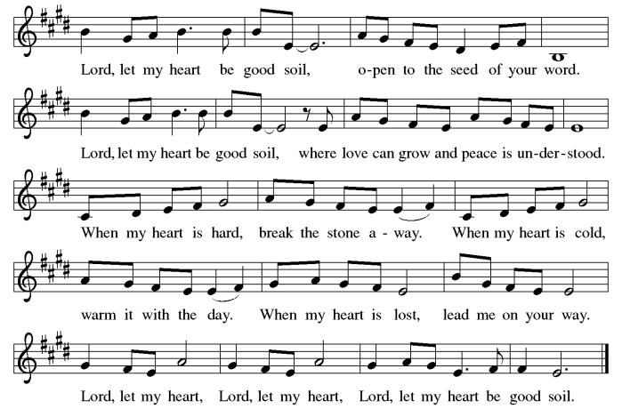
Lord, Let My Heart Be Good Soil ELW #512

*POST COMMUNION BLESSING
The body and blood of our Lord Jesus Christ strengthen you and keep you in his grace. Amen.

*PRAYER AFTER COMMUNION

Let us pray,
God of field and flower, wheat and grape, you have nourished us with the bread of heaven that gives life to the world. Strengthened by the body and blood of your Son, send us out to gather your good gifts for all who hunger and thirst, and embolden us to love and serve in Christ’s name. Amen.

SENDING
God blesses us and sends us in mission to the world.

*BLESSING

The love of God the Sovereign strengthen you, God the Son save you, and God the Holy Spirit anoint you for the work ahead. The holy Trinity bless you ☩ and grant you a faithful and courageous heart now and forever.
Amen.



*SENDING HYMN Oh, When the Saints Go Marching In
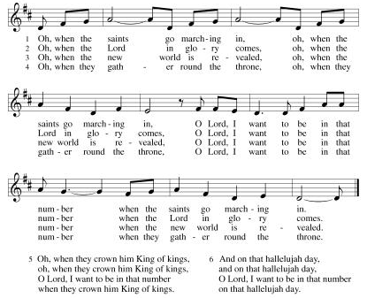

*Dismissal

Go in peace. Share the harvest.
Thanks be to God.

POSTLUDE Roger Halvorson

CHRIST LUTHERAN CHURCH STAFF

Pastor Rev. Nikki Fielder, pastor@christlutheranlb.com
Office Manager Kim Croes, officemanager@christlutheranlb.com
Preschool Director Lisa Clinton, info@clplb.com
Director of Senior Adult Ministry Shannon Howard, directorsam@christlutheranlb.com
Choir Director Kim Philips, kimsings@msn.com
Accompanist Roger Halvorson
A/V Technicians Brad Croes and Jett Baker
Missionary to Colombia Linda Gawthorne

Mission Statement
Living by Christ’s example, we welcome, serve, and love all through God’s grace.

Vision Statement
Embracing the truth that God’s love and grace is for all, Christ Lutheran Church is a vibrant and active community spreading the good news through acceptance, action, and benevolence.

Our Position
Christ is ALIVE!

Reconciling in Christ (RIC) Welcome Statement
Christ Lutheran Church is a congregation who joyfully welcomes everyone who enters our doors. We recognize that each of us is a unique creation made in the image of God. We celebrate and give thanks for the many diverse gifts that God has bestowed on us. We proclaim ourselves to be an open and affirming congregation to all of God's children, welcoming into our ministry persons of every race, culture age, gender identity, gender expression, sexual orientation, ability, and economic status. We commit ourselves to the work of anti-racism and creating an anti-racist space. We believe that through our openness we all grow in our faith through Christ's teaching to love one another as God loves us.

