Sixteenth Sunday after Pentecost
September 28, 2025
9:30am

Christ Lutheran Church
6500 E. Stearns Street
Long Beach, California 90815
Phone 562-598-2433
www.christlutheranlb.com

Preschool 562-594-6117
www.clplb.com

Welcome to worship! We’re glad you’re here!
To assist in your worship:
bold print means we respond together
* means rise in body or spirit,
+ you may make the sign of the cross should you so desire.

It is our joy to worship with your whole family!

We encourage everyone of all ages and abilities to worship together.
We offer a “pray-ground” located in the back left of the Sanctuary for those with littles to have some room for movement and activity. The Narthex (gathering space at the entry) also has some resources for families, including activity bags filled with crayons, paper and storybooks. These supplies can be used in the Narthex or brought into the Sanctuary. For those that find themselves in the Narthex, there is a speaker with which you can still hear the service. Lastly, a changing table is located in the restroom off the Narthex. Please ask an usher if you need any assistance.

TODAY’S worship THEME

Consideration of and care for those in need (especially those “at our gate,” visible to us, of whom we are aware) is an essential component of good stewardship. It is in the sharing of wealth that we avoid the snare of wealth. It is the one whom death could not hold—who comes to us risen from the dead—who can free us from the death grip of greed.

Worship services for Christ Lutheran Church- Long Beach
are live-streamed and archived to YouTube.
By entering the sanctuary and by your presence here,
you consent to be photographed,
filmed, and/or otherwise recorded.
Please alert an usher if this is of concern to you.

Our liturgy is taken from:
Sundays and Seasons.com. Copyright 2025 Augsburg Fortress. All rights reserved.
Reprinted by permission under Augsburg Fortress Liturgies Annual License #20338.
Reprinted by permission under CCLI license # 230154. All rights reserved.
Reprinted by permission under © 2025 One License #A-706154. All rights reserved.
Kildare: Alleluia, written by Rev. Steve Beckham.
PRELUDE Roger Halvorson

WELCOME AND ANNOUNCEMENTS

GATHERING
The Holy Spirit calls us together as the people of God.

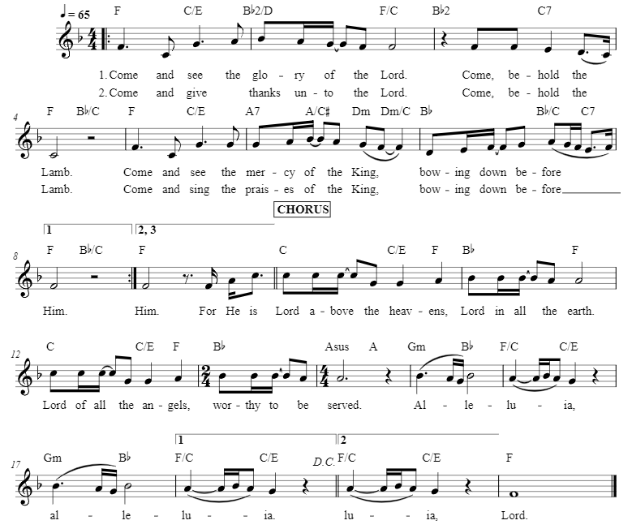
*GATHERING SONG Come and See W&P #29

*CONFESSION AND FORGIVENESS
Blessed be the holy Trinity, ☩ one God, our maker, our helper, and our keeper.
Amen.

Trusting in God’s mercy, let us confess our sin in the presence of God and of one another.

Silence is kept for reflection.
Merciful and loving God,
we are your stiff-necked people. We trample on the needy. We grumble about your grace to others. We turn away from the poor. Have mercy on us and forgive our sins. Rejoice over us as ones who were lost and have been found. Amen.

Even when we are faithless, God remains faithful. Jesus Christ came into the world to save sinners. You who were lost have been found. In the name of ☩ Jesus, your sins are forgiven!
Amen.

*GREETING
The grace of our Lord Jesus Christ, the love of God, and the communion of the Holy Spirit be with you all.
And also with you.

*KYRIE ELW Pg. 184 (verses 1 & 2)
*PRAYER OF THE DAY
Let us pray,
O God, rich in mercy, you look with compassion on this troubled world. Feed us with your grace, and grant us the treasure that comes only from you, through Jesus Christ, our Savior and Lord. Amen.

WORD
God speaks to us in scripture reading, preaching, and song.

CHILDREN’S CHAT
All children are welcomed forward for a children’s time. After that, they will be invited to Sunday school and will return during the passing of the peace.

FIRST READING Psalm 146 Pew Bible Old Testament Pg. 644

¹ Praise the Lord! Praise the Lord, O my soul!
² I will praise the Lord as long as I live; I will sing praises to my God all my life
long.
³ Do not put your trust in princes, in mortals, in whom there is no help.
⁴ When their breath departs, they return to the earth; on that very day their plans
perish.
⁵ Happy are those whose help is the God of Jacob, whose hope is in the Lord their God,
⁶ who made heaven and earth, the sea, and all that is in them; who keeps faith
forever;
⁷ who executes justice for the oppressed; who gives food to the hungry. The Lord sets
the prisoners free;
⁸ the Lord opens the eyes of the blind. The Lord lifts up those who are bowed
down; the Lord loves the righteous.
⁹ The Lord watches over the strangers; he upholds the orphan and the widow, but the
way of the wicked he brings to ruin.
¹⁰ The Lord will reign forever, your God, O Zion, for all generations. Praise
the Lord!

SECOND READING 1 Timothy 6:6-19 Pew Bible New Testament Pg. 226
Word of God, word of life. Thanks be to God.

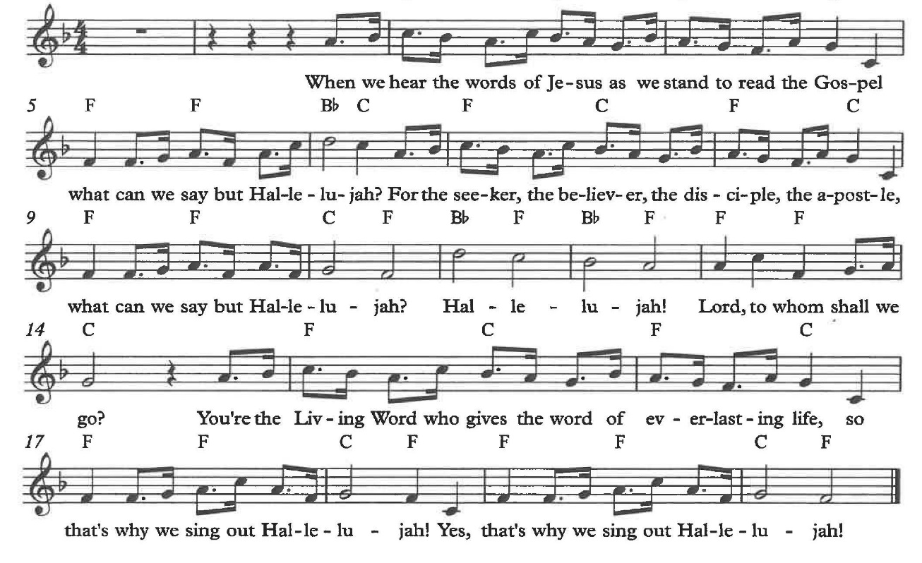
*GOSPEL ACCLAMATION Alleluia
*GOSPEL Luke 16:19-31 Pew Bible New Testament Pg. 81

The Holy Gospel according to Luke, the 16th chapter. Glory to you, O Lord.
The reading concludes: The Gospel of the Lord. Praise to you, O Christ.

SERMON Pastor Nikki Fielder

*SERMON HYMN Build a Longer Table ACS #1062

*APOSTLES’ CREED

I believe in God, the Father almighty, creator of heaven and earth.

I believe in Jesus Christ, God’s only Son, our Lord, who was conceived by the Holy Spirit, born of the virgin Mary, suffered under Pontius Pilate, was crucified, died, and was buried; he descended to the dead. On the third day he rose again; he ascended into heaven, he is seated at the right hand of the Father, and he will come to judge the living and the dead.

I believe in the Holy Spirit, the holy catholic church, the communion of saints, the forgiveness of sins, the resurrection of the body, and the life everlasting. Amen.
PRAYERS OF THE CHURCH

Gracious God, we come to you in prayer for the church, the world, and all in need.
A brief silence.
God of grace,
receive our prayer.

We entrust these prayers to you, O God, in the name of Jesus Christ, our redeemer and friend.
Amen.

*SHARING OF PEACE

The peace of Christ be with you always. And also with you.

OFFERTORY Roger Halvorson

*OFFERTORY RESPONSE We Give Thee But Thine Own ELW #686
( vs.1 & 2)

*OFFERTORY PRAYER

Let us pray together,
Lord of the harvest, we return to you a portion of what you have given to us.
Turn us to set our hope not on the uncertainty of riches, but on you, who richly provides for us. Multiply what we have gathered to bless all who are suffering and in need, through Jesus Christ our Lord. Amen.

MEAL
God feeds us with the presence of Jesus.

*THE GREAT THANKSGIVING

The Lord be with you. And also with you.
Lift up your hearts. We lift them to the Lord,
Let us give thanks to the Lord our God.
It is right to give our thanks and praise.

It is indeed right, our duty and our joy …
we praise your name and join their unending hymn:

*HOLY, HOLY, HOLY ELW Pg. 190

*THANKSGIVING AT THE TABLE

Holy, mighty, and merciful Lord…

…with you and the Holy Spirit, be all honor and glory, now and forever. Amen.
*LORD’S PRAYER
Our Father in heaven, hallowed be your name, your kingdom come, your will be done, on earth as in heaven. Give us today our daily bread. Forgive us our sins
as we forgive those who sin against us. Save us from the time of trial and deliver us from evil. For the kingdom, the power, and the glory are yours, now and forever. Amen.

DISTRIBUTION OF HOLY COMMUNION
We believe that this is Jesus' table. All are welcome and invited to commune. We serve communion by “intinction”; receive the bread and dip it in the chalice. Gluten free wafers are available; let your server know. Wine is offered on each side. White grape juice is offered at the center aisle. Should you choose not to commune, you are invited to come forward to receive a blessing. Please cross your arms across your chest to let us know to give you that blessing.
HEALING PRAYER
This morning we offer healing prayer. If you would like our healing minister to pray with and for you, please go to the right transept after taking communion.

INVITATION TO COMMUNION
Jesus welcomes sinners and eats with them. Come to this meal of mercy.

*lamb of god ELW Pg. 191

COMMUNION SONG Beauty for Brokenness W&P #17

Verse 1
Beauty for brokenness
Hope for despair
Lord in Your suff'ring world
This is our prayer
Bread for the children
Justice joy peace
Sunrise to sunset
Your kingdom increase

Verse 2
Shelter for fragile lives
Cures for their ills
Work for the craftsmen
Trade for their skills
Land for the dispossessed
Rights for the weak
Voices to plead the cause
Of those who can't speak

Chorus
God of the poor
Friend of the weak
Give us compassion we pray
Melt our cold hearts
Let tears fall like rain
Come change our love
From a spark to a flame

Verse 3
Refuge from cruel wars
Havens from fear
Cities for sanctu'ry
Freedoms to share
Peace to the killing fields
Scorched earth to green
Christ for the bitterness
His cross for the pain
Chorus

Verse 4
Rest for the ravaged earth
Oceans and streams
Plundered and poisoned
Our future our dreams
Lord end our madness
Carelessness greed
Make us content with
The things that we need
Chorus

Verse 5
Lighten our darkness
Breathe on this flame
Until Your justice
Burns brightly again
Until the nations
Learn of Your ways
Seek Your salvation
And bring You their praise
Chorus

*POST COMMUNION BLESSING
The body and blood of our Lord Jesus Christ strengthen you and keep you in his grace. Amen.

*PRAYER AFTER COMMUNION

Let us pray,
O God, through this meal you have strengthened us and appointed us to be your servants. Send us to do good and to share our possessions with all in need. We ask this in Jesus’ name. Amen.

SENDING
God blesses us and sends us in mission to the world.

*BLESSING

The God of righteousness, who gives justice to the oppressed, who gives food to the hungry, who sets the prisoners free, ☩ bless you now and forever.
Amen.

*SENDING HYMN Lord, I Lift Your Name on High ELW #857
Lord, I lift your name on high,
Lord, I love to sing your praises.
I’m so glad you’re in my life,
I’m so glad you came to save us.
You came from heaven to earth to show the way,
from the earth to the cross, my debt to pay;
from the cross to the grave, from the grave to the to the sky; Lord I lift your name on high. Repeat all

*Dismissal

Go in peace. Do not lose heart.
Thanks be to God.

POSTLUDE Roger Halvorson

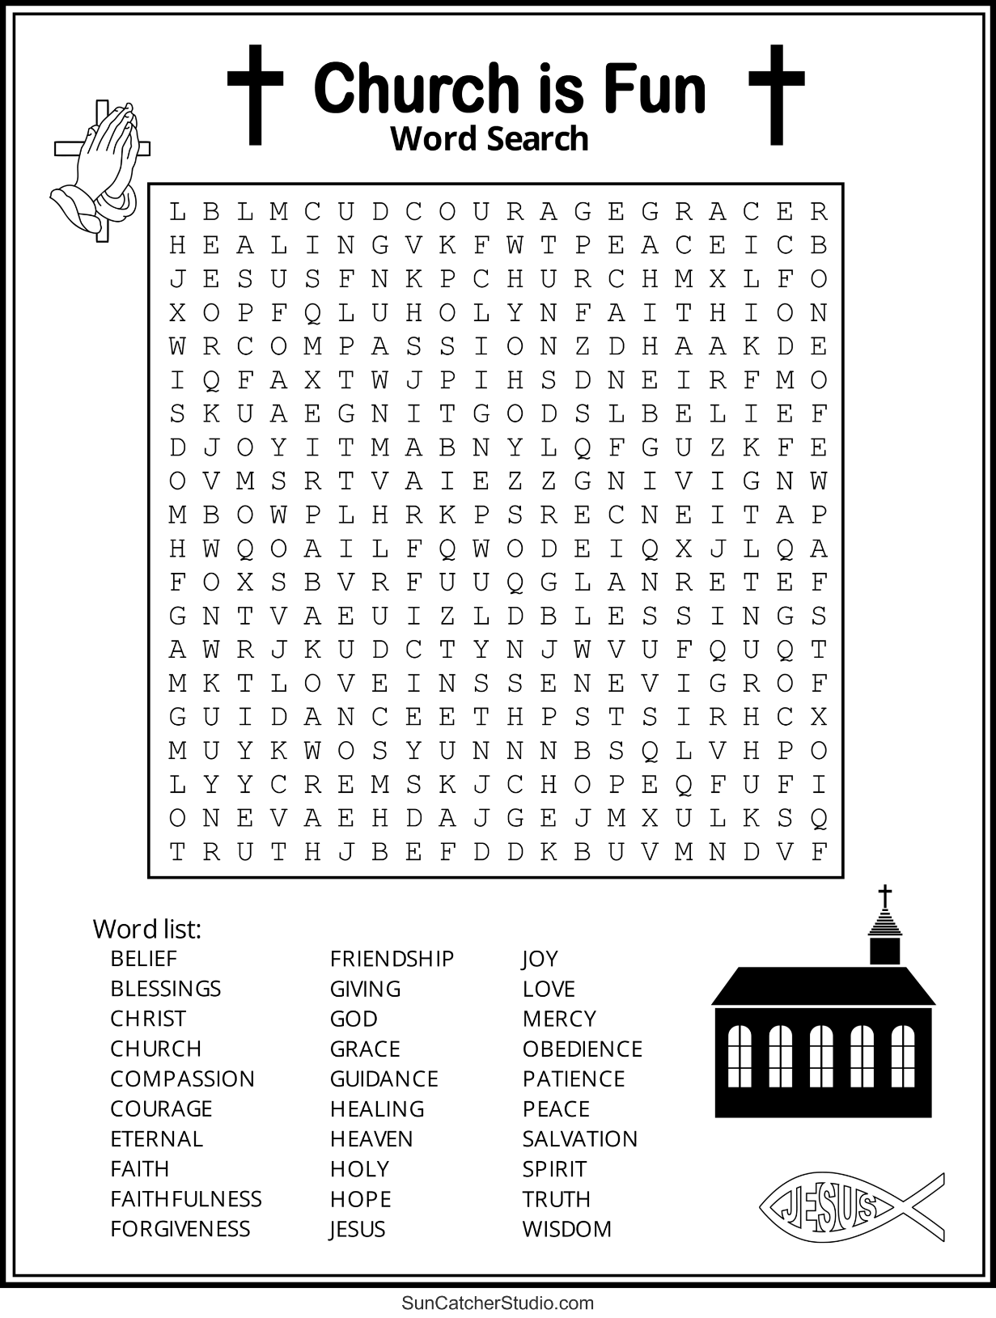
CHRIST LUTHERAN CHURCH STAFF

Pastor Rev. Nikki Fielder, pastor@christlutheranlb.com
Office Manager Kim Croes, officemanager@christlutheranlb.com
Preschool Director Lisa Clinton, info@clplb.com
Choir Director Kim Philips, kimsings@msn.com
Accompanist Roger Halvorson
A/V Technicians Brad Croes and Josh Baker
Missionary to Colombia Linda Gawthorne

Mission Statement
Living by Christ’s example, we welcome, serve, and love all through God’s grace.

Vision Statement
Embracing the truth that God’s love and grace is for all, Christ Lutheran Church is a vibrant and active community spreading the good news through acceptance, action, and benevolence.

Our Position
Christ is ALIVE!

Reconciling in Christ (RIC) Welcome Statement
Christ Lutheran Church is a congregation who joyfully welcomes everyone who enters our doors. We recognize that each of us is a unique creation made in the image of God. We celebrate and give thanks for the many diverse gifts that God has bestowed on us. We proclaim ourselves to be an open and affirming congregation to all of God's children, welcoming into our ministry persons of every race, culture, age, gender identity, gender expression, sexual orientation, ability, and economic status. We commit ourselves to the work of anti-racism and creating an anti-racist space. We believe that through our openness we all grow in our faith through Christ's teaching to love one another as God loves us.

