Fourteenth Sunday after Pentecost
September 14, 2025
9:30am

Christ Lutheran Church
6500 E. Stearns Street
Long Beach, California 90815
Phone 562-598-2433
www.christlutheranlb.com

Preschool 562-594-6117
www.clplb.com

Welcome to worship! We’re glad you’re here!
To assist in your worship:
bold print means we respond together
* means rise in body or spirit,
+ you may make the sign of the cross should you so desire.

It is our joy to worship with your whole family!

We encourage everyone of all ages and abilities to worship together.
We offer a “pray-ground” located in the back left of the Sanctuary for those with littles to have some room for movement and activity. The Narthex (gathering space at the entry) also has some resources for families, including activity bags filled with crayons, paper and storybooks. These supplies can be used in the Narthex or brought into the Sanctuary. For those that find themselves in the Narthex, there is a speaker with which you can still hear the service. Lastly, a changing table is located in the restroom off the Narthex. Please ask an usher if you need any assistance.

TODAY’S worship THEME

The grumbling of the religious leaders in today’s gospel is actually our holy hope: This Jesus welcomes sinners and eats with them. That our God seeks and saves the lost is not only a holy hope, it is our only hope. As the writer of 1 Timothy reminds us, “The saying is sure and worthy of full acceptance, that Christ Jesus came into the world to save sinners.” Thanks be to God.

Worship services for Christ Lutheran Church- Long Beach
are live-streamed and archived to YouTube.
By entering the sanctuary and by your presence here,
you consent to be photographed,
filmed, and/or otherwise recorded.
Please alert an usher if this is of concern to you.

Our liturgy is taken from:
Sundays and Seasons.com. Copyright 2025 Augsburg Fortress. All rights reserved.
Reprinted by permission under Augsburg Fortress Liturgies Annual License #20338.
Reprinted by permission under CCLI license # 230154. All rights reserved.
Reprinted by permission under © 2025 One License #A-706154. All rights reserved.
Islands of Faith: Kyrie, Alleluia, Holy, Holy, Holy, and Lamb of God, written by Rev. Steve Beckham.

PRELUDE Roger Halvorson

WELCOME AND ANNOUNCEMENTS

GATHERING
The Holy Spirit calls us together as the people of God.

*GATHERING SONG Come, Thou Fount of Every Blessing ELW #807

*CONFESSION AND FORGIVENESS
Blessed be the holy Trinity, ☩ one God, our maker, our helper, and our keeper.
Amen.

Trusting in God’s mercy, let us confess our sin in the presence of God and of one another.

Silence is kept for reflection.
Merciful and loving God,
we are your stiff-necked people. We trample on the needy. We grumble about your grace to others. We turn away from the poor Have mercy on us and forgive our sins. Rejoice over us as ones who were lost and have been found. Amen.

Even when we are faithless, God remains faithful. Jesus Christ came into the world to save sinners. You who were lost have been found. In the name of ☩ Jesus, your sins are forgiven!
Amen.

*GREETING
The grace of our Lord Jesus Christ, the love of God, and the communion of the Holy Spirit be with you all.
And also with you.

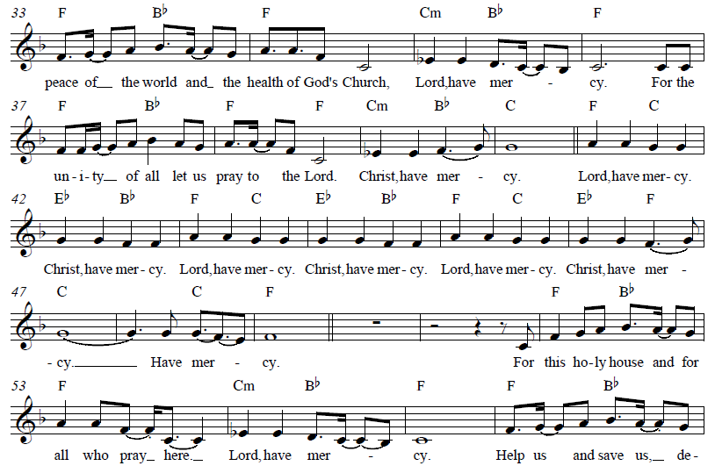
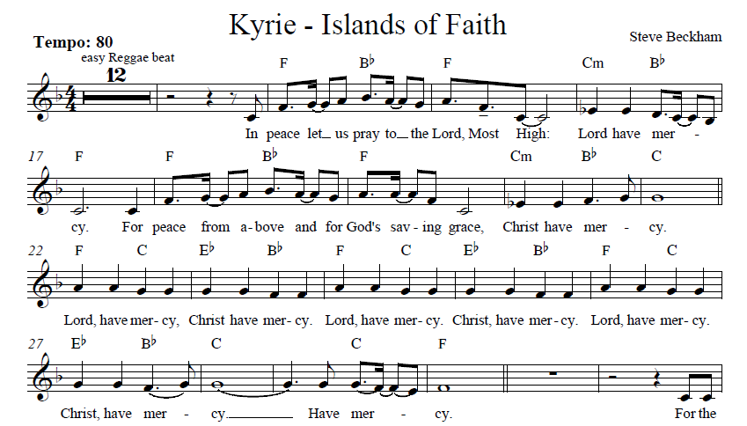
*KYRIE Islands of Faith
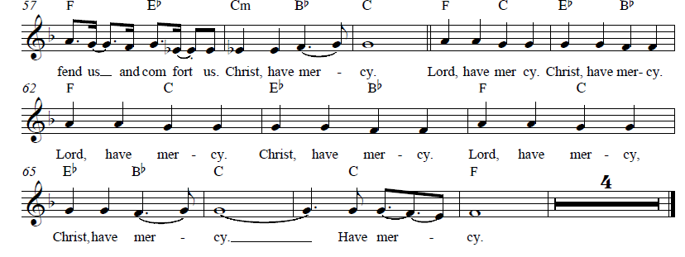
PRAYER OF THE DAY
Let us pray,
O God, overflowing with mercy and compassion, you lead back to yourself all those who go astray. Preserve your people in your loving care, that we may reject whatever is contrary to you and may follow all things that sustain our life in your Son, Jesus Christ, our Savior and Lord. Amen.

WORD
God speaks to us in scripture reading, preaching, and song.

CHILDREN’S CHAT
All children are welcomed forward for a children’s time. After that, they will be invited to Sunday school and will return during the passing of the peace.

FIRST READING Exodus 32:7-14 Pew Bible Old Testament Pg. 86

SECOND READING 1 Timothy 1:12-17 Pew Bible New Testament. Pg. 223
Word of God, word of life. Thanks be to God.

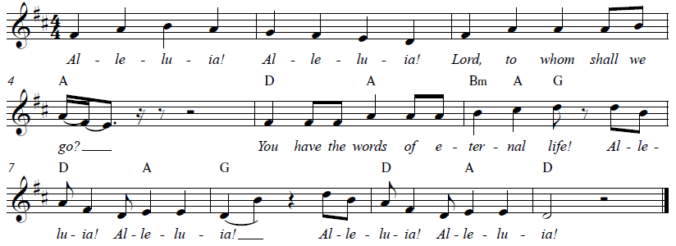
*GOSPEL ACCLAMATION Alleluia Islands of Faith

*GOSPEL Luke 15:1-10 Pew Bible New Testament Pg. 80

The Holy Gospel according to Luke, the 15th chapter. Glory to you, O Lord.
The reading concludes: The Gospel of the Lord. Praise to you, O Christ.

SERMON Pastor Nikki Fielder

*SERMON HYMN Amazing Grace ELW #779
(verses 1, 2, 4, 5)
*APOSTLES’ CREED

I believe in God, the Father almighty, creator of heaven and earth.

I believe in Jesus Christ, God’s only Son, our Lord, who was conceived by the Holy Spirit, born of the virgin Mary, suffered under Pontius Pilate, was crucified, died, and was buried; he descended to the dead. On the third day he rose again; he ascended into heaven, he is seated at the right hand of the Father, and he will come to judge the living and the dead.

I believe in the Holy Spirit, the holy catholic church, the communion of saints, the forgiveness of sins, the resurrection of the body, and the life everlasting. Amen.

PRAYERS OF THE CHURCH

Gracious God, we come to you in prayer for the church, the world, and all in need.
A brief silence.
God of grace,
receive our prayer.

We entrust these prayers to you, O God, in the name of Jesus Christ, our redeemer and friend.
Amen.



The wedding of
Karl Hansen & Nancy Brown
September 14, 2025

Introduction
Dear beloved community:
We come together in the presence of God to witness the marriage of
Karl & Nancy,
to hear their promises to each other and surround them with our prayers,
giving thanks to God for the gift of companionship
and asking God’s blessing upon them,
that they may be strengthened for their life together
and nurtured in the love of God.

Declaration of Intention
Giving of Rings
Acclamation
PRONOUNCEMENT

*SHARING OF PEACE

The peace of Christ be with you always. And also with you.

OFFERTORY I See the Light Angela Joseph
By Stefan Joseph in support of his sister, Angela

*OFFERTORY RESPONSE Step By Step

*OFFERTORY PRAYER

Let us pray together,
Lord of the harvest, we return to you a portion of what you have given to us.
Turn us to set our hope not on the uncertainty of riches, but on you, who richly provides for us. Multiply what we have gathered to bless all who are suffering and in need, through Jesus Christ our Lord. Amen.

MEAL
God feeds us with the presence of Jesus.

*THE GREAT THANKSGIVING

The Lord be with you. And also with you.
Lift up your hearts. We lift them to the Lord,
Let us give thanks to the Lord our God.
It is right to give our thanks and praise.

It is indeed right, our duty and our joy …
we praise your name and join their unending hymn:

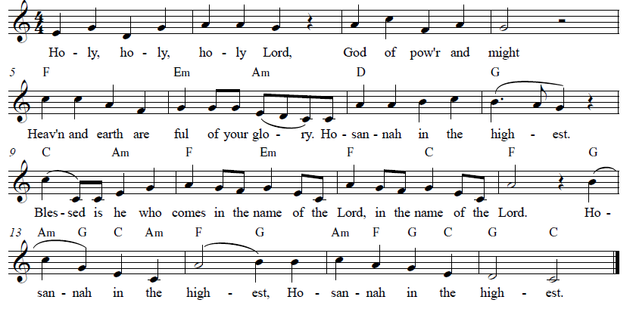
*HOLY, HOLY, HOLY Islands of Faith
*THANKSGIVING AT THE TABLE

Holy, mighty, and merciful Lord…

…with you and the Holy Spirit, be all honor and glory, now and forever. Amen.

*LORD’S PRAYER
Our Father in heaven, hallowed be your name, your kingdom come, your will be done, on earth as in heaven. Give us today our daily bread. Forgive us our sins
as we forgive those who sin against us. Save us from the time of trial and deliver us from evil. For the kingdom, the power, and the glory are yours, now and forever. Amen.

DISTRIBUTION OF HOLY COMMUNION
We believe that this is Jesus' table. All are welcome and invited to commune. We serve communion by “intinction”; receive the bread and dip it in the chalice. Gluten free wafers are available; let your server know. Wine is offered on each side. White grape juice is offered at the center aisle. Should you choose not to commune, you are invited to come forward to receive a blessing. Please cross your arms across your chest to let us know to give you that blessing.

HEALING PRAYER
This morning we offer healing prayer. If you would like our healing minister to pray with and for you, please go to the right transept after taking communion.

INVITATION TO COMMUNION
Jesus welcomes sinners and eats with them. Come to this meal of mercy.

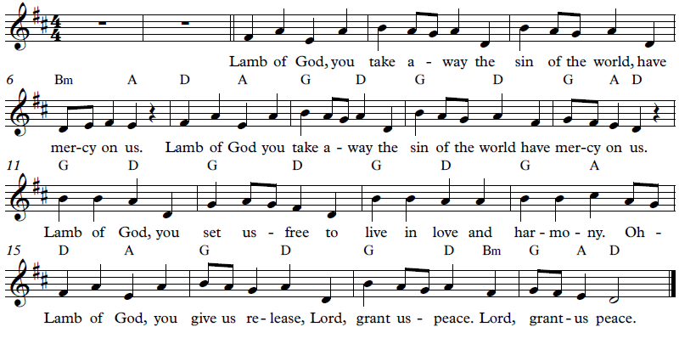
*lamb of god Islands of Faith
COMMUNION SONG Now We Join in Celebration ELW #462

*POST COMMUNION BLESSING
The body and blood of our Lord Jesus Christ strengthen you and keep you in his grace. Amen.

*PRAYER AFTER COMMUNION

Let us pray,
O God, through this meal you have strengthened us and appointed us to be your servants. Send us to do good and to share our possessions with all in need. We ask this in Jesus’ name. Amen.

SENDING
God blesses us and sends us in mission to the world.

*BLESSING

The God of righteousness, who gives justice to the oppressed, who gives food to the hungry, who sets the prisoners free, ☩ bless you now and forever.
Amen.

*SENDING HYMN Go, Make Disciples W&P #47
*Dismissal

Go in peace. Do not lose heart.
Thanks be to God.

POSTLUDE Roger Halvorson



CHRIST LUTHERAN CHURCH STAFF

Pastor Rev. Nikki Fielder, pastor@christlutheranlb.com
Office Manager Kim Croes, officemanager@christlutheranlb.com
Preschool Director Lisa Clinton, info@clplb.com
Choir Director Kim Philips, kimsings@msn.com
Accompanist Roger Halvorson
A/V Technicians Brad Croes and Josh Baker
Missionary to Colombia Linda Gawthorne

Mission Statement
Living by Christ’s example, we welcome, serve, and love all through God’s grace.

Vision Statement
Embracing the truth that God’s love and grace is for all, Christ Lutheran Church is a vibrant and active community spreading the good news through acceptance, action, and benevolence.

Our Position
Christ is ALIVE!

Reconciling in Christ (RIC) Welcome Statement
Christ Lutheran Church is a congregation who joyfully welcomes everyone who enters our doors. We recognize that each of us is a unique creation made in the image of God. We celebrate and give thanks for the many diverse gifts that God has bestowed on us. We proclaim ourselves to be an open and affirming congregation to all of God's children, welcoming into our ministry persons of every race, culture, age, gender identity, gender expression, sexual orientation, ability, and economic status. We commit ourselves to the work of anti-racism and creating an anti-racist space. We believe that through our openness we all grow in our faith through Christ's teaching to love one another as God loves us.

