
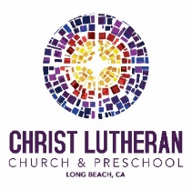
Life in Christ, Vol. 69 Issue 9
September, 2025

In July 2025, at our denomination’s tri-annual churchwide assembly, the voting members cast ballots and elected a new presiding bishop of the Evangelical Lutheran Church in America (ELCA). Our new presiding bishop to be, or Presiding Bishop-Elect, is Bishop Yehiel (Ya-heel) Curry. He currently serves as the Bishop of the Metro Chicago Synod and will take over in this new national call come
October 1st.
“When we’re talking about casting a vision, I think people want to be part of a vision because they want to share in the process. But they typically will also share in the burdens as well. So part of my vision is [about] those things we’ve lifted up as a church that we said we need to do, we’re going to do, and find a way to bring more people to the table so that we might embody that work instead of it just being a written document.” -Bishop Yehiel Curry
…Now that Curry has been elected the fifth presiding bishop of the ELCA—and the first of African descent—how does he feel? “That reality hasn’t really set in,” he said. “Even at this moment, I’m feeling a certain kind of way in understanding the weight and the impact.
I’m hopeful that, if presence matters, me being here does something for allowing others to consider, ‘Someone who looks like me, or is from my community, or speaks with an accent, or their mother tongue isn’t English [could take on a similar role].’ Hopefully that’s what that means.”
The role of Presiding Bishop is quite an undertaking for even the most qualified, intelligent, compassionate, and servant-hearted. It’s a unique position that is tasked to serve, care for and lead the nearly 3 million members of our denomination (the ELCA) which are many, varied, and diverse. Please join me today and in the coming years in praying for Presiding Bishop-Elect Curry and for us, that we might be supportive, uplifting, and faithful followers of his lead, for the sake of the Gospel.

𝗔 𝗛𝘂𝗺𝗯𝗹𝗲 𝗣𝗿𝗮𝘆𝗲𝗿 𝗼𝗳 𝗝𝗼𝘆 𝗮𝗻𝗱 𝗛𝗼𝗽𝗲 𝗳𝗼𝗿 𝗕𝗶𝘀𝗵𝗼𝗽 𝗬𝗲𝗵𝗶𝗲𝗹 𝗖𝘂𝗿𝗿𝘆- written by Aaron Wittnebel
Almighty God, with spirits open to your leading, we rejoice in the election of our new Presiding Bishop, the Rev. Dr. Yehiel Curry. We praise you for his remarkable journey of faith and service, recognizing that it is through your grace that he has been called from layperson, to Deacon, to his ordination and dedicated ministry, to his leadership as Bishop of the Metropolitan Chicago Synod, ELCA, and now to this historic call as the ELCA's first Black Presiding Bishop. We are filled with immense hope for the vision, wisdom, and gifts he will bring to our church and to the global community, trusting that you will guide his every step. Empower him by your Holy Spirit as he steps into this significant and groundbreaking role. As humble members of your body, we pray that his leadership will inspire us all to boldly live out our calling as your diverse people in the world, embodying your justice and grace, for the sake of your kingdom. Amen.
For more info on PB-E Curry, check out this article written by John Potter: https://www.livinglutheran.org/2025/07/casting-a-vision-for-the-church/
or this one written by Rev. Angela Denker:
https://www.startribune.com/reverend-yehiel-curry-elected-leader-elca-christianity/601447676.
With Bishop Curry’s election, the call of Presiding Bishop Elizabeth Eaton to this office begins to come to an end. Originally elected in 2013, PB Eaton has served the church faithfully in this capacity since then.
“Her ministry is holding all of it with grace—the grief, the joy, …the broken systems. This is what she’s done. Not for recognition. Not to build a legacy—she hates that word. But to show up. To do what is asked, what she has been called to do.
Ordinary. Extraordinary.”
-Beckah Selnick
If you’d like to read more about PB Eaton, check out this article written be Beckah Selnick, daughter of PB Eaton: https://www.livinglutheran.org/2025/07/ordinary-and-extraordinary/.
Please join me in prayers of thanks for Presiding Bishop Eaton’s service.
𝗔 𝗛𝘂𝗺𝗯𝗹𝗲 𝗣𝗿𝗮𝘆𝗲𝗿 𝗼𝗳 𝗣𝗿𝗼𝗳𝗼𝘂𝗻𝗱 𝗧𝗵𝗮𝗻𝗸𝘀𝗴𝗶𝘃𝗶𝗻𝗴 𝗳𝗼𝗿 𝗕𝗶𝘀𝗵𝗼𝗽 𝗘𝗹𝗶𝘇𝗮𝗯𝗲𝘁𝗵 𝗘𝗮𝘁𝗼𝗻'𝘀 𝗦𝗲𝗿𝘃𝗶𝗰𝗲- written by Aaron Wittnebel
Gracious and loving God, with humble hearts, we offer you profound thanksgiving this day for the exemplary service of Bishop Elizabeth Eaton, our outgoing Presiding Bishop of the ELCA. We are deeply grateful for her steadfast leadership, her unwavering commitment to the Gospel, and her courageous witness that made history as the first woman to hold this sacred office. We acknowledge your divine hand in empowering her, and we give thanks for the gifts you so richly bestowed upon her, which she, as your servant, so generously shared. We celebrate her impactful work within our church, the Lutheran World Federation, and the wider worldwide community of faith, all for your glory. May her legacy continue to inspire us, and may she be blessed abundantly as she continues to serve you in new ways. Amen.

+++++++++++++++++++++++++++++++++++++++++++++++++++++++++++++++++++

Stewardship Monthly Focus – Adult Education Committee
The Adult Education Committee provides a variety of learning opportunities for adults. These opportunities include a chance to study the Bible, to grow spiritual, to get a better understanding of church and society, to build small communities, and to discover new interests and skills that enhance our knowledge of God.
“I have found that I learn more about a topic by teaching it!!!” If you are ready to grow in God’s love and wisdom, please see a member of the Adult Education Committee about what you could teach or share. The Adult Education Committee includes Deb Albrecht, council representative, Pastor Nikki, Ron and Angie Nelson, Don Koepke, Kim Magee, and Laura Innes.
Look for the new and exciting classes for the 2025-2026 school year that will be coming your way.


Preschool News

Our Summer session, “Adventure Explorers: A Summer of Wonder" was a huge success. Our weekly themes included: Time Travelers: Adventures through History, Mission to Imagination: Space & Beyond, Backpack to the Wild: Nature Explorers, Ocean Commotion: Under the Sea, God's Creation, Our Awesome World: Community Helpers, Make Believe & Magic: Fairy Tales and Fantasy, and Super You! Special Guests included: Dino Adventure, a magician, Cabrillo Aquarium, petting zoo, Tooth Fairy, Police Car, a Construction Worker, Marionettes, a Librarian, and a Bounce House. We also had Guest Readers each week to read to all of the children out on the playground. We continued having Chapel and Music Makers throughout the summer. We also had so much fun participating in the Vacation Bible School week with a great turnout for the BBQ on Thursday of VBS week Thursday.
We had a new student orientation on Wednesday, August 13 from 3:30-4:30pm. We had about 8 new students come for orientation. We started off in the Social Hall for introductions, toured the school, then went on the playground to play and meet the teachers. Our end of summer celebration was on Friday, 8/15 and included a bounce house and school closed at 12:30pm. We closed 8/18-8/22 for our staff work week to get everything cleaned and prepped for fall.
Our 2025-2026 school year began on August 25th. Our teachers will be installed on Sunday, 9/21. Our staffing for fall will be Ms. Zacahula in Room 1, Ms. Nielsen and Ms. Foster in Room 2, Ms. Germain in Room 3, Ms. Meza in Room 4, Ms. Fitzpatrick in Room 5,
Ms. Villanueva in Room 6, Ms. Tompkins for our Afternoon Teacher, Ms. Scott as our Floater, and Ms. Theriault as our Asst. Dir. We will spend the month getting to know all of our new families and getting to know our current families even better. Back to School night will be Monday, 9/8 at 6:30pm.
We wish all of our graduates going on to Kindergarten success and look forward to welcoming our new and continuing students to another year of growing in God's Love at CLP.
Sincerely,
Lisa Clinton
Introducing a group created to support and pray for Social Justice:

My name is Andrea Joseph. I have been a member at Christ Lutheran Church for over 30 years. Currently, I sing in the choir, participate in the Church in Society Committee and serve on the Preschool Board.

I believe many of us find these times very challenging. Often times, I am so disturbed by what I see on the news that it is difficult not to feel sad, depressed, and hopeless. Worldwide, there is news about floods, fires, hunger, and wars. In our country, we live in a great time of division. We see policies that seem to dehumanize entire ethnic groups and generally anyone who appears to be different.

This is why I would like to invite you to a new group, called "Social Justice Prayer and Action Group". There is no need to carry the weight of the world on our shoulders. God is doing that for us. But there is a need to be there for those who do not have a voice; to stand up for our neighbors near and far who experience pain, injustice, and oppression. So, let's get together to pray, to support each other, to get creative in taking action for justice and peace, and to find joy in our faith journey.

The group meets every second and fourth Thursday in the Conference Room from 5:30pm to 7:00pm. The next meeting will be on September 11, 2025.
If you have any questions, please feel free to contact me by e-mail at clcpeace@yahoo.com

---------------------------------------------------------------------------------------------------------
Men’s Bible Study Zoom on Saturdays between 9-10am
led by Don Koepke

Here is the Zoom link along with the meeting ID/password.
https://us02web.zoom.us/j/84353579130?pwd=5aFpX9q9XacfT4E8NHv43NWWSehm50.1
Meeting ID: 843 5357 9130
Passcode: 830461
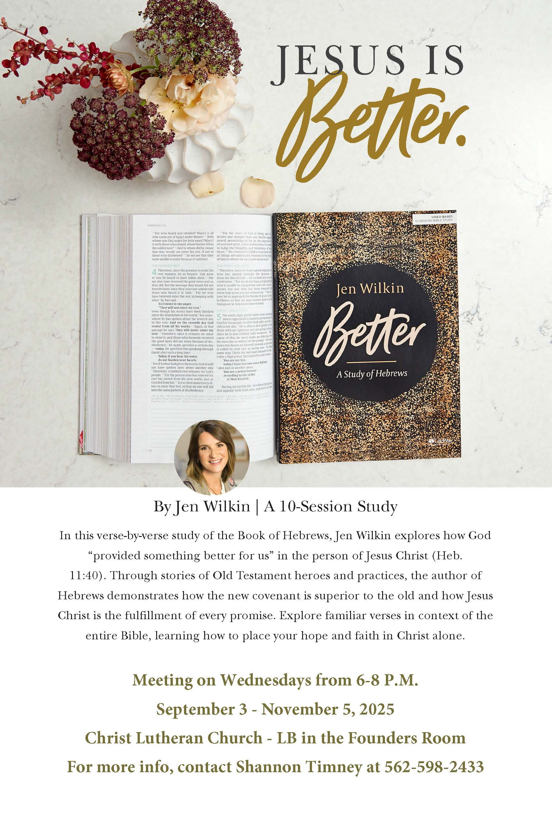


We pray for:
Members at Home or in Care Centers: Laurie Ennen, Ione Marchael, Gale Mussleman, Sydney Nichols, Phil Peterson, Bary & Janice Schlieder, and Frances Willms.

Those struggling with illness or other concerns: Don Darnauer, Paige, Judy Haenn, Daniel Howard, Shannon Howard, Beverly Koenen, Parker Treat, Kristine Trost, Gary & Linda Zimmerman.

Family & Friends: Irene Audett, Lois Brown, Tina Chang, Steven De La Rosa, Jasenko Dzinovic, Clark Enebo, Tamra Fitzgerald, Brechin Flournoy, Allan Gatzke, Cindy Gray, Bill Holford, Kylie & Crystal Huber, Bryan Koenen, Barb Korsmo, Katrina Lahr, Luke McCann, LaRaesha Murray, Linda, Steven, Alexis, Colin, Kristina & Scott Randolph, Sharry Reed, David Sarvela, Marlene Shafer, Laura Straus, Eleen Surette, Jason Thompson, Vicki Thompson, Kathy Van Buskirk, Jessica & Larisa West, and Bethany Wildes.

We pray for the ongoing work of:
+ Linda Gawthorne among the Kogi
people of Colombia
+ First responders who provide
safety, security, and care
+ Those serving in our nation's
Military, especially Samuel Brown,
Ryan Dorris, Morgan Llewellyn,
Austin Marsh, Johnny Luna, Jim
Reeder, Austin Rowell, Jalan Sanchez,
Steven, Brina and Michael Navarro.

We remember: Our unhoused neighbors, who find themselves without shelter and a place to call home. We pray for their safety, health, and wellness. We commit to treating them with compassion and working to combat systemic issues that leave our neighbors in need.

9/9 Morgan and Grant Green
9/10 Kim and Frank Croes
9/19 Barbi and Don Darnauer
9/27 Laurel and Adam Elliott
9/28 Claire and Glenn Hoxie


9/6 Nicholas Jenkins
9/6 Annie Johnson
9/12 Nathan Latiolait
9/14 Hannah Rodrigues
9/18 Don Darnauer
9/18 Emily Randig
9/21 Jonah Koch
9/25 Kameko Flournoy
9/25 Kathy Treat
9/26 Jax Johnson
9/28 Linda Peralta
9/29 Samantha McGee
9/30 Matthew Timney
Christ Lutheran Church
6500 Stearns Street
Long Beach, CA 90815-3497

Return Service Requested

Life In Christ
Is the newsletter of
Christ Lutheran Church
6500 Stearns Street
Long Beach, CA 90815-3497
562.598.2433
www.christlutheranlb.com
email:officemanager@christlutheranlb.com
Please join us in person for Sunday Worship 9:30am
Live on our YouTube Channel
https://www.youtube.com/@christlutheranlb
Be sure to LIKE us on Facebook.
facebook.com/christlutheranlb

Mission Statement
Living by Christ’s example,
we welcome, serve, and love
all through God’s grace.

Vision Statement
Embracing the truth that God’s love
and grace is for all, Christ
Lutheran Church is a vibrant
and active community spreading
the good news through acceptance,
action, and benevolence.

Our Position
Christ is ALIVE!

October Newsletter Deadline:
September 15

