August 17, 2025
9:30am

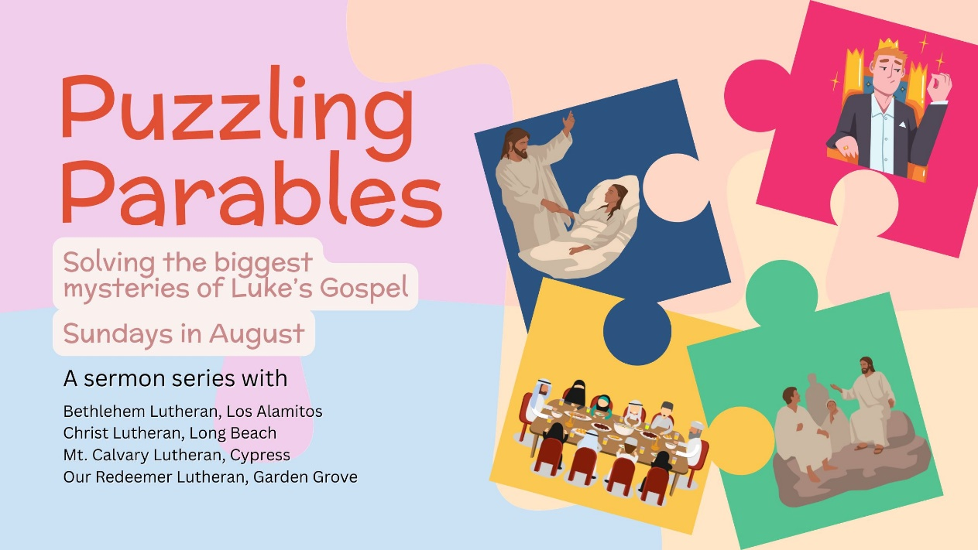

Christ Lutheran Church
6500 E. Stearns Street
Long Beach, California 90815
Phone 562-598-2433
www.christlutheranlb.com

Preschool 562-594-6117
www.clplb.com

Welcome to worship! We’re glad you’re here!
To assist in your worship:
bold print means we respond together
* means rise in body or spirit,
+ you may make the sign of the cross should you so desire.

It is our joy to worship with your whole family!
We encourage everyone of all ages and abilities to worship together.
We offer a “pray-ground” located in the back left of the Sanctuary for those with littles to have some room for movement and activity. The Narthex (gathering space at the entry) also has some resources for families, including activity bags filled with crayons, paper and storybooks. These supplies can be used in the Narthex or brought into the Sanctuary. For those that find themselves in the Narthex, there is a speaker with which you can still hear the service. Lastly, a changing table is located in the restroom off the Narthex. Please ask an usher if you need any assistance.

TODAY’S worship THEME

Today’s texts offer instruction and encouragement for all who are occasionally overwhelmed by the “unhappy business” of life. Jesus urges us to take care and be on guard against all kinds of greed. We who have died with Christ in holy baptism have also been raised with him and are encouraged to elevate our thinking, seeking the “things that are above.” To that end we seek the sustenance of the Lord’s supper and the encouragement of God’s word.

Worship services for Christ Lutheran Church- Long Beach
are live-streamed and archived to YouTube.
By entering the sanctuary and by your presence here,
you consent to be photographed,
filmed, and/or otherwise recorded.
Please alert an usher if this is of concern to you.

Our liturgy is taken from:
Sundays and Seasons.com. Copyright 2025 Augsburg Fortress. All rights reserved.
Reprinted by permission under Augsburg Fortress Liturgies Annual License #20338.
Reprinted by permission under CCLI license # 230154. All rights reserved.
Reprinted by permission under © 2025 One License #A-706154. All rights reserved.
Islands of Faith: Kyrie, Alleluia, Holy, Holy, Holy, and Lamb of God, written by Rev. Steve Beckham.
Call to Worship and Benediction, written by Rev. Carole Parmeter Dyer
PRELUDE Roger Halvorson

WELCOME AND ANNOUNCEMENTS

GATHERING
The Holy Spirit calls us together as the people of God.

*CALL TO WORSHIP
Gather us in and open our hearts to the mystery of presence.
We have come to enter the quiet immensity of Love.

Gather us in and give us joy and peace in the temple of our senses.
We come here to receive your encouragement, guidance and healing.

Gather us in and open our hearts to receive your word.
May we respond to your call and find the courage to follow your path. Amen.

*GATHERING SONG How Can I Be Free From Sin? W&P #65
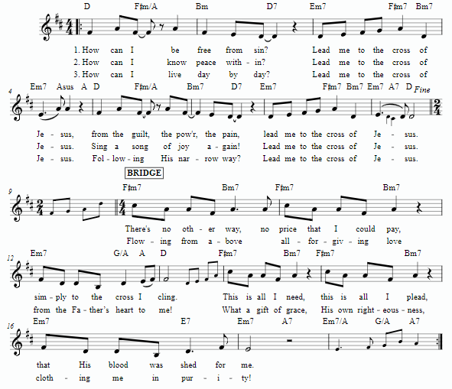
*CONFESSION AND FORGIVENESS
In the name of the Father, and of the ☩ Son, and of the Holy Spirit.
Amen.

Baptized into Christ, let us confess our sin.

Silence is kept for reflection.

Merciful God,
you free us to love others, but we neglect our neighbors and follow our own way.
You lead us by the Spirit of joy and peace, but we turn away from the abundant life you offer. You surround us with patience, kindness, and generosity,
but we grow weary in doing what is right. In your mercy, forgive us. Do not give up on us. Heal us, break our bonds, and show us the path of life. Amen.

You belong to Christ Jesus and you are God’s children through faith. In the cross of ☩ Christ, and through the power of the Holy Spirit, your sins are forgiven. Clothed with Christ, you are a new creation.
Amen.

*GREETING
The grace of our Lord Jesus Christ, the love of God, and the communion of the Holy Spirit be with you all.
And also with you.

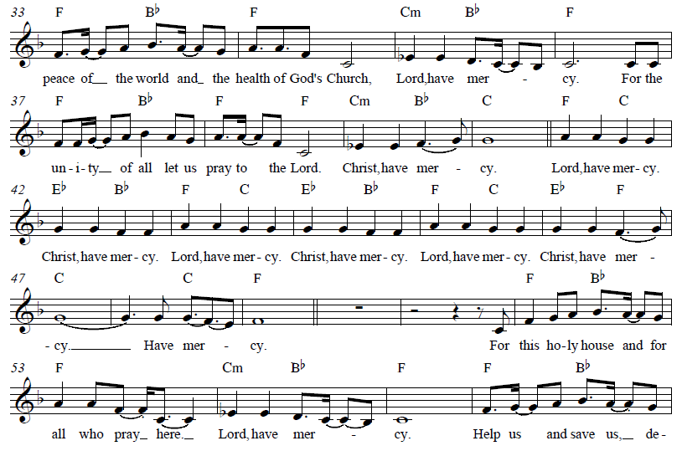
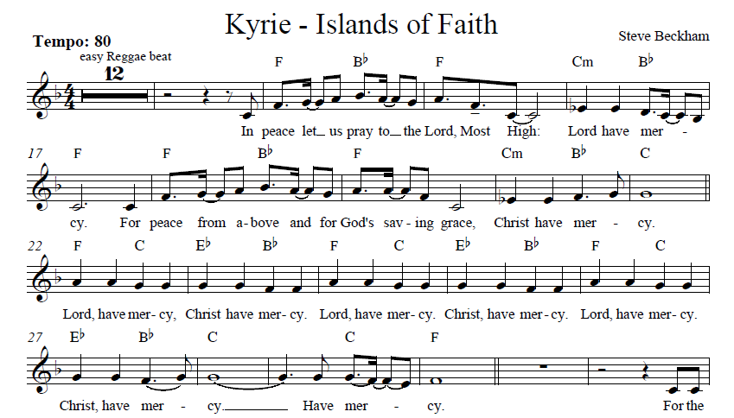
*KYRIE Islands of Faith
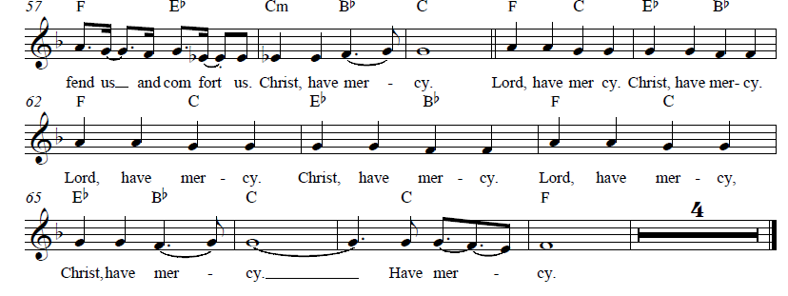
*PRAYER OF THE DAY
Let us pray,
Benevolent God, you are the source, the guide, and the goal of our lives. Teach us to love what is worth loving, to reject what is offensive to you, and to treasure what is precious in your sight, through Jesus Christ, our Savior and Lord. Amen.

WORD
God speaks to us in scripture reading, preaching, and song.

CHILDREN’S CHAT

FIRST READING Ecclesiastes 1:2, 12-14: 2:18-23 Pew Bible Old Testament Pg. 682
SECOND READING Colossians 3:1-11 Pew Bible New Testament. Pg. 215
Word of God, word of life. Thanks be to God.

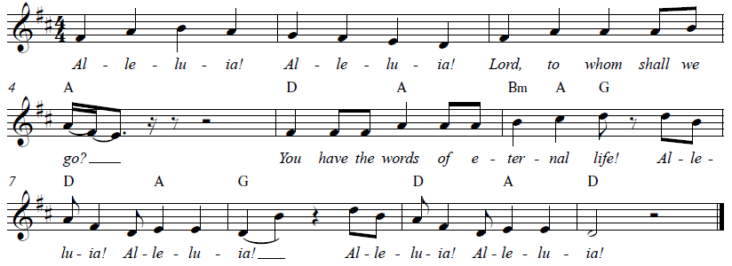
*GOSPEL ACCLAMATION Alleluia Islands of Faith

*GOSPEL Luke 12:13-21 Pew Bible New Testament Pg. 76

The Holy Gospel according to Luke, the 12th chapter. Glory to you, O Lord.
The reading concludes: The Gospel of the Lord. Praise to you, O Christ.

SERMON Pastor Jennifer Schultz

*SERMON HYMN Son of God, Eternal Savior ELW #655
(verses 1, 2, 4)

*APOSTLES’ CREED

I believe in God, the Father almighty, creator of heaven and earth.

I believe in Jesus Christ, God’s only Son, our Lord, who was conceived by the Holy Spirit, born of the virgin Mary, suffered under Pontius Pilate, was crucified, died, and was buried; he descended to the dead. On the third day he rose again; he ascended into heaven, he is seated at the right hand of the Father, and he will come to judge the living and the dead.

I believe in the Holy Spirit, the holy catholic church, the communion of saints, the forgiveness of sins, the resurrection of the body, and the life everlasting. Amen.

PRAYERS OF THE CHURCH

In solidarity with all creation, we join our voice to the voice of the whole church and pray for the needs of the world.

A brief silence.

God of grace,
hear our prayer.

Trusting in your lovingkindness, we place our prayer and hope in you, in the name of Jesus Christ.
Amen.

PRAYER OF GODSPEED FOR FAITH TIMNEY Rebecca Green

*SHARING OF PEACE

The peace of Christ be with you always. And also with you.

OFFERTORY How Can I Keep from Singing Kim Miller & Marvin Moon
by Chris Tomlin

*OFFERTORY RESPONSE Step By Step

*OFFERTORY PRAYER

Let us pray together,
Creator God, in your wisdom you bring forth all that is good and the harvest is plentiful. Strengthen us at your table with these gifts of the earth and our labor,
that we may work for the good of all; through Jesus Christ, our Savior. Amen.

MEAL
God feeds us with the presence of Jesus.

*THE GREAT THANKSGIVING

The Lord be with you. And also with you.
Lift up your hearts. We lift them to the Lord,
Let us give thanks to the Lord our God.
It is right to give our thanks and praise.

It is indeed right, our duty and our joy …
we praise your name and join their unending hymn:

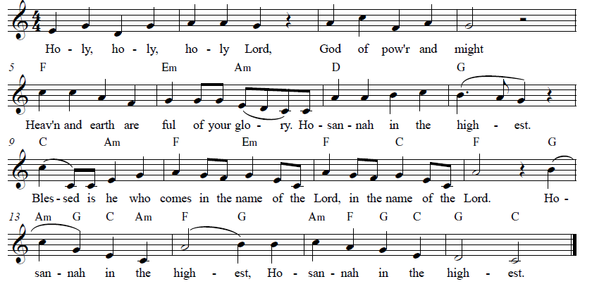
*HOLY, HOLY, HOLY Islands of Faith

*THANKSGIVING AT THE TABLE

Holy, mighty, and merciful Lord…

…with you and the Holy Spirit, be all honor and glory, now and forever. Amen.

*LORD’S PRAYER
Our Father in heaven, hallowed be your name, your kingdom come, your will be done, on earth as in heaven. Give us today our daily bread. Forgive us our sins
as we forgive those who sin against us. Save us from the time of trial and deliver us from evil. For the kingdom, the power, and the glory are yours, now and forever. Amen.

DISTRIBUTION OF HOLY COMMUNION
We believe that this is Jesus' table. All are welcome and invited to commune. We serve communion by “intinction”; receive the bread and dip it in the chalice. Gluten free wafers are available; let your server know. Wine is offered on each side. White grape juice is offered at the center aisle. Should you choose not to commune, you are invited to come forward to receive a blessing. Please cross your arms across your chest to let us know to give you that blessing.

INVITATION TO COMMUNION
The kingdom of God is set before you. Eat and rejoice.
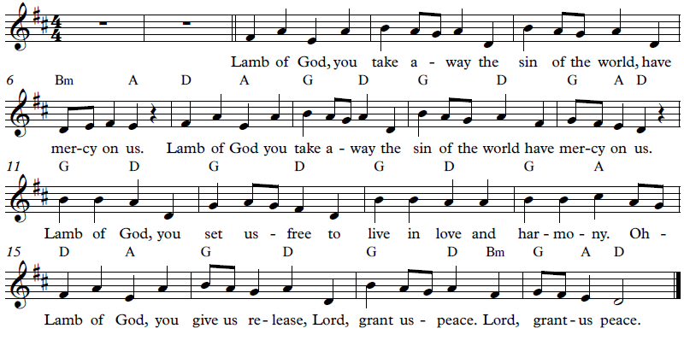
*lamb of god Islands of Faith

COMMUNION SONG Beauty for Brokenness W&P #17

Verse 1
Beauty for brokenness
Hope for despair
Lord in Your suff'ring world
This is our prayer
Bread for the children
Justice joy peace
Sunrise to sunset
Your kingdom increase

Verse 2
Shelter for fragile lives
Cures for their ills
Work for the craftsmen
Trade for their skills
Land for the dispossessed
Rights for the weak
Voices to plead the cause
Of those who can't speak
Chorus
God of the poor
Friend of the weak
Give us compassion we pray
Melt our cold hearts
Let tears fall like rain
Come change our love
From a spark to a flame

Verse 3
Refuge from cruel wars
Havens from fear
Cities for sanctu'ry
Freedoms to share
Peace to the killing fields
Scorched earth to green
Christ for the bitterness
His cross for the pain
Chorus
Verse 4
Rest for the ravaged earth
Oceans and streams
Plundered and poisoned
Our future our dreams
Lord end our madness
Carelessness greed
Make us content with
The things that we need
Chorus

Verse 5
Lighten our darkness
Breathe on this flame
Until Your justice
Burns brightly again
Until the nations
Learn of Your ways
Seek Your salvation
And bring You their praise
Chorus

*POST COMMUNION BLESSING
The body and blood of our Lord Jesus Christ strengthen you and keep you in his grace. Amen.

*PRAYER AFTER COMMUNION

Let us pray,
Mothering God, you gathered us to your table and we drank deeply of your grace. Send us out by your Spirit to love our neighbors as ourselves and proclaim your love in Jesus’ name. Amen.

SENDING
God blesses us and sends us in mission to the world.

*BLESSING

May the path that Christ walks to bring justice upon the earth, light to those who sit in darkness and healing to all creation be the path that runs through our life.
May we be the road that Christ takes. In the name of the One who created, redeems, + and sustains us.
Amen.

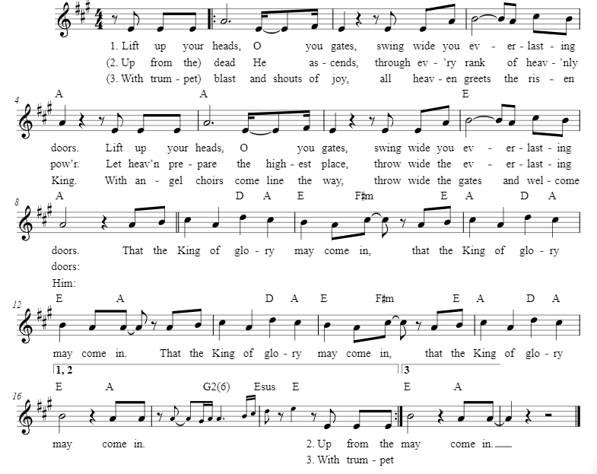
*SENDING HYMN Lift Up Your Heads W&P #88

*Dismissal

Go in peace. Live by the Spirit.
Thanks be to God.

POSTLUDE Roger Halvorson

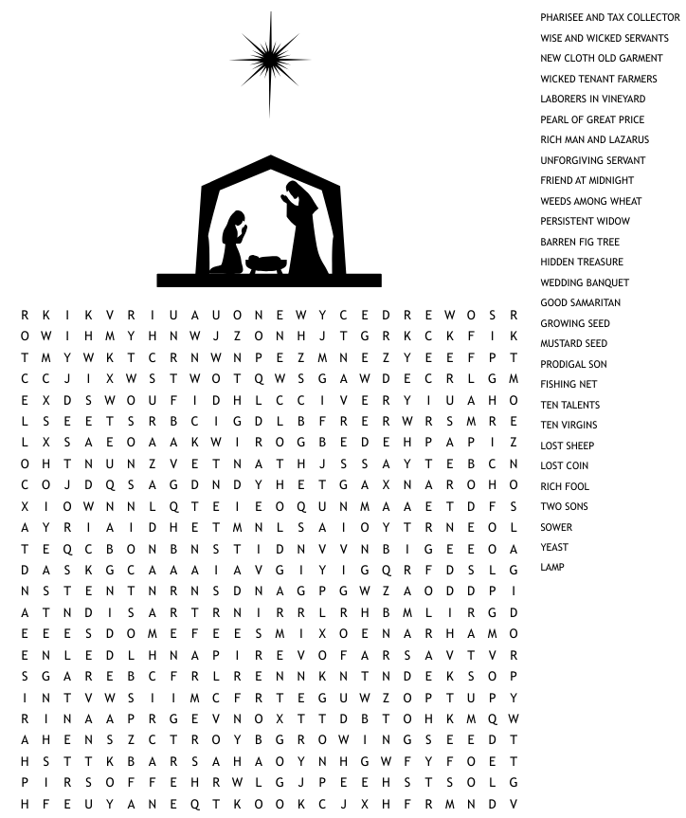

CHRIST LUTHERAN CHURCH STAFF

Pastor Rev. Nikki Fielder, pastor@christlutheranlb.com
Office Manager Kim Croes, officemanager@christlutheranlb.com
Preschool Director Lisa Clinton, info@clplb.com
Choir Director Kim Philips, kimsings@msn.com
Accompanist Roger Halvorson
A/V Technicians Brad Croes and Josh Baker
Missionary to Colombia Linda Gawthorne

Mission Statement
Living by Christ’s example, we welcome, serve, and love all through God’s grace.

Vision Statement
Embracing the truth that God’s love and grace is for all, Christ Lutheran Church is a vibrant and active community spreading the good news through acceptance, action, and benevolence.

Our Position
Christ is ALIVE!

Reconciling in Christ (RIC) Welcome Statement
Christ Lutheran Church is a congregation who joyfully welcomes everyone who enters our doors. We recognize that each of us is a unique creation made in the image of God. We celebrate and give thanks for the many diverse gifts that God has bestowed on us. We proclaim ourselves to be an open and affirming congregation to all of God's children, welcoming into our ministry persons of every race, culture, age, gender identity, gender expression, sexual orientation, ability, and economic status. We commit ourselves to the work of anti-racism and creating an anti-racist space. We believe that through our openness we all grow in our faith through Christ's teaching to love one another as God loves us.

