Third Sunday after Pentecost
June 29, 2025
9:30am


Christ Lutheran Church
6500 E. Stearns Street
Long Beach, California 90815
Phone 562-598-2433
www.christlutheranlb.com

Preschool 562-594-6117
www.clplb.com

Welcome to worship! We’re glad you’re here!
To assist in your worship:
bold print means we respond together
* means rise in body or spirit,
+ you may make the sign of the cross should you so desire.

It is our joy to worship with your whole family!
We encourage everyone of all ages and abilities to worship together.
We offer a “pray-ground” located in the back left of the Sanctuary for those with littles to have some room for movement and activity. The Narthex (gathering space at the entry) also has some resources for families, including activity bags filled with crayons, paper and storybooks. These supplies can be used in the Narthex or brought into the Sanctuary. For those that find themselves in the Narthex, there is a speaker with which you can still hear the service. Lastly, a changing table is located in the restroom off the Narthex. Please ask an usher if you need any assistance.

TODAY’S worship THEME

We have no good apart from God. That makes Jesus’ call to follow him an invitation to freedom. This is freedom to revel in the Spirit’s fruit: love, joy, peace, and patience. This is freedom to not be imprisoned by anything that would keep us from the fullness of the life God has given us. This is the path of life.

Worship services for Christ Lutheran Church- Long Beach
are live-streamed and archived to YouTube.
By entering the sanctuary and by your presence here,
you consent to be photographed,
filmed, and/or otherwise recorded.
Please alert an usher if this is of concern to you.

Our liturgy is taken from:
Sundays and Seasons.com. Copyright 2025 Augsburg Fortress. All rights reserved.
Reprinted by permission under Augsburg Fortress Liturgies Annual License #20338.
Reprinted by permission under CCLI license # 230154. All rights reserved.
Reprinted by permission under © 2025 One License #A-706154. All rights reserved.
Islands of Faith: Kyrie, Alleluia, Holy, Holy, Holy, and Lamb of God, written by Rev. Steve Beckham.

PRELUDE Roger Halvorson

WELCOME AND ANNOUNCEMENTS

GATHERING
The Holy Spirit calls us together as the people of God.

*GATHERING SONG Awake, O Sleeper, Rise from Death ELW #452
(verses 1-3 & 5)

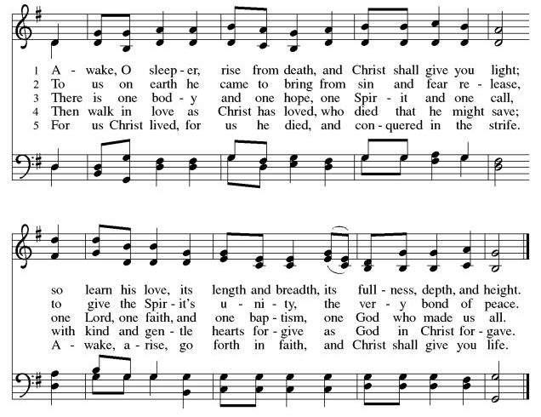

*CONFESSION AND FORGIVENESS
In the name of the Father, and of the ☩ Son, and of the Holy Spirit.
Amen.

Baptized into Christ, let us confess our sin.

Silence is kept for reflection.
Merciful God,
you free us to love others, but we neglect our neighbors and follow our own way.
You lead us by the Spirit of joy and peace, but we turn away from the abundant life you offer. You surround us with patience, kindness, and generosity,
but we grow weary in doing what is right. In your mercy, forgive us. Do not give up on us. Heal us, break our bonds, and show us the path of life. Amen.

You belong to Christ Jesus and you are God’s children through faith. In the cross of ☩ Christ, and through the power of the Holy Spirit, your sins are forgiven. Clothed with Christ, you are a new creation.
Amen.

*GREETING
The grace of our Lord Jesus Christ, the love of God, and the communion of the Holy Spirit be with you all.
And also with you.

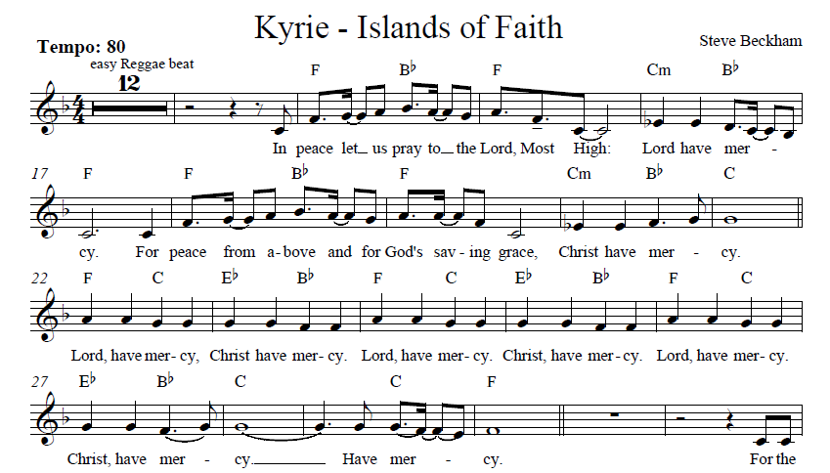
*KYRIE Islands of Faith
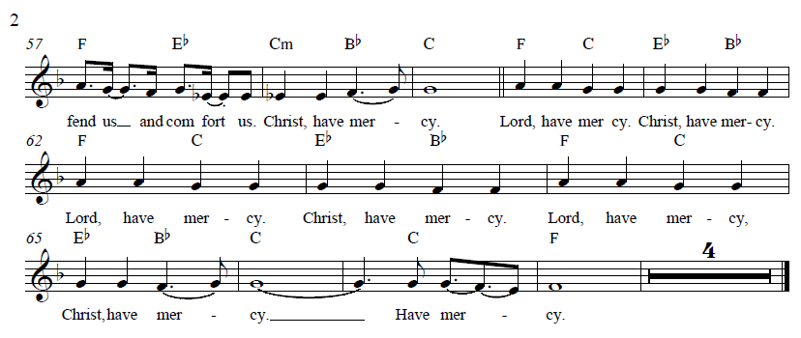
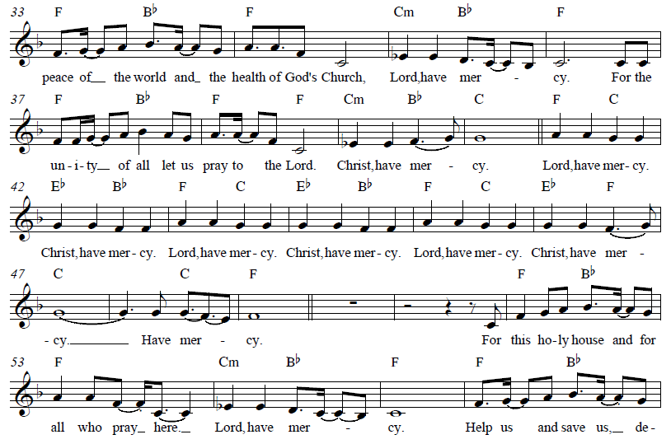

*PRAYER OF THE DAY
Let us pray together,
Sovereign God, ruler of all hearts, you call us to obey you, and you favor us with true freedom. Keep us faithful to the ways of your Son, that, leaving behind all that hinders us, we may steadfastly follow your paths, through Jesus Christ, our Savior and Lord. Amen.

WORD
God speaks to us in scripture reading, preaching, and song.

CHILDREN’S CHAT
first reading 1 Kings 19:15-16, 19-21 Pew Bible Old Testament Pg. 362
SECOND READING Galatians 5:1, 13-25 Pew Bible New Testament. Pg. 201
Word of God, word of life. Thanks be to God.

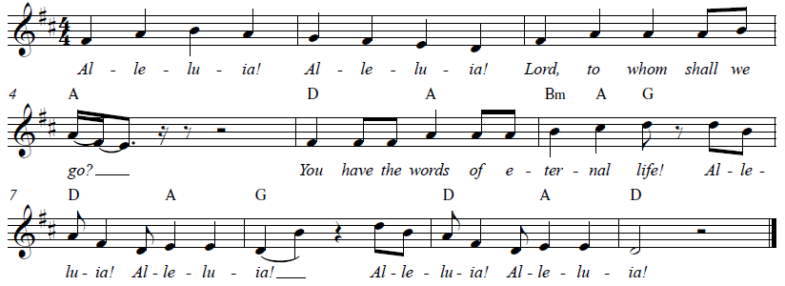
*GOSPEL ACCLAMATION Alleluia Islands of Faith

*GOSPEL Luke 9:51-62 Pew Bible New Testament Pg. 72

The Holy Gospel according to Luke, the 9th chapter. Glory to you, O Lord.
The reading concludes: The Gospel of the Lord. Praise to you, O Christ.

SERMON Pastor Nikki Fielder

*SERMON HYMN Here I Am, Lord ELW #574

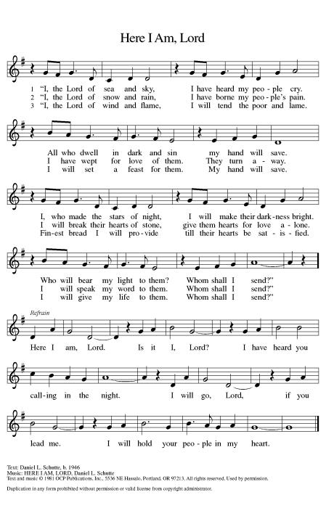

*APOSTLES’ CREED

I believe in God, the Father almighty, creator of heaven and earth.

I believe in Jesus Christ, God’s only Son, our Lord, who was conceived by the Holy Spirit, born of the virgin Mary, suffered under Pontius Pilate, was crucified, died, and was buried; he descended to the dead. On the third day he rose again; he ascended into heaven, he is seated at the right hand of the Father, and he will come to judge the living and the dead.

I believe in the Holy Spirit, the holy catholic church, the communion of saints, the forgiveness of sins, the resurrection of the body, and the life everlasting. Amen.

PRAYERS OF THE CHURCH

Drawn into the embrace of the holy Trinity, we lift our prayers for the wholeness of the church, the world, and all creation.

A brief silence.

God of grace,
hear our prayer.

Gather all our prayers in your mercy, O God, through Jesus Christ, our Savior.
Amen.

*SHARING OF PEACE

The peace of Christ be with you always. And also with you.

OFFERTORY Ride the Chariot Chancel Choir

*OFFERTORY RESPONSE Step by Step
*OFFERTORY PRAYER

Let us pray together,
Creator God, in your wisdom you bring forth all that is good and the harvest is plentiful. Strengthen us at your table with these gifts of the earth and our labor,
that we may work for the good of all; through Jesus Christ, our Savior. Amen.

MEAL
God feeds us with the presence of Jesus.

*THE GREAT THANKSGIVING

The Lord be with you. And also with you.
Lift up your hearts. We lift them to the Lord,
Let us give thanks to the Lord our God.
It is right to give our thanks and praise.

It is indeed right, our duty and our joy …
we praise your name and join their unending hymn:

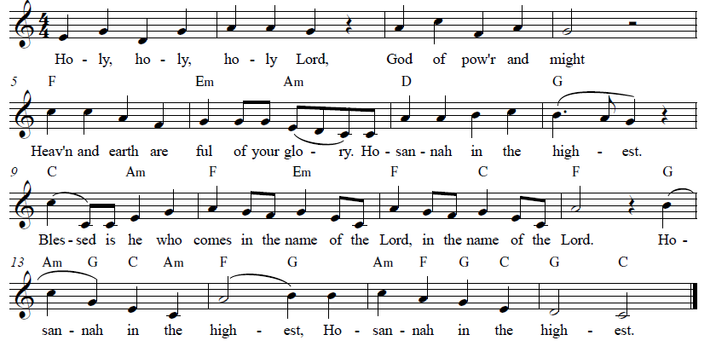
*HOLY, HOLY, HOLY Islands Of Faith

*THANKSGIVING AT THE TABLE

Holy, mighty, and merciful Lord…

…with you and the Holy Spirit, be all honor and glory, now and forever
Amen.

*LORD’S PRAYER
Our Father in heaven, hallowed be your name, your kingdom come, your will be done, on earth as in heaven. Give us today our daily bread. Forgive us our sins
as we forgive those who sin against us. Save us from the time of trial and deliver us from evil. For the kingdom, the power, and the glory are yours, now and forever. Amen.

DISTRIBUTION OF HOLY COMMUNION
We believe that this is Jesus' table. All are welcome and invited to commune. We serve communion by “intinction”; receive the bread and dip it in the chalice. Gluten free wafers are available; let your server know. Wine is offered on each side. White grape juice is offered at the center aisle. Should you choose not to commune, you are invited to come forward to receive a blessing. Please cross your arms across your chest to let us know to give you that blessing.

INVITATION TO COMMUNION
The kingdom of God is set before you. Eat and rejoice.

*lamb of god Islands of Faith
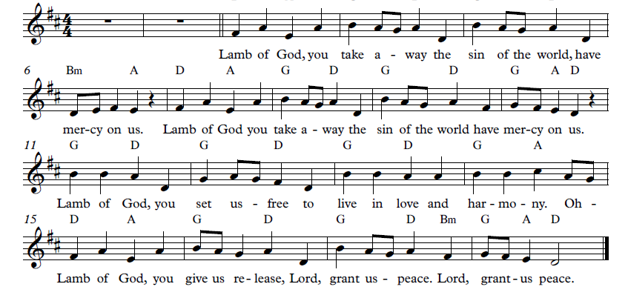

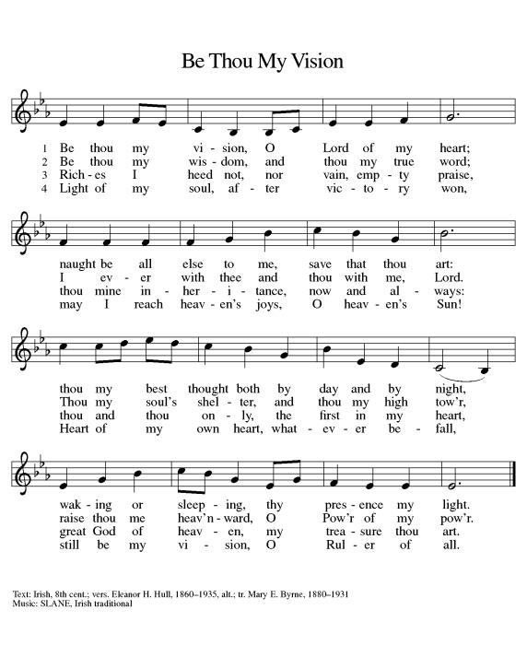
COMMUNION SONG Be Thou My Vision ELW #793

*POST COMMUNION BLESSING
The body and blood of our Lord Jesus Christ strengthen you and keep you in his grace. Amen.

*PRAYER AFTER COMMUNION

Let us pray,
Mothering God, you gathered us to your table and we drank deeply of your grace. Send us out by your Spirit to love our neighbors as ourselves and proclaim your love in Jesus’ name. Amen.

SENDING
God blesses us and sends us in mission to the world.

*BLESSING

The love of God abound in you; the grace of our Savior Jesus Christ fill your hearts; and the life of the Spirit ☩ bless you and give you peace.
Amen.

*SENDING HYMN Jesus Messiah

Verse 1
He became sin, who knew no sin;
That we might become His righteousness;
He humbled Himself, and carried the cross.
Love so amazing, love so amazing.

Chorus
Jesus, Messiah; Name above all names;
Blessed Redeemer; Emmanuel.
The Rescue for sinners,
The Ransom from heaven;
Jesus, Messiah, Lord of all.

Verse 2
His body the bread, His blood the wine
Broken and poured out, all for love.
The whole earth trembled, and the veil was torn.
Love so amazing, love so amazing.

(Chorus)

Bridge
All our hope is in You,
All our hope is in You;
All the glory to You, God,
The Light of the world.

(Chorus)

*Dismissal
Go in peace. Live by the Spirit.
Thanks be to God.

POSTLUDE Roger Halvorson

Thank you to all those who volunteered with
Education
for adults and youth
this school year!
We appreciate you.

Deb Albrecht, Chair
- Chris Caldwell
- Joyce Carter
- Ruth Depuy
- Ingrid Fuelleman-Ramos
- Rebecca Green
- Shannon Howard
- Steve Howard

- Laura Innes
- Amanda Johnson
- Andrea Joseph
- Don Koepke
- Kim Magee
- Ron Nelson
- Shannon Timney

CHRIST LUTHERAN CHURCH STAFF

Pastor Rev. Nikki Fielder, pastor@christlutheranlb.com
Office Manager Kim Croes, officemanager@christlutheranlb.com
Preschool Director Lisa Clinton, info@clplb.com
Choir Director Kim Philips, kimsings@msn.com
Accompanist Roger Halvorson
A/V Technicians Brad Croes and Josh Baker
Missionary to Colombia Linda Gawthorne

Mission Statement
Living by Christ’s example, we welcome, serve, and love all through God’s grace.

Vision Statement
Embracing the truth that God’s love and grace is for all, Christ Lutheran Church is a vibrant and active community spreading the good news through acceptance, action, and benevolence.

Our Position
Christ is ALIVE!

Reconciling in Christ (RIC) Welcome Statement
Christ Lutheran Church is a congregation who joyfully welcomes everyone who enters our doors. We recognize that each of us is a unique creation made in the image of God. We celebrate and give thanks for the many diverse gifts that God has bestowed on us. We proclaim ourselves to be an open and affirming congregation to all of God's children, welcoming into our ministry persons of every race, culture, age, gender identity, gender expression, sexual orientation, ability, and economic status. We commit ourselves to the work of anti-racism and creating an anti-racist space. We believe that through our openness we all grow in our faith through Christ's teaching to love one another as God loves us.

