Ash Wednesday

February 22, 2023



Christ Lutheran Church
6500 E. Stearns Street
Long Beach, California 90815
Phone 562-598-2433 www.christlutheranlb.com
Christ Lutheran Preschool
Preschool 562-594-6117
www.clplb.com

Welcome to worship! We’re glad you’re here!

To assist in your worship: * means stand as you are able, bold print means we respond.

TODAY’S worship THEME
On Ash Wednesday we begin our forty-day journey toward Easter with a day of fasting and repentance. Marking our foreheads with dust, we acknowledge that we die and return to the earth. At the same time, the dust traces the life-giving cross indelibly marked on our foreheads at baptism. While we journey through Lent to return to God, we have already been reconciled to God through Christ. We humbly pray for God to make our hearts clean while we rejoice that “now is the day of salvation.” Returning to our baptismal call, we more intentionally bear the fruits of mercy and justice in the world.



Our liturgy is taken from:
Sundays and Seasons.com. Copyright 2023 Augsburg Fortress. All rights reserved.
Reprinted by permission under Augsburg Fortress Liturgies Annual License #20338.
Reprinted by permission under CCLI license # 230154. All rights reserved
Reprinted by permission under © 2023, One License #A-706154. All rights reserved
GATHERING
The Holy Spirit calls us together as the people of God.

PRELUDE Roger Halvorson

WELCOME AND ANNOUNCEMENTS

*GATHERING SONG O Lord, throughout These Forty Days #319

*GREETING

The grace of our Lord Jesus Christ, the love of God and the communion of the Holy Spirit be with you all. And also with you.

*PRAYER OF THE DAY

Let us pray together. A brief silence. Almighty and ever-living God, you hate nothing you have made, and you forgive the sins of all who are penitent. Create in us new and honest hearts, so that, truly repenting of our sins, we may receive from you, the God of all mercy, full pardon and forgiveness through your Son, Jesus Christ, our Savior and Lord, who lives and reigns with you and the Holy Spirit, one God, now and forever. Amen.

WORD
God speaks to us in scripture reading, preaching, and song.

SCRIPTURE READING: Joel 2:1-2, 12-17 Pew Bible Old Testament Pg. 943

The Word of the Lord. Thanks be to God

RESPONSIVE PSALM: Psalm 51:1-17 Pew Bible Old Testament Pg. 574

Have mercy on me, O God, according to your steadfast love; according to your abundant mercy blot out my transgressions.
²Wash me thoroughly from my iniquity, and cleanse me from my sin.
³For I know my transgressions, and my sin is ever before me.
⁴Against you, you alone, have I sinned, and done what is evil in your sight, so that you are justified in your sentence and blameless when you pass judgment.
⁵Indeed, I was born guilty, a sinner when my mother conceived me.
⁶You desire truth in the inward being; therefore teach me wisdom in my secret heart.
⁷Purge me with hyssop, and I shall be clean; wash me, and I shall be whiter than snow.
⁸Let me hear joy and gladness; let the bones that you have crushed rejoice.
⁹Hide your face from my sins, and blot out all my iniquities.
¹⁰Create in me a clean heart, O God, and put a new and right spirit within me.
¹¹Do not cast me away from your presence, and do not take your holy spirit from me.
¹²Restore to me the joy of your salvation, and sustain in me a willing spirit.
¹³Then I will teach transgressors your ways, and sinners will return to you.
¹⁴Deliver me from bloodshed, O God, O God of my salvation, and my tongue will sing aloud of your deliverance.
¹⁵O LORD, open my lips, and my mouth will declare your praise.
¹⁶For you have no delight in sacrifice; if I were to give a burnt offering, you would not be pleased.
¹⁷The sacrifice acceptable to God is a broken spirit; a broken and contrite heart, O God, you will not despise.

*GOSPEL VERSE

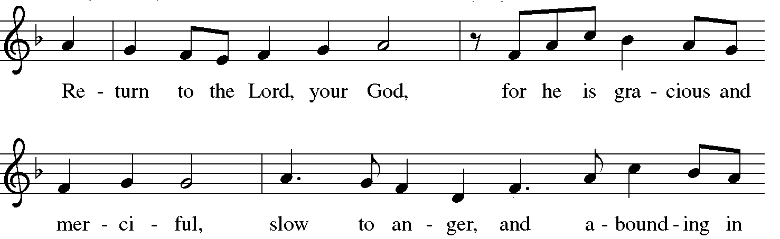

*GOSPEL: Matthew 6:1-6, 16-21 Pew Bible New Testament Pg. 5

The Holy Gospel according to Matthew the 6th chapter. Glory to you, O Lord.

The reading concludes: The Gospel of the Lord. Praise to you, O Christ.

SERMON Pastor Laurie Arroyo

*SERMON HYMN Will You Let Me Be Your Servant #659

*INVITATION TO THE LENTEN DISCIPLINE

*CONFESSION OF SIN

Let us confess our sin in the presence of God and of one another. (pause for silent reflection)

Most holy and merciful God, we confess to you and to one another, and before the whole company of heaven, that we have sinned by our fault, by our own fault, by our own most grievous fault, in thought, word, and deed, by what we have done and by what we have left undone.

We have not loved you with our whole heart, and mind, and strength. We have not loved our neighbors as ourselves. We have not forgiven others as we have been forgiven. Have mercy on us, O God.

We have shut our ears to your call to serve as Jesus served us. We have not been true to the mind of Christ. We have grieved your Holy Spirit. Have mercy on us, O God.

Our past unfaithfulness, the pride, envy, hypocrisy, and apathy that have infected our lives, we confess to you. Have mercy on us, O God.

Our self-indulgent appetites and ways, and our exploitation of other people, we confess to you. Have mercy on us, O God.

Our negligence in prayer and worship, and our failure to share the faith that is in us, we confess to you. Have mercy on us, O God.

Our neglect of human need and suffering, and our indifference to injustice and cruelty, we confess to you. Have mercy on us, O God.

Our false judgments, our uncharitable thoughts toward our neighbors, and our prejudice and contempt toward those who differ from us, we confess to you. Have mercy on us, O God.

Our waste and pollution of your creation, and our lack of concern for those who come after us, we confess to you. Have mercy on us, O God.

Restore us, O God, and let your anger depart from us. Hear us, O God, for your mercy is great.

*IMPOSITION OF ASHES

Almighty God, you have created us out of the dust of the earth. May these ashes be a sign of our mortality and penitence, reminding us that only by the cross of our Lord Jesus Christ are we given eternal life; through the same Jesus Christ, our Savior and Lord. Amen.

People may come forward and kneel or stand to receive the ashes.

SPECIAL MUSIC Ash Wednesday Chant Chancel Choir
Carol Parmeter-Dyer

Accomplish in us, O God, the work of your salvation, that we may show forth your glory in the world.
By the cross and passion of your Son, our Savior, bring us with all your saints to the joy of his resurrection.
Almighty God have mercy on us, forgive us all our sins through our Lord Jesus Christ, strengthen us in all goodness, and by the power of the Holy Spirit keep us in eternal life. Amen.

PRAYERS OF THE CHURCH
Sustained by God’s abundant mercy, let us pray for the church, the world, and all of creation.

Merciful God, receive our prayer.

We lift our prayers to you, O God, trusting in your steadfast love and your promise to renew your whole creation; through Jesus Christ our Savior. Amen.

SHARING OF THE PEACE

OFFERTORY

OFFERTORY RESPONSE Create in Me a Clean Heart

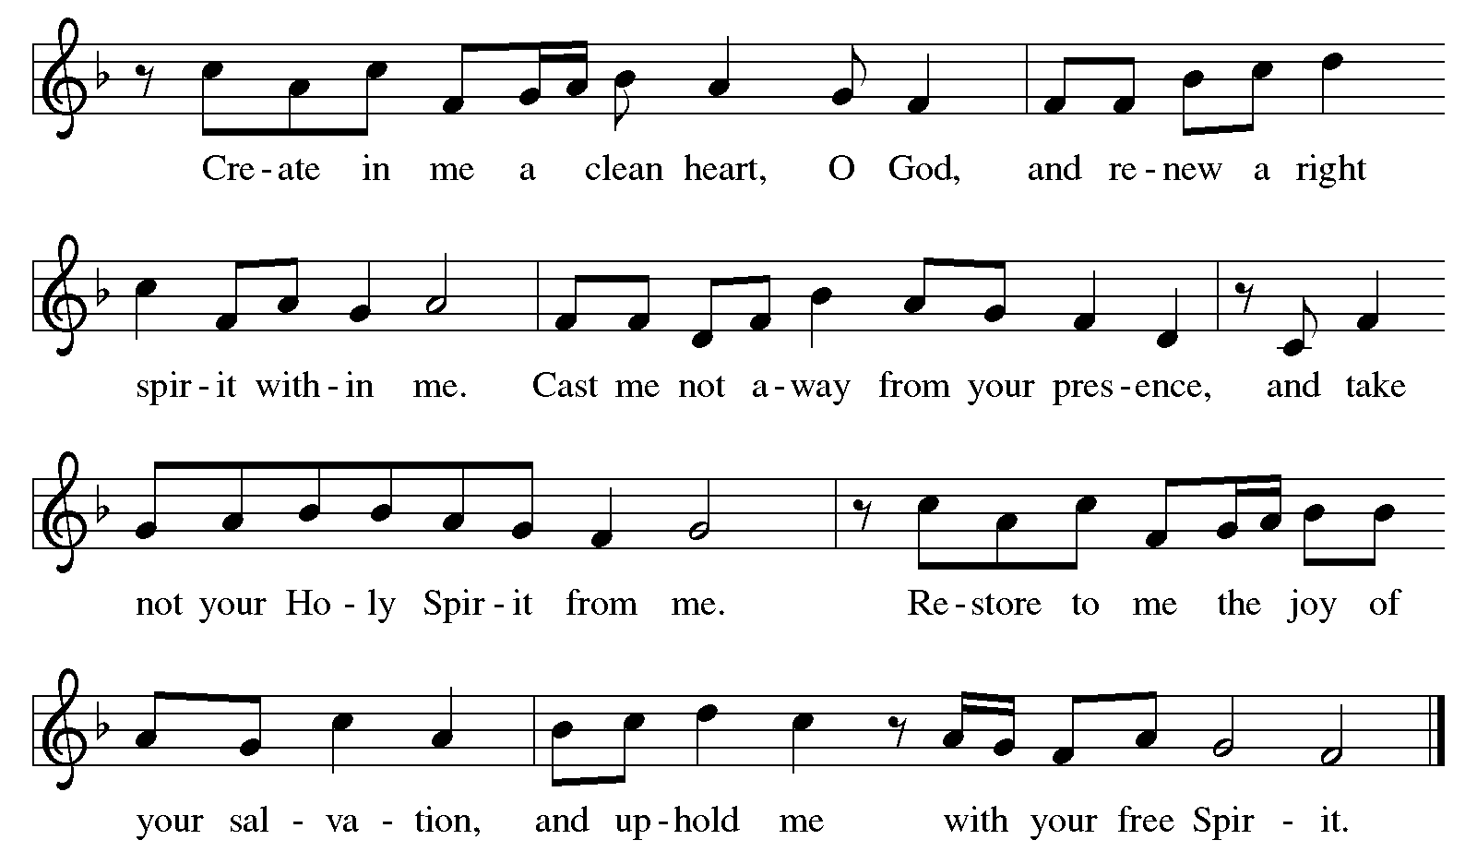

Let us pray together, God of good gifts, receive these and all our offerings as we present them in faithful service for the sake of the gospel. Prepare our hearts to receive you in this meal as you pour out your very presence through Jesus Christ, the wellspring of eternal life. Amen.

MEAL
God feeds us with the presence of Jesus.

*THE GREAT THANKSGIVING

The Lord be with you. And also with you.
Lift up your hearts. We lift them to the Lord,
Let us give thanks to the Lord our God. It is right to give our thanks and praise.
It is indeed right, our duty and our joy … we praise your name and join their unending hymn:
*HOLY, HOLY, HOLY
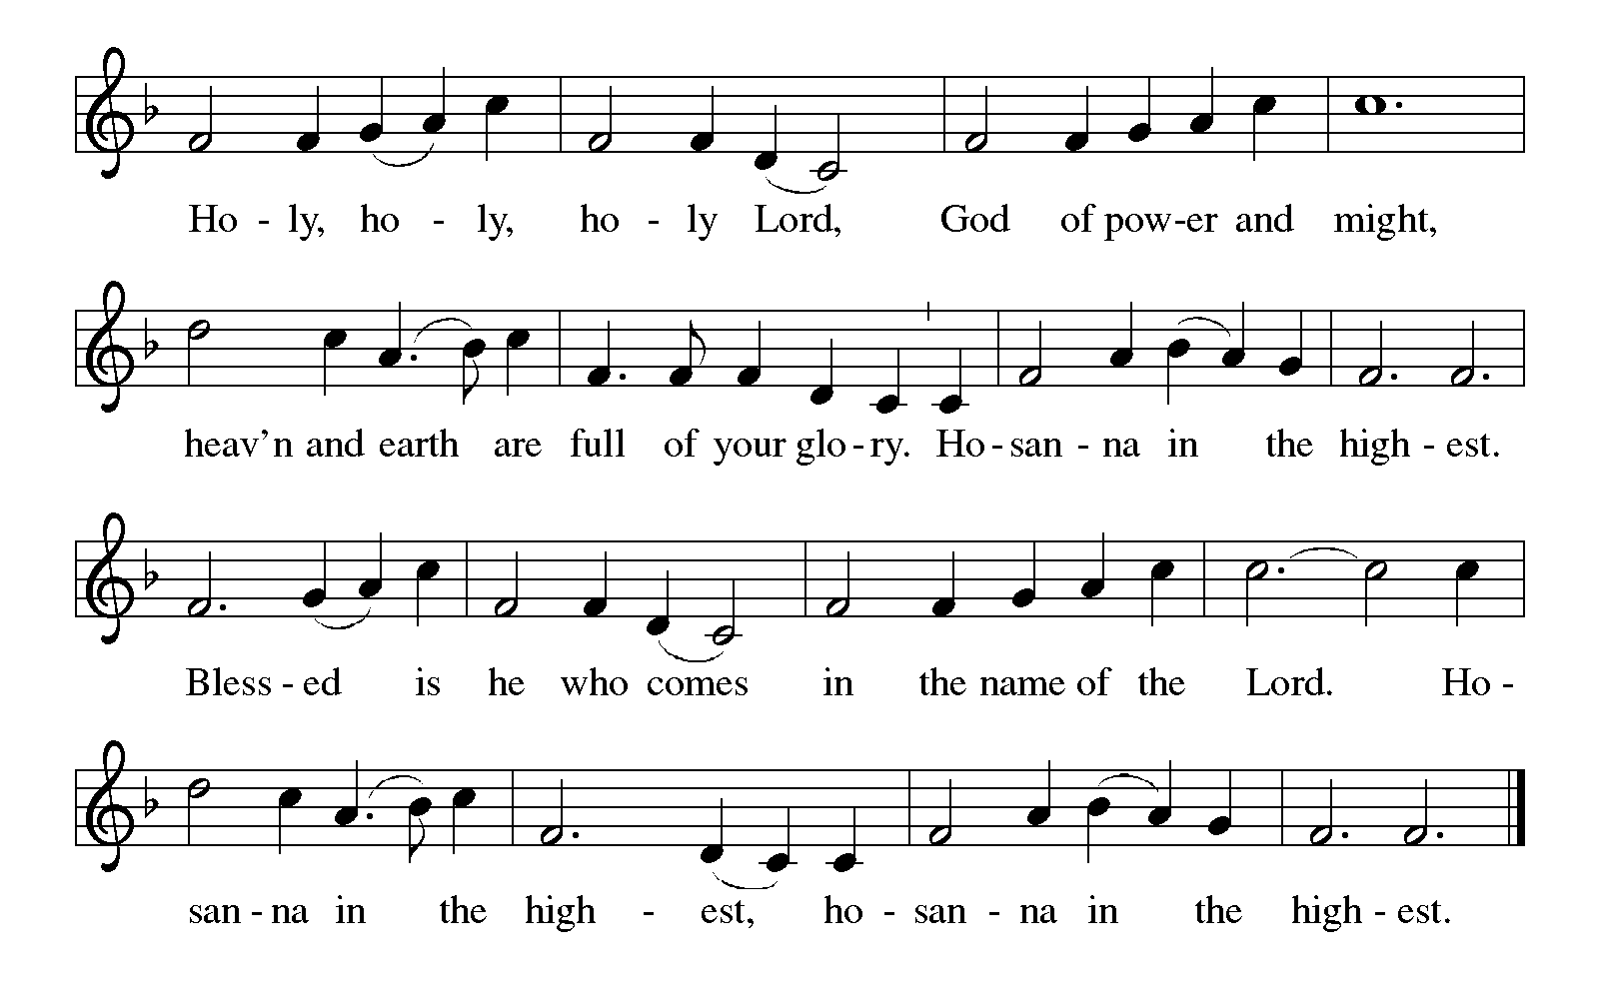
*THANKSGIVING AT THE TABLE

Blessed are you, O God of the universe…

With this bread and cup we remember our Lord’s passover from death to life as we proclaim the mystery of faith:
Christ has died. Christ is risen. Christ will come again.

…Grace our table with your presence.
Come, Holy Spirit.

…Send us forth, burning with justice, peace, and love.
Come, Holy Spirit.

…we praise you, O God, blessed and holy Trinity, now and forever.
Amen.

*LORD’S PRAYER

Our Father in heaven, hallowed be your name, your kingdom come, your will be done, on earth as in heaven. Give us today our daily bread. Forgive us our sins
as we forgive those who sin against us. Save us from the time of trial and deliver us from evil. For the kingdom, the power, and the glory are yours, now and forever. Amen.

DISTRIBUTION OF HOLY COMMUNION
We believe that this is Jesus' table. All are welcome and invited to commune. We serve communion by “intinction”; receive the bread and dip it in the chalice of red wine. Currently we are offering individual communion cups as an alternative to intinction if you so desire. Both wine and grape juice (white) are offered in the tray. Gluten free bread is available; let your server know. Should you choose not to commune, please come forward to receive a blessing. Please cross your arms across your chest.



O LAMB OF GOD
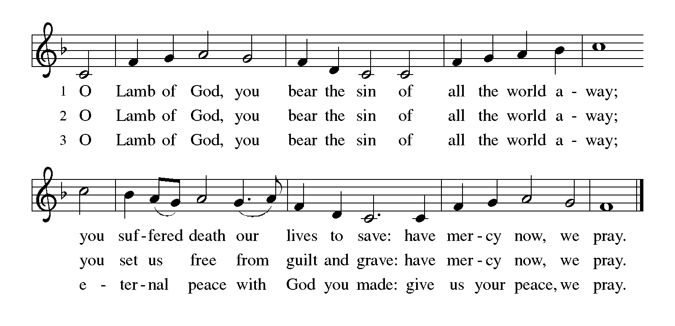

COMMUNION SONG Just As I Am, without One Plea #592

PRAYER AFTER COMMUNION
Let us pray together. Embodied God, at your table, we have tasted the goodness of Jesus. With the eyes of our hearts open to your promise, empower us to hear the needs of our neighbors and touch the world with your love.
Amen.

SENDING
God blesses us and sends us in mission to the world.

*BLESSING

SENDING HYMN I Want Jesus to Walk with Me #325

DISMISSAL
Go in peace. Serve in love. Thanks be to God.

POSTLUDE Roger Halvorson


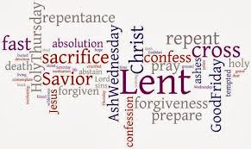

CHRIST LUTHERAN CHURCH STAFF

Interim Pastor Rev. Laurie Arroyo, lauriethere@msn.com
Office Manager Kim Croes, officemanager@christlutheranlb.com
Preschool Director Lisa Clinton, info@clplb.com
Interim Choir Director Kim Philips, kimsings@msn.com
Accompanist Roger Halvorson
Percussionist Nathan Latiolait
Missionary to Colombia Linda Gawthorne

It is our joy to worship with your whole family this morning!

CHILDCARE

We encourage everyone of all ages and abilities to worship together. If you do need to take a "time out", please do so in the narthex (gathering space at the entry), and return to worship when you are ready. A changing table is located in the restroom off the narthex. Activity bags, filled with crayons, paper and storybooks, are available in the narthex. Please ask an usher if you need any assistance.

OUR MISSION STATEMENT

Christ Is Alive!

OUR VISION STATEMENT

Christ Lutheran Church is a community of believers committed to praising our Savior Jesus Christ. With his love, we reach out to those in need and welcome all with open hearts. Our worship dynamically combines, word, song and prayer to share God’s incredible message. Having faith in this, we go forth knowing that with God and the power of the Holy Spirit, anything is possible.

LIKE us on Facebook at www.facebook.com/christlutheranlb

Write a review of Christ Lutheran Church on YELP!

