**First Sunday of Advent**

**November 27, 2022**

**9:30am**



**Christ Lutheran Church**

6500 E. Stearns Street

Long Beach, California 90815

Phone 562-598-2433

www.christlutheranlb.com

Preschool 562-594-6117

[www.clclb.com](http://www.clclb.com)

**Welcome to worship! We’re glad you’re here!**

To assist in your worship:

**bold** print means we respond together

**\*** meansstand as you are able,

+ you may make the sign of the cross should you so desire.

**TODAY’S worship THEME**

The new church year begins with a wake-up call: Christ is coming soon! In today’s readings both Paul and Jesus challenge us to wake from sleep, for we know neither the day nor hour of the Lord’s coming. Isaiah proclaims the day when God will gather all people on the holy mountain and there will be no more war or suffering. Though we vigilantly watch for the promised day of salvation, we wait for what we already have: Christ comes among us this day as the word and meal that strengthens our faith in the promises of God.



Our liturgy is taken from:

Sundays and Seasons.com. Copyright 2022 Augsburg Fortress. All rights reserved.

Reprinted by permission under Augsburg Fortress Liturgies Annual License #20338.

Reprinted by permission under CCLI license # 230154. All rights reserved

Reprinted by permission under © 2022 One License #A-706154. All rights reserved

**GATHERING**

*The Holy Spirit calls us together as the people of God._________________________*

**PRELUDE**

**WELCOME AND ANNOUNCEMENTS**

**LIGHTING THE ADVENT WREATH**

**Praise to you, O God, our salvation who is near.**

**You hold us in our waiting and keep us awake to the world.**

**You show up in our lives at unexpected times.**

**Bless us as we light this candle to keep vigil for your arrival.**

**We trust that even though we do not know the day or the hour,**

**you hurry to gather all people to your peace. Amen.**

**ADVENT CANDLE SONG *Light One Candle to Watch for Messiah # 240 vs 1***

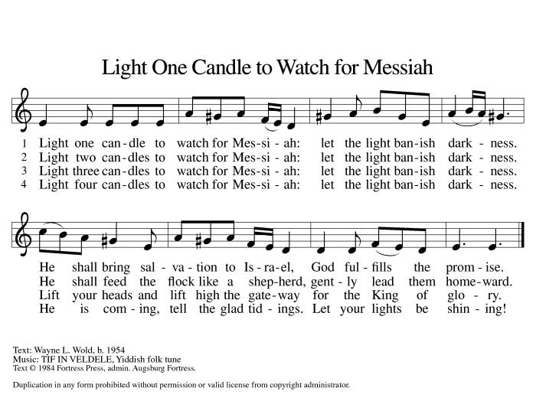

**CONFESSION AND FORGIVENESS**

*All may make the sign of the cross, the sign that is marked at baptism, as the presiding minister begins.*

Blessed be the Lord, the God of Israel, who alone does wondrous things.

**Blessed be God’s name forever.**

**Amen.**

Beloved, now is the time to wake from sleep. Let us confront our sins, and confess them to the one who is merciful and just.

*Silence is kept for reflection.*

God of new beginnings, **we confess that we have not welcomed your holy reign. We have strayed from your paths. We prepare for war instead of peace. We dishonor one another and your creation. Purify us with your refining fire and set us again on your way of love, that we may bear fruit worthy of repentance, and welcome your coming among us.**

**Amen.**

People of God, a new thing is growing in our midst, a tender branch, a living sign.

By water and the Spirit you are joined to this wonder. You have put on ☩ Christ,

and your sins have been washed away. Rejoice in the way of the Lord.

**Amen.**

**GATHERING SONG** *Prepare the Royal Highway #264*

**\*GREETING**

The grace of our Lord Jesus Christ, the love of God,and the communion of the Holy Spirit be with you all. **And also with you.**

**\*canticle of praise**  *Glory Be To God*

**\*PRAYER OF THE DAY**

Let us pray. *A brief silence***. Stir up your power, Lord Christ, and come. By your merciful protection save us from the threatening dangers of our sins, and enlighten our walk in the way of your salvation, for you live and reign with the Father and the Holy Spirit, one God, now and forever. Amen.**

**WORD**

*God speaks to us in scripture reading, preaching, and song.______________________*

**CHILDREN’S MESSAGE**

**ANTHEM** *Like a Child, I Wait* Ruth Elaine Schram

Chancel Choir

**SCRIPTURE READING** Isaiah 2:1-5 PewBible Old Testament Pg.700

Word of God, Word of Life. **Thanks be to God.**

**RESPONSIVE PSALM** Psalm 122 PewBible Old Testament Pg.633

**I was glad when they said to me, "Let us go to the house of the LORD!"** 2Our feet are standing within your gates, O Jerusalem.  
 **3Jerusalem — built as a city that is bound firmly together.** 4To it the tribes go up, the tribes of the LORD, as was decreed for Israel, to give thanks to the name of the LORD.  
**5For there the thrones for judgment were set up, the thrones of the house of David.** 6Pray for the peace of Jerusalem: "May they prosper who love you.  
 7Peace be within your walls, and security within your towers."  
 8For the sake of my relatives and friends I will say, "Peace be within you."  
 **9For the sake of the house of the LORD our God, I will seek your good.**

**\*GOSPEL ACCLAMATION** *He Came Down #253*

**\*GOSPEL** Matthew 24:36-44  Pew Bible New Testament Pg. 28

The Holy Gospel according to Matthew, the 24th chapter. **Glory to you, O Lord.**

The reading concludes: The Gospel of the Lord. **Praise to you, O Christ.**

**SERMON**

**\*SERMON SONG** *People, Look East #248*

**\*APOSTLES’ CREED**

**I believe in God, the Father almighty, creator of heaven and earth.**

**I believe in Jesus Christ, God's only Son, our Lord, who was conceived by the Holy Spirit, born of the virgin Mary, suffered under Pontius Pilate, was crucified, died, and was buried; he descended to the dead. On the third day he rose again; he ascended into heaven, he is seated at the right hand of the Father, and he will come to judge the living and the dead.**

**I believe in the Holy Spirit, the holy catholic Church, the communion of saints,**

**the forgiveness of sins, the resurrection of the body, and the life everlasting. Amen.**

**PRAYERS OF THE CHURCH**

As we prepare for the fullness of Christ’s presence, let us pray for a world that yearns for new hope.

*A brief silence.*

God of all, your children everywhere cry out for mercy. Awaken the global church to the urgent needs of our time. Break down barriers of culture and custom and unite people of all faiths in your redemptive and healing work.

God, in your mercy, **hear our prayer.**

God of our longing, you know our deepest needs. By your Spirit, gather our prayers and join them with the prayers of all your children. In Jesus’ name we pray.

**Amen.**

**\*SHARING OF PEACE**

The peace of the Lord be with you always. **And also with you.**

**OFFERTORY**

**\*OFFERTORY RESPONSE** *Give Thanks*

**\*OFFERTORY PRAYER**

Let us pray,Eternal God, you make the desert bloom and send springs of water to thirsty ground. Receive these simple gifts of bread, wine, and money, and make us messengers of your mercy and love for all in need of your healing and justice. We ask this through Christ our Savior. **Amen.**

**MEAL**

*God feeds us with the presence of Jesus.*

**\*THE GREAT THANKSGIVING**

The Lord be with you. **And also with you.**

Lift up your hearts. **We lift them to the Lord,**

Let us give thanks to the Lord our God. **It is right to give our thanks and praise.**

It is indeed right, our duty and our joy … we praise your name and join their unending hymn:

**\*HOLY, HOLY, HOLY**

**\*THANKSGIVING AT THE TABLE**

Blessed are you, O God...

…For as often as we eat this bread and drink this cup, we proclaim the Lord’s death until he comes. **Christ has died. Christ is risen. Christ will come again.**

\***LORD’S PRAYER**

**Our Father, who art in heaven, hallowed be thy name, thy kingdom come, thy will be done, on earth as it is in heaven. Give us this day our daily bread; and forgive us our trespasses, as we forgive those who trespass against us; and lead us not into temptation, but deliver us from evil. For thine is the kingdom, and the power, and the glory, forever and ever. Amen.**

**DISTRIBUTION OF HOLY COMMUNION**

We believe that this is Jesus' table. All are welcome and invited to commune.  We serve communion by “intinction”; receive the bread and dip it in the chalice of red wine. Currently we are offering individual communion cups as an alternative to intinction if you so desire. Both wine and grape juice (white) are offered in the tray. Gluten free bread is available; let your server know. Should you choose not to commune, please come forward to receive a blessing. Please cross your arms across your chest.





**lamb of god**

**COMMUNION SONG** *I Have Decided Amy Grant*

Marvin Moon and Gary Burkard

**\*PRAYER AFTER COMMUNION**

**Faithful God, in this meal you have remembered your mercy, bringing heaven to earth in the body and blood of Christ. As we wait for the day when all your promises will be fulfilled, sustain us and strengthen us by this holy mystery. Guide us toward your promised future, coming to birth in Jesus Christ our Savior and Lord.** **Amen.**

**SENDING**

*God blesses us and sends us in mission to the world.*

*______________________________________________________________________*

**\*BLESSING**

God the eternal Word, who dwells with us in Jesus, and who holds us in the grace of the Holy Spirit, ☩ bless you now and forever. **Amen.**

**\*SENDING** *The King Shall Come Down #260*

**\*Dismissal**

Go in peace. Christ is near. **Thanks be to God.**

**POSTLUDE**



**CHRIST LUTHERAN CHURCH STAFF**

**Interim Pastor**  Rev. Laurie Arroyo, [pastor@christlutheranlb.com](mailto:pastor@christlutheranlb.com)

**Office Manager** Kim Croes, [officemanager@christlutheranlb.com](mailto:officemanager@christlutheranlb.com)

**Interim Choir Director** Kim Philips, kimsings@msn.com

**Preschool Director** Lisa Clinton, info@clplb.com

**Accompanist** Roger Halvorson

**Percussionist** Nathan Latiolait

**Missionary to Colombia** Linda Gawthorne

**It is our joy to worship with your whole family this morning!**

**CHILDCARE**

We encourage everyone of all ages and abilities to worship together. If you do need to take a "time out", please do so in the narthex (gathering space at the entry), and return to worship when you are ready. A changing table is located in the restroom off the narthex. Activity bags, filled with crayons, paper and storybooks, are available in the narthex. Please ask an usher if you need any assistance.

**OUR MISSION STATEMENT**

*Christ Is Alive!*

**OUR VISION STATEMENT**

*Christ Lutheran Church is a community of believers committed to praising our Savior Jesus Christ. With his love, we reach out to those in need and welcome all with open hearts. Our worship dynamically combines, word, song and prayer to share God’s incredible message. Having faith in this, we go forth knowing that with God and the power of the Holy Spirit, anything is possible.*

**LIKE** us on **Facebook** at [www.facebook.com/christlutheranlb](http://www.facebook.com/christlutheranlb)

Write a review of Christ Lutheran Church on **YELP!**