Fourth Sunday of Easter
April 21, 2024
9:30am

Christ Lutheran Church
6500 E. Stearns Street
Long Beach, California 90815
Phone 562-598-2433
www.christlutheranlb.com

Preschool 562-594-6117
www.clplb.com

Welcome to worship! We’re glad you’re here!

To assist in your worship:

bold print means we respond together
* means stand as you are able,
+ you may make the sign of the cross should you so desire.

TODAY’S worship THEME
The image of the good shepherd shows us how the risen Christ brings us to life. It is the relationship between the shepherd and the sheep, one of mutual knowledge and love, that gives the shepherd authority. The shepherd’s willingness to lay down his life for the sheep shows his love. First John illustrates what it means to lay down our lives for one another by the example of sharing our wealth with any sibling in need.

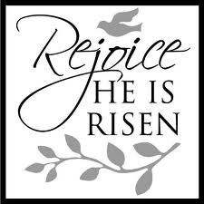

Our liturgy is taken from:
Sundays and Seasons.com. Copyright 2024 Augsburg Fortress. All rights reserved.
Reprinted by permission under Augsburg Fortress Liturgies Annual License #20338.
Reprinted by permission under CCLI license # 230154. All rights reserved.
Reprinted by permission under © 2024 One License #A-706154. All rights reserved.
PRELUDE Roger Halvorson

WELCOME AND ANNOUNCEMENTS

GATHERING
The Holy Spirit calls us together as the people of God.

*THANKSGIVING FOR BAPTISM

Blessed be the holy Trinity, ☩ one God, the wellspring of grace, our Easter and our joy.
Amen.

Look, here is water! Here is our water of life! Alleluia!

Immersed in the promises of baptism, let us give thanks for what God has done for us.

We give you thanks, O God, for in the beginning your voice thundered over the deep
and water became the essence of life. Adam and Eve beheld Eden’s verdant rivers.
The ark carried your creation through the flood into a new day. Miriam led the dancing as your people passed through the sea into freedom’s land. In a desert pool the Ethiopian official entered your boundless baptismal life.

At the river your beloved Son was baptized by John and anointed with the Holy Spirit.
By the baptism of Jesus’ death and resurrection you opened the floodgates of your reconciling love, freeing us to live as Easter people. We rejoice with glad hearts,
giving all honor and praise to you, through the risen Christ, our source of living water,
in the unity of the Holy Spirit, now and forever. Amen.

Look, here is water! Here is our water of life! Alleluia!

*GATHERING SONG Gather Us In ELW #532

*GREETING
The grace of our Lord Jesus Christ, the love of God, and the communion of the Holy Spirit be with you all. And also with you.

*PRAYER OF THE DAY
Let us pray. A brief silence. O Lord Christ, good shepherd of the sheep, you seek the lost and guide us into your fold. Feed us, and we shall be satisfied; heal us, and we shall be whole. Make us one with you, for you live and reign with the Father and the Holy Spirit, one God, now and forever. Amen.

WORD
God speaks to us in scripture reading, preaching, and song.______________________

CHILDREN’S CHAT After this time, children will be invited to Sunday school. They will return during the passing of the peace.

SPECIAL MUSIC Chancel Choir

RESPONSIVE PSALM Psalm 23 Pew Bible Old Testament Pg.553
¹The LORD is my shepherd, I shall not want.
²He makes me lie down in green pastures; he leads me beside still waters;
³he restores my soul. He leads me in right paths for his name's sake.
⁴Even though I walk through the darkest valley, I fear no evil; for you are with me;
your rod and your staff — they comfort me.
⁵You prepare a table before me in the presence of my enemies; you anoint my head with oil; my cup overflows.
⁶Surely goodness and mercy shall follow me all the days of my life, and I shall dwell in the house of the LORD my whole life long.

READING 1 John 3:16-24 Pew Bible New Testament Pg.260

Word of God, Word of Life. Thanks be to God.

*GOSPEL ACCLAMATION Alleluia ELW pg.142

*GOSPEL John 10:11-18 Pew Bible New Testament Pg. 107

The Holy Gospel according to John the 10th chapter. Glory to you, O Lord.
The reading concludes: The Gospel of the Lord. Praise to you, O Christ.

SERMON Pastor Nikki Fielder

*SERMON HYMN Have No Fear, Little Flock ELW #764

*APOSTLES’ CREED

I believe in God, the Father almighty, creator of heaven and earth.

I believe in Jesus Christ, God’s only Son, our Lord, who was conceived by the Holy Spirit, born of the virgin Mary, suffered under Pontius Pilate, was crucified, died, and was buried; he descended to the dead. On the third day he rose again; he ascended into heaven, he is seated at the right hand of the Father, and he will come to judge the living and the dead.

I believe in the Holy Spirit, the holy catholic church, the communion of saints, the forgiveness of sins, the resurrection of the body, and the life everlasting. Amen.

PRAYERS OF THE CHURCH

Rejoicing that Jesus is risen, and love has triumphed over fear, let us pray for the church, the world, and all those in need of good news.

A brief silence.

God of grace,
hear our prayer.

Into your hands, most merciful God, we commend all for whom we pray, trusting in your abiding love; through Jesus Christ, our resurrected and living Lord. Amen.

*SHARING OF PEACE

The peace of Christ be with you always. And also with you.

OFFERTORY Music Makers

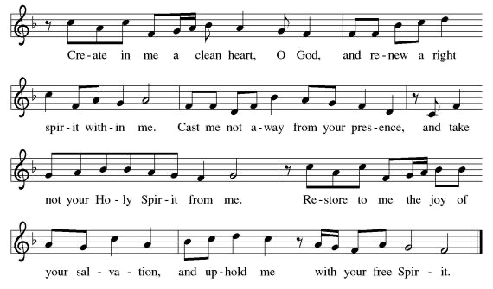
*OFFERTORY RESPONSE Create in Me a Clean Heart ELW #186
*OFFERTORY PRAYER

Let us pray together, Risen One, you call us to believe and bear fruit. May the gifts that we offer here be signs of your abiding love. Form us to be your witnesses in the world, through Jesus Christ, our true vine. Amen.
MEAL
God feeds us with the presence of Jesus.

*THE GREAT THANKSGIVING

The Lord be with you. And also with you.
Lift up your hearts. We lift them to the Lord,
Let us give thanks to the Lord our God. It is right to give our thanks and praise.
It is indeed right, our duty and our joy…
…and with angels and archangels, cherubim and seraphim, we praise your name and join their unending hymn:
*HOLY, HOLY, HOLY Holy, Holy, Holy ELW pg.153
*THANKSGIVING AT THE TABLE

…with this bread and cup, we remember our Lord’s passover from death to life as we proclaim the mystery of faith: Christ has died. Christ is risen. Christ will come again.

…Grace our table with your presence. Come, Holy Spirit.
…Send us forth, burning with justice, peace, and love. Come, Holy Spirit.
…blessed and holy Trinity, now and forever. Amen.

*LORD’S PRAYER

Our Father in heaven, hallowed be your name, your kingdom come, your will be done, on earth as in heaven. Give us today our daily bread. Forgive us our sins
as we forgive those who sin against us. Save us from the time of trial and deliver us from evil. For the kingdom, the power, and the glory are yours, now and forever. Amen.

DISTRIBUTION OF HOLY COMMUNION
We believe that this is Jesus' table. All are welcome and invited to commune. We serve communion by “intinction”; receive the bread and dip it in the chalice of red wine. Currently we are offering individual communion cups as an alternative to intinction if you so desire. Both wine and grape juice (white) are offered in the tray. Gluten free bread is available; let your server know. Should you choose not to commune, please come forward to receive a blessing. Please cross your arms across your chest.

INVITATION TO COMMUNION

The risen Christ is made known to us in the breaking of the bread. Come and eat at God’s table.

lamb of god Lamb of God ELW pg.154

COMMUNION SONG Sheperd Me, O God ELW #780
*POST COMMUNION BLESSING
The body and blood of our Lord Jesus Christ strengthen you and keep you in his grace. Amen.

*PRAYER AFTER COMMUNION

Let us pray, Shepherding God, you have prepared a table before us and nourished us with your love. Send us forth from this banquet to proclaim your goodness and share the abundant mercy of Jesus, our redeemer and friend. Amen.
SENDING
God blesses us and sends us in mission to the world.

*BLESSING

Alleluia! Christ is risen! Christ is risen indeed! Alleluia!
The God of resurrection power, the Christ of unending joy, and the Spirit of Easter hope
☩ bless you now and always. Amen.

*SENDING HYMN Go Out With Joy (2 times through)
Go out with joy and be led forth in peace,
the mountains and the hills shall break forth singing.
Go out with joy and be led forth in peace,
the mountains and the hills shall break forth singing.

And all the trees of the field shall clap their hands,
The Lord almighty shall be praised.
And all the trees of the field shall clap their hands,
the word of the Lord shall be forever.
*Dismissal
Alleluia! Go in peace. Rejoice and be glad.
Thanks be to God. Alleluia!

POSTLUDE Roger Halvorson

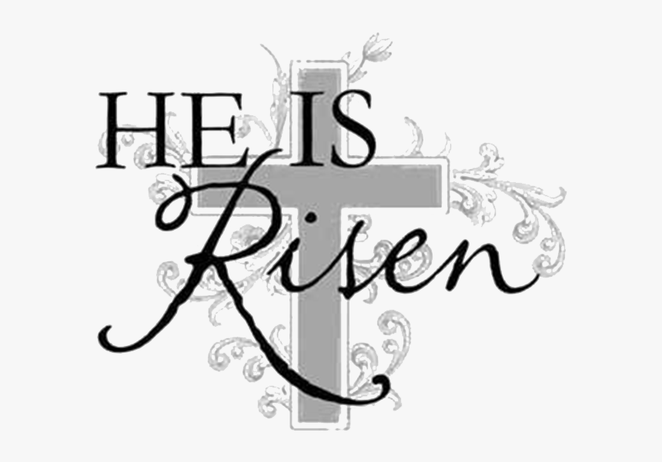

CHRIST LUTHERAN CHURCH STAFF

Pastor Rev. Nikki Fielder, pastor@christlutheranlb.com
Office Manager Kim Croes, officemanager@christlutheranlb.com
Preschool Director Lisa Clinton, info@clplb.com
Choir Director Kim Philips, kimsings@msn.com
Accompanist Roger Halvorson
A/V Technicians Brad Croes and Josh Baker
Missionary to Colombia Linda Gawthorne

It is our joy to worship with your whole family this morning!

We encourage everyone of all ages and abilities to worship together. If you do need to take a "time out", please do so in the narthex (gathering space at the entry), and return to worship when you are ready. A changing table is located in the restroom off the narthex. Activity bags, filled with crayons, paper and storybooks, are available in the narthex. Please ask an usher if you need any assistance.

Mission Statement
Living by Christ’s example, we welcome, serve, and love all through God’s grace.

Vision Statement
Embracing the truth that God’s love and grace is for all, Christ Lutheran Church is a vibrant and active community spreading the good news through acceptance, action, and benevolence.

Our Position
Christ is ALIVE!

LIKE us on Facebook at www.facebook.com/christlutheranlb

Write a review of Christ Lutheran Church on YELP

