Second Sunday of Lent
February 25, 2024
9:30am

Christ Lutheran Church
6500 E. Stearns Street
Long Beach, California 90815
Phone 562-598-2433
www.christlutheranlb.com

Preschool 562-594-6117
www.clplb.com
Welcome to worship! We’re glad you’re here!

To assist in your worship:

bold print means we respond together
* means stand as you are able,
+ you may make the sign of the cross should you so desire.

TODAY’S worship THEME
The second covenant in this year’s Lenten readings is the one made with Abraham and Sarah: God’s promise to make them the ancestors of many, with whom God will remain in everlasting covenant. Paul says this promise comes to all who share Abraham’s faith in the God who brings life into being where there was no life. We receive this baptismal promise of resurrection life in faith. Sarah and Abraham receive new names as a sign of the covenant, and we too get new identities in baptism, as we put on Christ.

Our liturgy is taken from:
Sundays and Seasons.com. Copyright 2024 Augsburg Fortress. All rights reserved.
Reprinted by permission under Augsburg Fortress Liturgies Annual License #20338.
Reprinted by permission under CCLI license # 230154. All rights reserved
Reprinted by permission under © 2024 One License #A-706154. All rights reserved

PRELUDE Roger Halvorson

WELCOME AND ANNOUNCEMENTS

GATHERING
The Holy Spirit calls us together as the people of God._______________________

CONFESSION AND FORGIVENESS
All may make the sign of the cross, the sign that is marked at baptism, as the presiding minister begins.

Blessed be the holy Trinity, ☩ one God, who writes the law on our hearts, who draws all people together through Jesus. Amen.

Held in God’s mercy, let us confess our sin in the presence of God and of one another.

(Silence is kept for reflection.)

Holy God, we confess that we are caught in snares of sin and cannot break free.
We hoard resources while our neighbors are hungry and cold. We speak in ways that silence others. We are silent when we should speak up. We keep score in our hearts. We let hurts grow into hatred. For all these things and for sins only you know, forgive us, Lord. Amen.

Here is a flood of grace: Out of love for the whole world, God draws near to us, breaks every snare of sin, washes away our wrongs, and restores the promise of life through ☩ Jesus Christ. Amen.

*GATHERING SONG I Will Call Upon the Lord (2x through)

*GREETING The grace of our Lord Jesus Christ, the love of God, and the communion of the Holy Spirit be with you all. And also with you.

*pRAYER OF THE DAY
Let us pray together. A brief silence. O God, by the passion of your blessed Son you made an instrument of shameful death to be for us the means of life. Grant us so to glory in the cross of Christ that we may gladly suffer shame and loss for the sake of your Son, Jesus Christ, our Savior and Lord, who lives and reigns with you and the Holy Spirit, one God, now and forever. Amen.

WORD
God speaks to us in scripture reading, preaching, and song.______________________

CHILDREN’S MESSAGE After this time, children will be invited to Sunday school. They will return during the passing of the peace.

FIRST READING Genesis 17:1-7,15-16 Pew Bible Old Testament Pg. 14

SECOND READING Romans 4:13-25 Pew Bible New Testament Pg. 161

Word of God, Word of Life. Thanks be to God

*GOSPEL ACCLAMATION Return to the Lord ELW pg.142

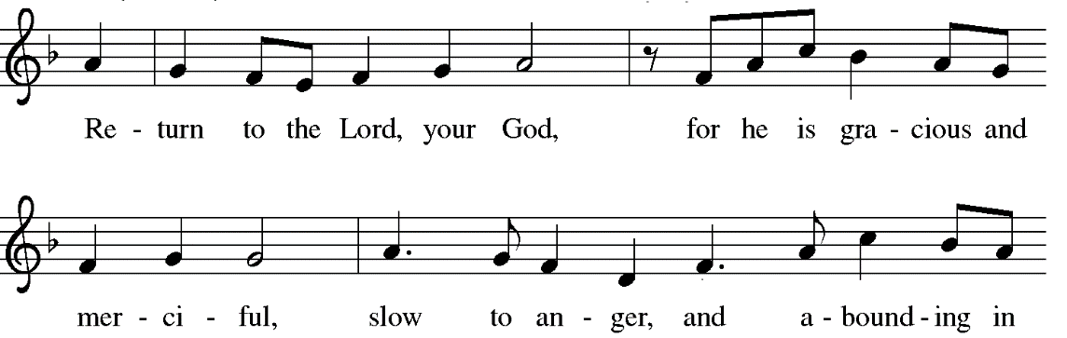

*GOSPEL Mark 8:31-38 Pew Bible New Testament Pg.44
The Holy Gospel according to Mark the 8th chapter. Glory to you, O Lord.
The reading concludes: The Gospel of the Lord. Praise to you, O Christ.

SERMON Pastor Nikki Fielder

*SERMON SONG Will You Come and Follow Me ELW #798

*APOSTLES’ CREED

I believe in God, the Father almighty, creator of heaven and earth.

I believe in Jesus Christ, God’s only Son, our Lord, who was conceived by the Holy Spirit, born of the virgin Mary, suffered under Pontius Pilate, was crucified, died, and was buried; he descended to the dead. On the third day he rose again; he ascended into heaven, he is seated at the right hand of the Father, and he will come to judge the living and the dead.

I believe in the Holy Spirit, the holy catholic church, the communion of saints, the forgiveness of sins, the resurrection of the body, and the life everlasting. Amen

PRAYERS OF THE CHURCH

Trusting in God’s promise to reconcile all things, let us pray for the church, the well-being of creation, and a world in need.
A brief silence.
Hear us, O God. Your mercy is great.

Accompany us on our journey, God of grace, and receive the prayers of our hearts, through Jesus Christ, our Savior. Amen.

*SHARING OF PEACE

The peace of the Lord be with you always. And also with you.

OFFERTORY Be Ye Glad Chancel Choir

*OFFERTORY RESPONSE Create in Me a Clean Heart ELW #186
*OFFERTORY PRAYER

Let us pray together: Jesus, you are the bread of life and the host of this meal. Bless these gifts that we have gathered that all people may know your goodness. Feed us not only with this holy food but with hunger for justice and peace. We pray this in your name. Amen.
MEAL
God feeds us with the presence of Jesus._____________________________________

*THE GREAT THANKSGIVING

The Lord be with you. And also with you.
Lift up your hearts. We lift them to the Lord,
Let us give thanks to the Lord our God. It is right to give our thanks and praise.
It is indeed right, our duty and our joy…
We praise your name and join their unending hymn:
*SONG OF THANKSGIVING Holy, Holy, Holy ELW pg.207

*THANKSGIVING AT THE TABLE

…with this bread and cup, we remember our Lord’s passover from death to life as we proclaim the mystery of faith: Christ has died. Christ is risen. Christ will come again.

…Grace our table with your presence. Come, Holy Spirit.
… Send us forth, burning with justice, peace, and love. Come, Holy Spirit.
… blessed and holy Trinity, now and forever. Amen.

*LORD’S PRAYER
Our Father in heaven, hallowed be your name, your kingdom come, your will be done, on earth as in heaven. Give us today our daily bread. Forgive us our sins
as we forgive those who sin against us. Save us from the time of trial and deliver us from evil. For the kingdom, the power, and the glory are yours, now and forever. Amen.

DISTRIBUTION OF HOLY COMMUNION
We believe that this is Jesus' table. All are welcome and invited to commune. We serve communion by “intinction”; receive the bread and dip it in the chalice of red wine. Currently we are offering individual communion cups as an alternative to intinction if you so desire. Both wine and grape juice (white) are offered in the tray. Gluten free bread is available; let your server know. Should you choose not to commune, please come forward to receive a blessing. Please cross your arms across your chest.

INVITATION TO COMMUNION
Bread for the journey. A feast for hungry hearts. Come!

lamb of god O Lamb of God ELW #208

COMMUNION SONG Make Me a Channel of Your Peace
*POST COMMUNION BLESSING
The body and blood of our Lord Jesus Christ strengthen you and keep you in his grace. Amen.

*PRAYER AFTER COMMUNION
Let us pray together. Generous God, at this table we have tasted your immeasurable grace. As grains of wheat are gathered into one bread, now make us one loaf to feed the world; in the name of Jesus, the Bread of life. Amen.
SENDING
God blesses us and sends us in mission to the world.__________________________

*BLESSING

Beloved, we are God’s own people, holy, washed, renewed. God bless you and keep you, shower you with mercy, fill you with courage, and ☩ give you peace. Amen.

*SENDING SONG The God of Abraham Praise ELW #831
*DISMISSAL
Go in peace. Share your bread. Thanks be to God.

POSTLUDE Roger Halvorson
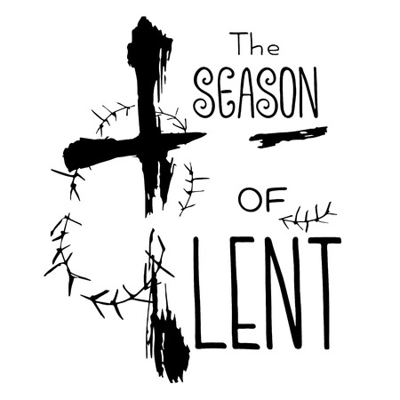

CHRIST LUTHERAN CHURCH STAFF

Pastor Rev. Nicole Fielder, pastor@christlutheranlb.com
Office Manager Kim Croes, officemanager@christlutheranlb.com
Preschool Director Lisa Clinton, info@clplb.com
Interim Choir Director Kim Philips, kimsings@msn.com
Accompanist Roger Halvorson
A/V Technician Brad Croes
Missionary to Colombia Linda Gawthorne

It is our joy to worship with your whole family this morning!

We encourage everyone of all ages and abilities to worship together. If you do need to take a "time out", please do so in the narthex (gathering space at the entry), and return to worship when you are ready. A changing table is located in the restroom off the narthex. Activity bags, filled with crayons, paper and storybooks, are available in the narthex. Please ask an usher if you need any assistance.

Mission Statement
Living by Christ’s example, we welcome, serve, and love all through God’s grace.

Vision Statement
Embracing the truth that God’s love and grace is for all, Christ Lutheran Church is a vibrant and active community spreading the good news through acceptance, action, and benevolence.

Our Position
Christ is ALIVE!

LIKE us on Facebook at www.facebook.com/christlutheranlb

Write a review of Christ Lutheran Church on YELP

