Baptism of Our Lord
January 7, 2024
9:30am

Christ Lutheran Church
6500 E. Stearns Street
Long Beach, California 90815
Phone 562-598-2433
www.christlutheranlb.com

Preschool 562-594-6117
www.clclp.com

Welcome to worship! We’re glad you’re here!

To assist in your worship:

bold print means we respond together
* means stand as you are able,
+ you may make the sign of the cross should you so desire.

TODAY’S worship THEME
Our re-creation in baptism is an image of the Genesis creation, where the Spirit of God moved over the waters. Both Mark’s gospel and the story in Acts make clear that it is the Spirit’s movement that distinguishes Jesus’ baptism from John’s. The Spirit has come upon us as upon Jesus and the Ephesians, calling us God’s beloved children and setting us on Jesus’ mission to re-create the world in the image of God’s vision of justice and peace.

Our liturgy is taken from:
Sundays and Seasons.com. Copyright 2024 Augsburg Fortress. All rights reserved.
Reprinted by permission under Augsburg Fortress Liturgies Annual License #20338.
Reprinted by permission under CCLI license # 230154. All rights reserved
Reprinted by permission under © 2024 One License #A-706154. All rights reserved

PRELUDE Roger Halvorson

WELCOME AND ANNOUNCEMENTS

GATHERING

The Holy Spirit calls us together as the people of God._______________________

CONFESSION AND FORGIVENESS
All may make the sign of the cross, the sign that is marked at baptism, as the presiding minister begins.

Blessed be the holy Trinity, ☩ one God, creator of darkness and light, word of truth,
wind sweeping over the waters. Amen.

Let us confess our sin in the presence of God and of one another.
Silence is kept for reflection.

God, our rock and refuge, we pour out our hearts before you. We have known you but have not always loved you. We have wounded one another and sinned against you. We have not always recognized the Holy Spirit dwelling in each of us. Remember your covenant. Renew your creation. Restore us, that we might proclaim your good news to all. Amen.

The voice of the Lord is upon the waters. God has spoken: The time of grace is now.
In Jesus, the reign of God has come near. By the authority of ☩ Jesus Christ, your sins are forgiven. You are God’s beloved. Amen.

*GATHERING SONG Rise, Shine, You People ELW #665

*GREETING
The grace of our Lord Jesus Christ, the love of God, and the communion of the Holy Spirit be with you all. And also with you.

*pRAYER OF THE DAY
Let us pray together. A brief silence. Holy God, creator of light and giver of goodness, your voice moves over the waters. Immerse us in your grace, and transform us by your Spirit, that we may follow after your Son, Jesus Christ, our Savior and Lord, who lives and reigns with you and the Holy Spirit, one God, now and forever. Amen.

WORD
God speaks to us in scripture reading, preaching, and song.______________________

CHILDREN’S MESSAGE After this time, children will be invited to Sunday school. They will return during the passing of the peace.

SCRIPTURE READING Acts 19:1-7 Pew Bible New Testament Pg. 145

Word of God, Word of Life. Thanks be to God

RESPONSIVE PSALM Psalm 29 Pew Bible Old Testament Pg. 557

¹Ascribe to the LORD, O heavenly beings, ascribe to the LORD glory and strength.
²Ascribe to the LORD the glory of his name; worship the LORD in holy splendor.
³The voice of the LORD is over the waters; the God of glory thunders, the LORD, over mighty waters.
⁴The voice of the LORD is powerful; the voice of the LORD is full of majesty.
⁵The voice of the LORD breaks the cedars; the LORD breaks the cedars of Lebanon.
⁶He makes Lebanon skip like a calf, and Sirion like a young wild ox.
⁷The voice of the LORD flashes forth flames of fire.
⁸The voice of the LORD shakes the wilderness; the LORD shakes the wilderness of Kadesh.
⁹The voice of the LORD causes the oaks to whirl, and strips the forest bare; and in his temple all say, "Glory!"
¹⁰The LORD sits enthroned over the flood; the LORD sits enthroned as king forever.
¹¹May the LORD give strength to his people! May the LORD bless his people with peace!

*GOSPEL ACCLAMATION Listen, God is Calling ELW #513

*GOSPEL Mark 1:1-14 Pew Bible New Testament Pg. 34

The Holy Gospel according to Mark the 1st chapter. Glory to you, O Lord.
The reading concludes: The Gospel of the Lord. Praise to you, O Christ.

SERMON Pastor Nikki Fielder

*SERMON SONG Baptized and Set Free ELW #453

*Nicene CREED
We believe in one God, the Father, the Almighty, maker of heaven and earth, of all that is, seen and unseen.
We believe in one Lord, Jesus Christ, the only Son of God, eternally begotten of the Father, God from God, Light from Light, true God from true God, begotten, not made, of one Being with the Father; through him all things were made. For us and for our salvation he came down from heaven, was incarnate of the Holy Spirit and the virgin Mary and became truly human. For our sake he was crucified under Pontius Pilate; he suffered death and was buried. On the third day he rose again in accordance with the scriptures; he ascended into heaven and is seated at the right hand of the Father. He will come again in glory to judge the living and the dead, and his kingdom will have no end.
We believe in the Holy Spirit, the Lord, the giver of life, who proceeds from the Father and the Son, who with the Father and the Son is worshiped and glorified, who has spoken through the prophets.
We believe in one holy catholic and apostolic church. We acknowledge one baptism for the forgiveness of sins. We look for the resurrection of the dead, and the life of the world to come. Amen.
PRAYERS OF THE CHURCH

As we celebrate Christ embodied in human form, we pray for God’s blessing on the church, the world, and all of creation.
A brief silence.
God of grace, receive our prayer.

Knowing the Holy Spirit intercedes for us, we offer these prayers and the silent prayers of our hearts in the name of our Savior, Jesus Christ. Amen.

*SHARING OF PEACE

The peace of the Lord be with you always. And also with you.

OFFERTORY Lonnie Timney and Roger Halvorson

*OFFERTORY RESPONSE I Want to Walk as a Child of the Light ELW #815

*OFFERTORY PRAYER
Let us pray together: Blessed are you, Holy One, for all good things come from you.
In bread and cup you open heaven to us. Meet us at this table, that we receive what we seek and follow your Son, Jesus, in whose name we pray. Amen.

MEAL___________________________________________
God feeds us with the presence of Jesus.

*THE GREAT THANKSGIVING

The Lord be with you. And also with you.
Lift up your hearts. We lift them to the Lord,
Let us give thanks to the Lord our God. It is right to give our thanks and praise.
It is indeed right, our duty and our joy…
We praise your name and join their unending hymn:

*SONG OF THANKSGIVING Holy, Holy, Holy
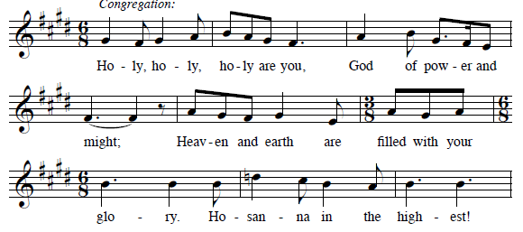

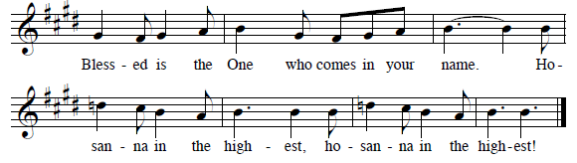

*THANKSGIVING AT THE TABLE

…with this bread and cup, we remember our Lord’s passover from death to life as we proclaim the mystery of faith: Christ has died. Christ is risen. Christ will come again.

*LORD’S PRAYER
Our Father in heaven, hallowed be your name, your kingdom come, your will be done, on earth as in heaven. Give us today our daily bread. Forgive us our sins
as we forgive those who sin against us. Save us from the time of trial and deliver us from evil. For the kingdom, the power, and the glory are yours, now and forever. Amen.

DISTRIBUTION OF HOLY COMMUNION
We believe that this is Jesus' table. All are welcome and invited to commune. We serve communion by “intinction”; receive the bread and dip it in the chalice of red wine. Currently we are offering individual communion cups as an alternative to intinction if you so desire. Both wine and grape juice (white) are offered in the tray. Gluten free bread is available; let your server know. Should you choose not to commune, please come forward to receive a blessing. Please cross your arms across your chest.

INVITATION TO COMMUNION
At Jesus’ table, heaven and earth are joined as one. Come and see.

lamb of god
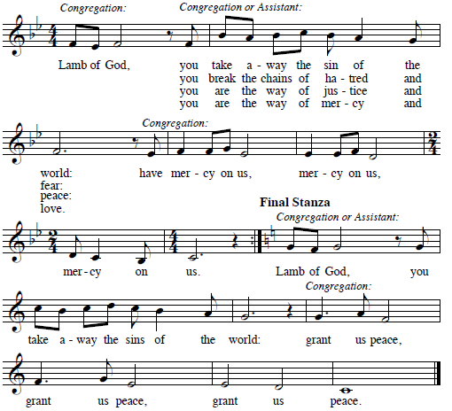

COMMUNION SONG Song Over the Waters
*PRAYER AFTER COMMUNION
Let us pray together. Giver of every gift, Christ’s body is our food, and we are Christ’s body. Raise us to life by your power for the benefit of all and to your glory, now and forever. Amen.

SENDING__________________________________________
God blesses us and sends us in mission to the world.

*BLESSING

God who names you, Christ who claims you, and the Holy Spirit who dwells in you,
☩ bless you and remain with you always. Amen.

*SENDING SONG Wade in the Water ELW #459

*DISMISSAL
Go is peace. You are God’s beloved. Thanks be to God.

POSTLUDE Roger Halvorson

CHRIST LUTHERAN CHURCH STAFF

Pastor Rev. Nicole Fielder, pastor@christlutheranlb.com
Office Manager Kim Croes, officemanager@christlutheranlb.com
Preschool Director Lisa Clinton, info@clplb.com
Interim Choir Director Kim Philips, kimsings@msn.com
Accompanist Roger Halvorson
Missionary to Colombia Linda Gawthorne

It is our joy to worship with your whole family this morning!

We encourage everyone of all ages and abilities to worship together. If you do need to take a "time out", please do so in the narthex (gathering space at the entry), and return to worship when you are ready. A changing table is located in the restroom off the narthex. Activity bags, filled with crayons, paper and storybooks, are available in the narthex. Please ask an usher if you need any assistance.

Mission Statement
Living by Christ’s example, we welcome, serve, and love all through God’s grace.

Vision Statement
Embracing the truth that God’s love and grace is for all, Christ Lutheran Church is a vibrant and active community spreading the good news through acceptance, action, and benevolence.

Our Position
Christ is ALIVE!

LIKE us on Facebook at www.facebook.com/christlutheranlb

Write a review of Christ Lutheran Church on YELP

