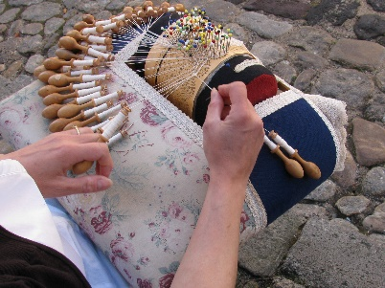

Wrapping Our Nation in Prayer

Healer of or every ill,
Breathe in and among all of us who dwell in this land.
Calm our fears.
Mend our divisions.
Hope of all tomorrows,
Open our deaf ears and fill us with Compassion.
Tender our hearts.
Inspire creative ideas to address
The cries of our sisters, brothers, and earth itself.
Send forth your Spirit of Love and Unity.
Transform pointed fingers of blame
Into hands open in reverence to receive one another.
Fan into flame the gift of our founding
Abd let us be known again as a people
United for the goodness, justice
And peace of all people forever.
Amen

Written by Pat Bergan, CSJ
Congregation of St. Joseph

