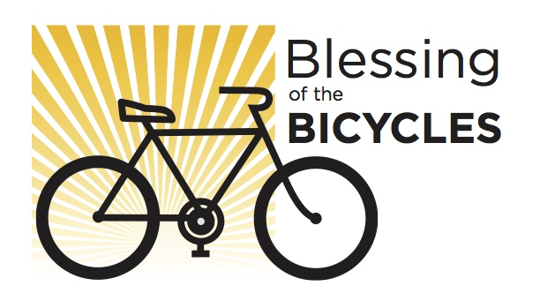

Sunday, March 19, 9:30am

Park bikes in the Narthex

Blessing at the end of Worship

group ride to

Rivers End Beach

(bring a picnic lunch)

6500 E. Stearns St., Long Beach, CA

www.***christlutheran***lb.com

Christ Lutheran Church