

**January 2017**

**Volume 61, Issue 1**

**Pastor Pam’s Pennings**

***For surely I know the plans I have for you, says the Lord, plans for your welfare and not for harm,***

***to give you a future with hope*. Jeremiah 29.11**

We have a new year ahead of us and it is God alone who knows all that is in store for these 365 days. This New Year feels different than many of late. We have a new President-elect after eight years of President Obama, and the country is adjusting to a new day in Washington D.C.

In the New Year, we pause and look back, and look ahead:

* We say a BIG thank you to Tom and Carole Parmeter Dyer for their excellent work as Interim Directors of Worship and Music. They stepped in and helped us out after Kenny’s leaving and we will be forever grateful that these two faithful members of Christ Lutheran did their part. They finished on the 31st. Thank God for them!
* We say hello and welcome to Brian Madigan, our new Director of Worship and Music, who has a passion for young people learning music and offering their gifts to God’s glory. He’s excited to be here, to have so many functioning music groups with which to work, and looks forward to meeting all of you. He begins January 1st.
* We begin the 500th Anniversary of the Reformation in 2017. It’s going to be a big birthday year for the Protestant Church – especially for us, the Lutherans!
  + - * + I hope you will all plan to join me as we study the Small Catechism in Adult Education starting March 5. Make this be part of your Lenten Discipline!
        + Bishop Guy Erwin continues his Reformation Road Trip gatherings in our synod. Join him and learn more about the Reformation. There is a poster by the office.
        + Plus, Bishop Guy will be leading a trip to Germany this year. Look to the Synod website for more information.

My prayer is that we as individuals, and as a congregation, steep this year in prayer – for our country and its leaders, for our congregation and its leaders, for each other as sisters and brothers in Christ – and in that time of prayer we, as Jeremiah says so beautifully,… *to give you a future with hope.*

Happy New Year!

Pastor Pam Challis

**++++++++++++++++++++++++++++++++++++++++++++++++++++++**

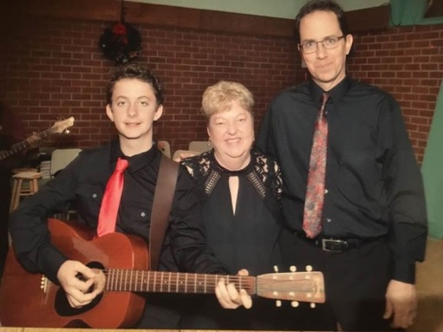

It has been a joy to serve as your musicians these past several months. Thank you to everyone who contributed to the music in worship and at the Christmas Concert. We couldn’t have been more pleased with the music and the turn out! We will be praying for you as you enter a new season with a new music director, and wish you many blessings.

God’s Peace and Hope,

Tom and Carole Parmeter Dyer

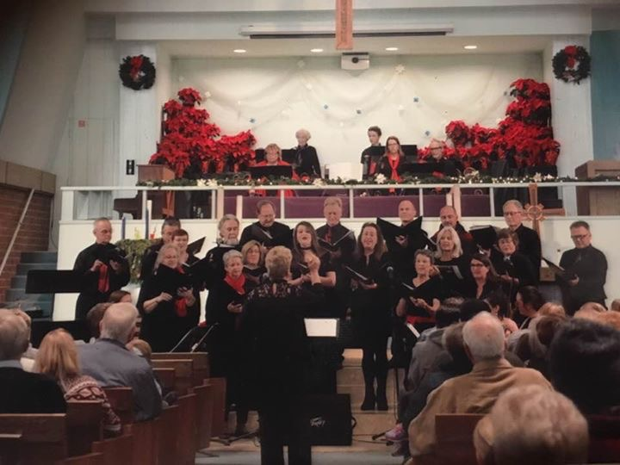

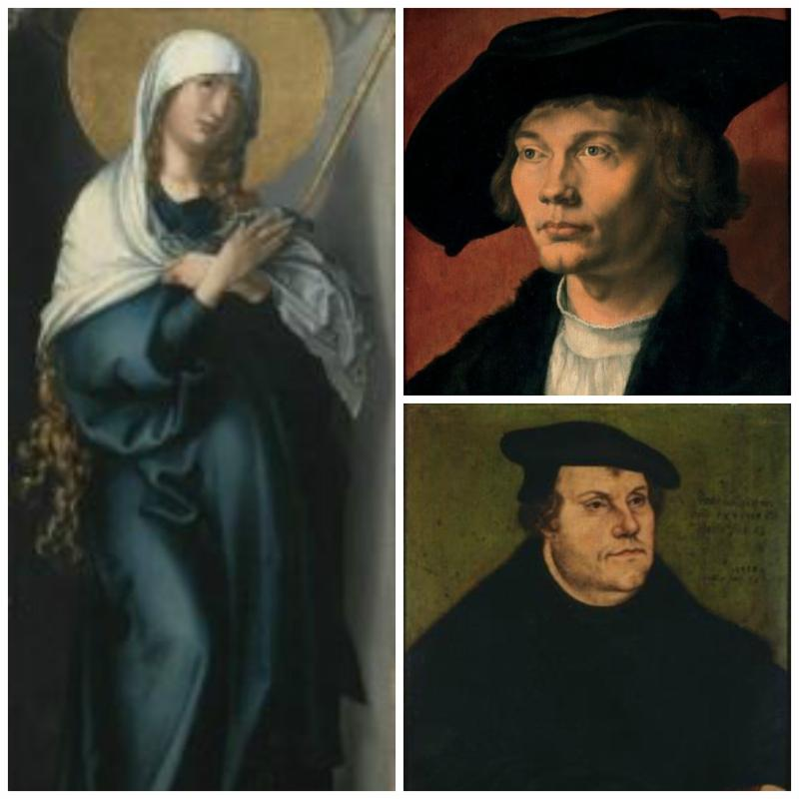**Renaissance and Reformation Exhibit at LACMA**

**Los Angeles County Museum of Art presents**

**"**[Renaissance and Reformation](http://r20.rs6.net/tn.jsp?f=001cKay5qTt2BWFtAJEj1aaCfYW6-pS3-Z74oNb3sSDjqkA_lUnqZG6dAHTpPN4Y0poLyxa6IP_9jezmc6nsFMBurIS-9CYDH91LQ8rekTi_gk8yu5iDjYaJGkUz8C3MUNYiZ-gAg5iXjTVGJYvkdrlmME6ELnUYfwEYsayeC9TRKbU_v2PTID2iE2eC5PfpkcVrIVtDR3QZsrQpVspT5cqUzBQm20Jo3VTa62RvI09jYsH6UR0Evg2k-pf60gDQ2bxFeIURFYxaGUJXlQcQafjrg==&c=mTflKcToTydxkAGZyEEThQlKee6lf6WM84eTBrmrVjCjGWWmgCq7WA==&ch=ISoQ6dfGTGU7nu7K9xxNmFiIFgEzr5jXy7z7pachBfQHgF-23E48RA==)**:**

**German Art in the Age of**

**Dürer and Cranach"**

**November 20, 2016 - March 26, 2017 at the Resnick Pavilion**

**5905 Wilshire Boulevard, Los Angeles, CA, 90036**

Coinciding with the 500th anniversary of the Reformation, "Renaissance and Reformation: German Art in the Age of Dürer and Cranach" brings to Los Angeles some of the greatest achievements of German Renaissance art.  The period was marked by conflicts, civil wars, and complex relationships with neighboring countries, but also witnessed a flourishing of many states and cities, reflected in the skills of their craftsmen. The exhibition comprises over 100 pieces, including paintings, drawings, sculptures, arms and armors, as well as decorative arts. Consider organizing a group from your congregation, fellowship, or ministry group to visit LACMA as part of your Reformation 500 observance! Admission to "Renaissance and Reformation" is part of LACMA's general admission - no special tickets are necessary.

++++++++++++++++++++++++++++++++++++++++++++++++++++++++++++++++

**Mark your calendars:**

**Sunday, January 15** - Linda Gawthorne will be visiting from Colombia. She will bring updates from her work with the Kogi people during the Adult education hour.

**Sunday, January 22** – Our annual Congregational meeting will be held in the social hall immediately following worship. We will vote on the annual budget, incoming council members and hear about plans for 2017. We will need a quorum for voting, plus you don’t want to miss finding out what is in store for CLC in the coming year. Light refreshments will be provided.

[](https://www.google.com/imgres?imgurl=http://i01.i.aliimg.com/wsphoto/v0/657057397/2012-new-brand-fashion-long-sleeve-sleepwear-cotton-kids-pajamas-children-homewear-6pcs-lot-free-shipping.jpg&imgrefurl=http://pajamasforallages.blogspot.com/2014/10/boys-pajamas-pajamas-for-women-for-men.html&docid=B2S4l3wEt6h1XM&tbnid=h34m-uCM2FSYXM:&vet=1&w=930&h=1116&bih=899&biw=1280&q=free%20clip%20art%20pajamas&ved=0ahUKEwiRt42G4IPRAhWM5oMKHSiGB1Q4ZBAzCBcoFTAV&iact=mrc&uact=8)**[](http://www.clipartof.com/portfolio/bnpdesignstudio/illustration/group-of-diverse-kids-looking-up-433029.html)Preschool News**

[](http://www.google.com/url?sa=i&rct=j&q=&esrc=s&source=imgres&cd=&cad=rja&uact=8&ved=0ahUKEwiayLbL4IPRAhWL64MKHeoRD2IQjRwIBw&url=http://www.canstockphoto.com/illustration/story-book.html&psig=AFQjCNHiQEhVGqeFjN8K14wlLAXV9lYs-w&ust=1482357080282279)**We found so many ways to celbrate the coming of Christmas throughout December. We collected 35 pairs of pajamas and many more books to send to the Lutheran Navajo Mission in Arizona. Thank you to everyone who brought warm jammies and story books that definitely made Christmas more special to children helped at the mission.**

[](https://www.google.com/imgres?imgurl=https://s-media-cache-ak0.pinimg.com/236x/61/1f/05/611f056cbcc67129925958c8a2c40efb.jpg&imgrefurl=https://www.pinterest.com/pambaker2012/clipart/&docid=jMqgHs4GgPZjJM&tbnid=2-_tXjXPfrl8xM:&vet=1&w=236&h=195&bih=899&biw=1280&q=free%20clip%20art%20story%20childrerns%20choir&ved=0ahUKEwjOxITr4IPRAhWY14MKHaEDCGwQMwhFKCIwIg&iact=mrc&uact=8)

**Our students from Room 5 who participate in Music Makers, sang in the church’s Christmas choir concert on Sunday, December 11 and then we then had a special family outing with a Christmas lights tour of Naples on the Big Red Bus. What a great way to get in the Christmas spirit!**

[](https://www.google.com/url?sa=i&rct=j&q=&esrc=s&source=images&cd=&cad=rja&uact=8&ved=0ahUKEwji46Kt4YPRAhVL6IMKHXm4CMoQjRwIBw&url=https://www.pinterest.com/sugarlipskellie/christmas-clipart-graphics/&psig=AFQjCNGscEwCAI1s5947rPmQdfVUrxhjSQ&ust=1482357238123697)**Our annual Christmas program, "Who Is Coming to Our House" was on Friday, December 16th. The sanctuary was packed as usual. After this sweet program, we enjoyed hot cocoa and cookies that were baked by the children with Ms. Clinton, Pastor Pam, and Mr. Aaron.**

**We close for winter break December 23 through January 2nd. School resumes on January 3rd.**

**Our preparations never end and we are now planning our 2017 auction which will be on Friday, March 10th at 6pm. We are in the process of sending out letters to collect donations to make some exciting baskets for you to bid on. Looking forward to this fun-filled event!**

*Happy New Year!*

***Lisa Clinton***

“*Loose Threads"*

**[](http://www.bing.com/images/search?q=free+clip+art+needle+and+thread&id=317B5A68A4E1C8350C028C32C25CA8BC1EE9EA83&FORM=IQFRBA#view=detail&id=317B5A68A4E1C8350C028C32C25CA8BC1EE9EA83&selectedIndex=0)Loose Threads is a small group of sewers and quilters, who meet once a month, bring their sewing machines and a wide assortment of projects to work on. It’s having that dedicated time to work on a sewing project free from distractions that is not only nice, but fun when in the company of friends!   We welcome all age levels and all degrees of sewing abilities to join us. We meet at 12:30pm on specified Sunday afternoon in the Social Hall. Our next gathering will be on Sunday, January 8, 2017.  Call Chris Panos (562)986-4393 for more information and 2017’s schedule.**

**++++++++++++++++++++++++++++**

**Men’s Bible Study**

**Meets on the second Monday of each month. Men of all ages are welcome to meet in the conference room on January 9 at 7:00pm.**

**++++++++++++++++++++++++++++**



**The Sons of Norway meet in CLC’s Social Hall at noon on the second Saturday of each month. Everyone is welcome to attend their meetings to see what this cultural group is all about. Please plan to come to our first meeting of the new year on January 14 at 12:00pm.**

###### +++++++++++++++++++++++++++++

**Pray for Peace in the Middle East**

**[](http://all-free-download.com/free-vector/vector-clip-art/jean_victor_balin_dove_clip_art_22251.html)Join Pastor Pam in the Sanctuary on the 24th of each month at 7pm to pray for peace in this fragile and volatile area of the world. Raising our voices together in hope for respect and resolution is one way that we can support our brothers and sisters in this region.**

**REMEMBER IN PRAYER**

**Members at Home or in Care Centers:** Anne Bruner, Coleen & Spud Fenton, Jean Johnson and Mikki Nemnich.

**Those struggling with illness or other concerns:** Justin Bartlow, Judy Haenn, Dorothy Henriksen, Ione Marchael, Chris Nelson, Bary and Janice Schlieder.

**Family & Friends:** Bruce Ayers, Ellen Benner, Melanie Baggao, Anthony Callaghan, Edi Callas, Nancy Dionne, Kathy Goodwin, Alberta Gray, Carol Gray, John Gumas, Anne Harrington, Bobbie Hoenig, Leslie Hoskins, Kylie & Crystal Huber, Laurie Kelly, William Jacobsen, Doris Jung, Katrina Lahr, Doris List, Mabel Manzur, Steve Nelson, Kristina & Scott Randolph, Nohemy Ruiz, Debra Sarvela, Yvonne Seymour, Perry Taggart, Jack Taylor, Rev. Paul Theiss, Janette Velarde, Dick, Jenny & Steve West and Gary Zimmerman.

**We pray for the ongoing work of:** Linda Gawthorne among the Kogi people of Colombia.

**Those serving in our nation's military; especially** Jason Arellano, Samuel Brown, Gene Chen, Rachel & Victor Colon, Ethan Cordle, Michael Cote, Aaron Crayton, William Eaton, Nicholas Flournoy, Richard Gallegos, Chandler Hoover, John Lamberton, Brittany Graham, Davis McElwain, Morgan Llewellyn, Haley Fessenden, Johnny Luna, Shawn McRae, Emily Merritt, Steven Andrew Navarro, Michael Joseph Navarro, Jim Reeder, Sophie Schade, Douglas Steelhammer, Jonah Westcott, Joshua Wauchope and Collin White.



***Happy Anniversary***

***1/516 Heidi and Richard Espinoza***

Clipart - thing, object, 
celebration, congratulation, 
birthday, placard. 
fotosearch - search 
clipart, illustration 
posters, drawings 
and vector eps 
graphics images

***1/2*** ***Beverly Koenen***

***1/2 Jared Petrbok***

***1/5 Bary Schlieder***

***1/7 Kristine Trost***

***1/9 Matt Green***

***1/9 Jennifer Latiff***

***1/11 Melissa Biel***

***1/16 Linda McGee***

***1/18 Kathy Klute-Nelson***

***1/20 Marvin Moon***

***1/22 Gloria Tadlock***

***1/24 Rob Randig***

***1/27 Mark Ennen***

***1/27 Garrett Latiolait***

**Mark Your Calendars and Plan to Attend Justin Randig’s**

**Eagle Scout Project**

**Pancake Breakfast Fundraiser**



Sunday, February 12, 2017

Christ Lutheran Church

6500 Stearns St., Long Beach, CA 90815

9:00AM to 11:30AM

Bring your family and friends. I will be holding a pancake breakfast to help raise money for the construction of my Eagle Scout Project. My project is to modify the Christ Lutheran Church courtyard to have better drainage, and I will install a prayer labyrinth above it.

Donations are appreciated and will go to support my Eagle Scout Project

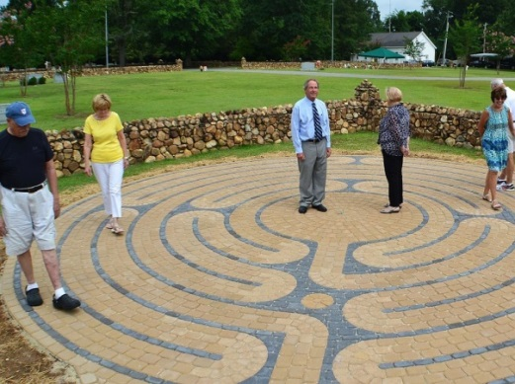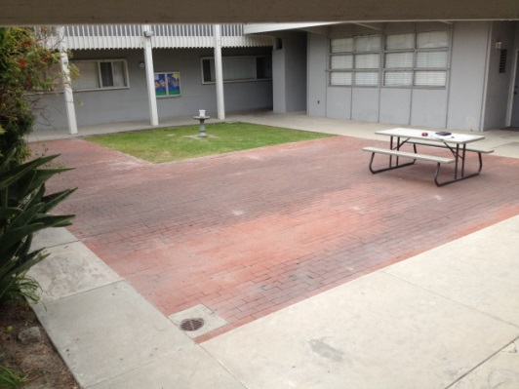

Help turn this into that.