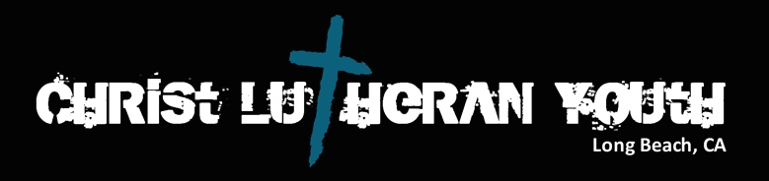
CLC Youth Calendar
September 2016- July 2017
Tentative
September
- 7th Confirmation Organization Meeting 7pm (Social Hall)
- 11th God’s Work, Our Hands (All Church activity) after 9:15 Service
- 14th Confirmation/Kaleidoscope/LOFT begin. (Weekly)
- 25th Bible Study, Games, and planning (All Youth and Parents) 10:45-1pm

October
- 9th Bowling and lunch High School 11:00am-2:30pm
- 23rd Indoor Rock Climbing Middle School 11:00am-2:30pm
- 30th Reformation Brats and Dogs Church Potluck after church

November
- 13th Prepping for the Holiday Season High School 11:00am-1:00pm
- 18th-20th Middle School Youth Gathering in Anaheim. Cost; ($110) Confirmation Churches will join us.
- 26th LB LYFE Tamale making at Our Saviours 9:30am-1:00pm

December
- 2nd & 3rd Alternative Christmas Faire 10:00am-1:00pm Saturday, after church on Sunday
- 11th Middle School Advent Party 11am-2pm
- 18th High School Advent Party 11am-2pm
- 24th Both Groups are welcome to assist with the Christmas Eve Family Service
- 28th Rose Bowl Float Decorating with the Pedal Pushers 7am-4pm

January
- 8th The Bible in 50 Words with Pictures Middle School Youth 10:45am-1pm
- 16th MLK Jr Celebration of Music TBA
- 27th-29th Elementary School Winter Retreat at El Camino Pines

February
- 3rd-5th High School Winter Retreat at El Camino Pines
- 26th Ronald McDonald House Serving Lunch Middle School Youth

March
- 5th LB LYFE Book Festival at Our Saviors, Long Beach (All youth are invited to help lead this activity)
- 19th High School (Outing)
- 26th Middle School (Outing)

April
- 15th Easter Breakfast Setup (All CLC Youth)
- 16th Easter Breakfast (All CLC Youth)
- 30th Camp Fire at CLC (LB LYFE) 4pm-6:30

May
- 12th Rummage Sale Setup
- 13th Rummage Sale and cleanup
- 21st High School (Visit Orphanage in Mexico)

June
- 4th Middle School Beach Cleanup and Play day
- 28th-July 2 Western States Youth Gathering High School at California Lutheran University, Thousand Oaks

July
- 10th-14th CLC Vacation Bible School

September- June

Wednesdays at Christ Lutheran Church
Guitar Lessons with Aaron 4:30pm-5:15pm
Confirmation 5:30pm-7:30pm
LOFT and Confirmation begin with Dinner

